Year 10 Chemistry Workbook

- Section 1 – 5 Quick Questions (Lesson Starters) Page 2

- Section 2 - Course Content

  - Topic 0 – Formulae, equations and hazards Page 12
- Topic 1 – Key concepts in chemistry Page 24
- Topic 2 – States of matter and mixtures Page 89
- Topic 2 – Methods of separating and purifying substances Page 95
- Topic 3 – Chemical change: Acids Page 109
- Topic 3 – Chemical change: Electrolytic processes Page 126
- Topic 4 – Obtaining and using metals Page 144
- Topic 4 – Reversible reactions and equilibria Page 156

- Section 3 – Glossary Page 162

- Section 4 – Essential Knowledge Questions and Answers to be learnt Page 167

- Section 5 – Homework Page 179
Homework is due once per fortnight and every question must be attempted. If you are stuck, you should watch the video or seek help from your teacher.

5 Quick Questions
Lesson 1
1) What is the formula of oxygen?
2) What is the formula of aluminium?
3) What is the formula of water?
4) Where would you find an element’s mass number?
5) Where would you find an element’s atomic number?
Lesson 2
How many atoms of each element are in the following compounds?
1) CuSO₄
2) Al₂(SO₄)₃
3) Fe(NO₃)₂
4) Ca(OH)₂
5) Write a balanced symbol equation for the reaction of aluminium with chlorine to make aluminium chloride. (AlCl₃).
Lesson 3
1) Write a balanced symbol equation for the reaction of carbon dioxide and carbon to make carbon monoxide (CO).
2) What is the formula of chlorine?
3) What is the formula of carbon?
4) What is the formula of nitrogen?
5) What is the formula of helium?
Lesson 4
1) What are the 3 states of matter?
2) How many atoms in (NH₄)₂SO₄?
3) Write a balanced symbol equation for the reaction of sodium with oxygen to make sodium oxide (Na₂O).
4) What is the formula of Argon?
5) What is the formula of Iodine?
Lesson 5
1) In an atom where are the neutrons found?
2) In an atom where are the protons found?
3) In an atom where are the electrons found?
4) What is the formula of bromine?
5) What is the formula of sulfur?
Lesson 6
1) Look at the periodic table and calculate the number of protons, neutrons and electrons in fluorine.
2) What is the definition of an isotope?
3) Which sub atomic particle is unique to all atoms of the same element?
4) Which sub atomic particle can atoms gain or lose?
5) What is the charge on an electron?
Lesson 7
1) What is the charge on a proton?
2) What is the mass of an electron?
3) What is the mass of a neutron?
4) What is the formula of oxygen?
5) Write a balanced symbol equation for the reaction of propane (C₃H₈) burning to make carbon dioxide and water.
Lesson 8
1) What is the relative atomic mass of a sample of iridium that is comprised 37% iridium-191 and 63% iridium-193?

2) How did Mendeleev arrange the elements in his version of the periodic table?
3) Why did Mendeleev leave gaps in his periodic table?
4) How is the modern periodic table different to Mendeleev’s?
5) What is the link between an elements group number and its electronic configuration?
Lesson 9
Look at a periodic table.
1) Name a non-metal in period 2.
2) Name an element with 3 electron shells (not aluminium).
3) What element has the electronic configuration 2.8.7?
4) Draw a diagram showing the bonding when ₄Be reacts with ₉F.
5) What is the name of Al₂S₃?
Lesson 10
1) What is the formula of the compound formed between Na⁺ ions and O²⁻ ions?
2) Draw a diagram to show how ₁₁Na reacts with ₈O.
3) What is the formula of iron(III) oxide?
4) What is the formula of the compound formed between Ca²⁺ ions and NO₃⁻ ions?
5) Explain whether the melting point of ionic compounds is high or low.
Lesson 11
1) How many protons, neutrons and electrons in the Na⁺ ion?
2) Why does sodium chloride solution conduct electricity whereas sodium chloride solid will not?
3) What is the definition of a covalent bond?
4) Draw a diagram to show the bonding when chlorine reacts with oxygen.
5) Write a balanced symbol equation for the reaction of chlorine with oxygen.
Lesson 12
1) Draw a diagram to show the bonding in the oxygen molecule. (₈O)

2) Why does oxygen have a low boiling point?

3) Would you expect liquid oxygen to conduct electricity?

4) Write a balanced equation for magnesium reacting with oxygen.

5) What type of bonding is present in magnesium oxide?

Lesson 13
1) Why is carbon diamond used in cutting tools?

2) Why is carbon graphite used as a lubricant?

3) Do giant molecules made of carbon conduct electricity?

4) What is the relative atomic mass of a sample of thallium that is comprised 30% thallium-203 and 70% thallium-205?

5) Write a balanced equation for the reaction of hydrogen with bromine to make hydrogen bromide (HBr).

Lesson 14.
1) Why does carbon graphite conduct electricity?

2) Why does solid copper sulfate not conduct electricity?

3) Why does aqueous copper sulfate conduct electricity?

4) Why does copper metal conduct electricity?

5) Do fullerenes conduct electricity?

Lesson 15?
What is the type of bonding in:
1) Fullerene

2) graphene

3) magnesium sulfate?

4) sulfur dioxide?
5) graphite

Lesson 16
1) Describe a metallic structure.

2) Explain why metals have high melting points.

3) Calculate the relative formula mass of Cu(NO₃)₂ (A_{r} Cu = 63.5, N = 14, O = 16).

4) Calculate how many atoms are present in 3 moles of iron. (Avogadro constant = 6.02 x 10²³).

5) Calculate how many atoms are present in 3 moles of water (H₂O)(Avogadro constant = 6.02 x 10²³)

Lesson 17
1) Calculate how many molecules are present in 3 moles of water (H₂O).
(Avogadro constant = 6.02 x 10²³)

2) How many moles of carbon dioxide are equivalent to 9.03x10²³ molecules?

How many moles in:
3) 250 g of CaCO₃ (A_{r} Ca = 40, C = 12, O = 16)

4) 3.65 g of HCl (A_{r} H = 1, Cl = 35.5)

5) How many molecules in 36 g of H₂O? (A_{r} H = 1, O = 16) (Avogadro constant = 6.02x10²³)

Lesson 18
What is the empirical formula of:
1) H₂O₂

2) X_{0.06}Y_{0.03}

3) Fe_{0.0123}O_{0.0164}

4) Calculate the number of protons, neutrons and electrons in the Ca²⁺ ion.

5) 10 grams calcium reacts with 9.5 grams of fluorine. Calculate the empirical formula of calcium fluoride? (A_{r} Ca = 40, F = 19)

Lesson 19
1) What equipment would you need to do an experiment to deduce the empirical formula of magnesium oxide?

2) Define relative atomic mass.

3) What is an isotope?

4) Describe the structure of a lithium atom.

5) What type of bonding is present in lithium chloride?

Lesson 20
1) How many atoms are present in 0.25 mole of Lithium oxide (Li₂O)? (Avogadro constant = 6.02 x 10²³)

2) How many moles are present in 69g lithium oxide? (A_{r} Li = 7, O = 16)

3) Does lithium oxide have a high or low melting point?

4) Does lithium oxide conduct electricity?
5) Write a balanced symbol equation for the reaction of lithium with oxygen.

Lesson 21
1) A compound X_{x}Y_{y} is formed when 3.36 g of X reacts with 1.44 g of Y. What is its empirical formula? (A_{r} X = 56, Y = 16).

2) What is the formula of sodium sulphide (Na⁺S²⁻)?

3) What is the formula of iron(II) nitrate (NO₃)⁻ ?

4) What is the mass of an electron?

5) How many protons, electrons and neutrons in potassium (mass number 39, atomic number 19)?

Lesson 22
1) Element X is in period 2 group 6. What is its electronic configuration?

2) 14 g of lithium reacts with excess oxygen. How many moles of lithium are used? (A_{r} Li = 7, O = 16).
4Li + O₂ 2Li₂O

3) How many moles of lithium oxide are made?

4) What mass of lithium oxide is made?

5) Does lithium oxide have a high or low melting point?

Lesson 23
1) How much aluminium is produced from 204 g of aluminium oxide? (A_{r} Al = 27, O = 16)
2Al₂O₃ 4Al + 3O₂

2) What type of bonding is present in SO₂?

3) What is the difference between an ionic bond and a covalent bond?

4) How many protons electrons and neutrons in the O²⁻ ion?

5) What is an isotope?

Lesson 24
1) Why do ionic substances have high melting points?

2) Why do simple molecular substances have low melting points?

3) Why do metals have high melting points?

4) Why do giant molecules have high melting points?

5) What type of bonding is present in fullerene?

Lesson 25
1) What do all atoms of the same element have in common?

2) What is the charge on an electron?

3) If an element loses 2 electrons to become an ion what will be its charge?

4) An element has the electronic configuration of 2:8:1, what group of the periodic table will it be found in?

5) Calculate the mass of lithium needed to make 6 g of hydrogen (A_{r} Li = 7, H = 1).
2Li + 2H₂O 2LiOH + H₂

Lesson 26
1) Convert 50 cm³ into dm³.

2) How many cm³ in a dm³.

3) 20 g of sodium hydroxide is dissolved in 50 cm³ of water, what is its concentration in g dm⁻³?

4) A piece of magnesium is burnt, does it’s mass go up, down or stay the same?

5) What sub atomic particle(s) are found in the nucleus?

Lesson 27
1) How did Mendeleev order the elements in his version of the periodic table?

2) What is the mass, in grams, of a single atom of silver? (A_{r} Ag = 108, Avogadro constant = 6.02x10²³)?

3) Describe how the atoms are arranged in a lump of silver?

4) When silver is heated it will eventually melt, what happens to the temperature of silver as it is melting?

5) Describe how particles are arranged in a liquid.

Lesson 28
1) Draw a diagram to show the bonding in oxygen (₈O).

2) Why is diamond used in cutting tools?

3) Why is graphite used for electrodes?

4) What mass of chlorine is needed to make 267 g of aluminium chloride? (A_{r} Al = 27, Cl = 35.5)
2Al + 3Cl₂ 2AlCl₃

5) What charge do protons, electrons and neutrons have?
Lesson 29
1) What is the mass of 1 proton, 1 electron and 1 neutron?

2) How could you separate the dyes found in an ink spot?

3) How could you separate a mixture of salt and water?

4) How could you separate a mixture of alcohol (ethanol) and water?

5) What is the concentration, in g dm⁻³, of the solution formed when 20 g of salt is dissolved in 100 cm³ water?

Lesson 30
1) An ink spot runs 28 mm on a filter paper, the solvent front is measured at 49 mm. what is the R_{f} of this ink?

2) Another ink spot also runs exactly 28 mm on a different piece of filter paper. The solvent front on this paper is 68 mm. Are the inks the same or different?

3) A different ink spot does not run any distance at all. Why not?

4) In chromatography which is the stationary phase and which is the mobile phase?

5) Why does chlorine have a relative atomic mass of 35.5 and is not a whole number?

Lesson 31
1) How can sodium chloride be made to conduct electricity?

2) What is an ion?

3) Draw a diagram to show how sodium bonds with chlorine.

4) What is the structure of sodium chloride?

5) There are 210.6 g of sodium chloride in a jar. How many moles is this equivalent to? (A_{r} Na = 23, Cl = 35.5)

Lesson 32
1) A high concentration of which ion makes a substance strongly alkaline?

2) A high concentration of which ion makes a solution strongly acidic?

3) As an acid is neutralised the pH of the solution changes. As the pH changes from 2.2.to 3.2 what happens to the concentration of hydrogen ions?

4) What is the formula of sulphuric acid?

5) What is the formula of nitric acid?

Lesson 33
1) What is the formula of hydrochloric acid?
2) What group of the periodic table is Ca in?

3) How many electrons are on the outer shell of Ca?

4) What is the charge of the Ca ion?

5) What is the charge on the chloride ion?

Lesson 34
1) What is the formula of calcium chloride?

2) What is the formula of calcium carbonate? The carbonate ion is (CO₃²⁻)

3) Write a balanced symbol equation for the reaction of calcium carbonate with hydrochloric acid.

4) What type of reaction is this?

5) What mass of carbon dioxide is made when 20 g of calcium carbonate react with excess hydrochloric acid? (A_{r} Ca = 40, C = 12, O = 16)

Lesson 35
1) Is silver chloride soluble in water?

2) is ammonium hydroxide soluble in water?

3) is copper sulfate soluble in water?

4) Is the product of the reaction between silver nitrate and sodium chloride soluble?

5) How would you obtain a pure dry sample of iron hydroxide from the reaction of iron sulfate and sodium hydroxide?

Lesson 36
1) How would you obtain a pure dry sample of copper sulfate from the reaction of insoluble copper oxide and sulfuric acid?

2) How would you obtain a pure dry sample of sodium sulfate from the reaction of sulfuric acid and sodium hydroxide?

3) Write a balanced symbol equation for the reaction of sulfuric acid and sodium hydroxide?

4) Sodium hydroxide is comprised 57.5% sodium, 2.5% hydrogen, and 40% oxygen. Prove the formula is NaOH (A_{r} Na = 23, O = 16, H = 1)

5) What substances undergo electrolysis?

Lesson 37
1) What is the electronic configuration of the oxide ion (O²⁻)?

2) What is the electronic configuration of the oxygen atom?

3) Write a half equation for the formation oxygen from oxide ions?

4) Write a half equation for the formation of zinc atoms from zinc ions (Zn²⁺)

5) Why does carbon dioxide have a low boiling point?

Lesson 38
1) Is SO₄²⁻ a cation or anion?

2) Write a half equation for the formation of hydrogen gas from hydrogen ions.

3) Write a half equation for the formation of chlorine gas from chloride ions.

4) What are the products of electrolysis from NaCl(l)

5) What are the products of electrolysis from CuCl₂ (aq)

Lesson 39
1) Write a balanced equation for the formula of ammonia from nitrogen and hydrogen.

2) What is phytomining?

3) What is bioleaching?

4) Write half equations for the anode and cathode for the electrolytic purification of copper.

5) Define oxidation and reduction using electrons.

Lesson 40
1) Why is iron extracted from its ore by smelting with carbon whereas electrolysis is used for the extraction of aluminium?

2) How many tonnes of aluminium oxide are needed to produce 135 tonnes of aluminium? (A_{r} Al = 27, O = 16) 2Al₂O₃ 4Al + 3O₂

3) Why is the Haber process heated to 450 ºC?

4) Why is a pressure of 200 atmospheres used in the Haber process?

5) A hydrocarbon has a relative formula mass of 112, its empirical formula is CH₂, what is its molecular formula? (A_{r} C = 12, H = 1).

Topic 0 - Content and Checklist

For each content point put a tick next to it when firstly you understand it and secondly when you have learnt it. If you don’t understand a content point you must ask your teacher.

 | Content | Understand it | Learnt it
1 | Learn the formulae of simple elements, compounds and ions.
2 | Write word equations for reactions.
3 | Write balanced symbol equations for reactions including state symbols (s), (l), (g) and (aq).
4 | Write balanced ionic equations (higher only)
5 | Name the common hazard symbols, know why these substances are dangerous and know the precautions that need to be taken when working with them.
6 | Be able to recognise the risks associated with an experiment and suggest suitable safety precautions.

Use your periodic table to find the symbols for the first 20 elements.

Atomic number | Element name | Element symbol | Atomic number | Element name | Element symbol
1 |  |  | 11
2 |  |  | 12
3 |  |  | 13
4 |  |  | 14
5 |  |  | 15
6 |  |  | 16
7 |  |  | 17
8 |  |  | 18
9 |  |  | 19
10 |  |  | 20

Now use your periodic table to find the symbols of 10 other elements that you have heard of:

Atomic number | Element name | Element symbol | Atomic number | Element name | Element symbol

Although the periodic table shows the symbols of all the elements the common non-metals often exist in pairs in their natural state. For example, hydrogen would be H₂ and not H.

Write a word and symbol equation for Hydrogen reacting with Chlorine to make Hydrogen Chloride (HCl)

Word
Symbol

Complete Homework 1 tonight. All the formulae in the table need learning.

Balancing Equations
Stage 1 – Counting atoms
Rules
- Every time there is a new capital letter there is a new element to count. For example:
  - CO = 1 x Carbon and 1 x Oxygen.
  - Whereas, Co = 1 x Cobalt
- If there is no number present (big or small) there is actually an invisible number 1. For example:
  - CuSO₄ would probably be more clear if it were written like this 1Cu₁S₁O₄ and contains 1 x Copper, 1 x Sulphur and 4 x Oxygen
- If a big number is before a substance everything needs to be multiplied by that number. For example:
  - 4H₂O = 4 x 2 = 8 Hydrogen and 4 x 1 = 4 Oxygen
- If there are brackets everything inside the brackets needs to be multiplied by the number outside the brackets. For example:
  - Zn(NO₃)₂ = 1 x Zinc as it is outside the brackets. Inside the brackets there is 1 x Nitrogen and 3 x Oxygen but they both need to be multiplied by the 2 outside the bracket. So the total number of atoms is: 1 x Zinc, 2 x Nitrogen and 6 x Oxygen.
- To balance equations, you need to count the total number of atoms on each side of the equation. It is possible for the same element to appear in more than 1 substance on one side of the equation. For example:
  - CO₂ + H₂O in this example 2 x Oxygen are in the CO₂ and 1 x Oxygen are in the H₂O. The total atoms are therefore 1 x Carbon, 2 x Hydrogen and 3 x Oxygen.

Check you understand the rules:
Count the atoms in:
- CO₂ (if you think the answer is 2 x Cobalt see rule 1 but if you think there are
2 x Carbon see rule 2)

- H₂O (if you think there 2 x Oxygen see rule 2)

- 2CO₂ (if you think there are 4 Carbons see rule 2, if you think there are 2 Oxygen atoms see rule 3)

- 4CO₂

- 2CO₂ + H₂O (if you think there are 4 Oxygen atoms see rule 5)

- 5CO₂ + 4H₂O

- NH₄NO₃

- Co(OH)₂ (if you think there is 1 Oxygen see rule 4)

- Al₂(SO₄)₃

- 4C₂H₅OH + 12O₂

Stage 2 – Balancing Equations

 | 3 Golden Rules
1 | The number and type of atoms on the left of the arrow must equal the number and type of atoms on the right of the arrow
2 | Don’t mess with the little numbers
3 | Big numbers must go before substances

For Example:
Example 1
Mg + HCl → MgCl₂ + H₂
On the left of the arrow there are: | On the right of the arrow there are:
1 x Mg | 1 x Mg
1x H | 2 x H
1 x Cl | 2 x Cl

It may seem easy to change MgCl₂ to MgCl but that breaks rule 2.
There are less Hydrogen and Chlorine atoms on the left of the arrow so we must increase the number of them. To do this we may change the big numbers before the substances, at present there are no numbers but it would possibly be more helpful if a big 1 was before each substance. As shown below:
1 Mg + 1 HCl → 1 MgCl₂ + 1 H₂
To increase the numbers of H and Cl atoms on the left of the arrow we can change the 1 before the HCl to a 2:
1 Mg + 2 HCl → 1 MgCl₂ + 1 H₂
1 Mg + 2 HCl → 1 MgCl₂ + 1 H₂
On the left of the arrow there are: | On the right of the arrow there are:
1 x Mg | 1 x Mg
2x H | 2 x H
2 x Cl | 2 x Cl

To complete we should show the equation without any number 1s.
Mg + 2 HCl → MgCl₂ + H₂

Example 2

Mg + O₂ → MgO
On the left of the arrow there are: | On the right of the arrow there are:
1 x Mg | 1 x Mg
2 x O | 1 x O

It might seem easy to change the MgO on the right hand side to look like this Mg2O but that breaks rule 3. Again with this example big numbers can only be put before substances so the big number 2 has to go before the MgO as shown:
1 Mg + 1 O₂ → 2 MgO
On the left of the arrow there are: | On the right of the arrow there are:
1 x Mg | 2 x Mg
2 x O | 2 x O

Doing this has balanced the Oxygen atoms but has unbalanced the Magnesium atoms, this does not mean the change is wrong, it just means we haven’t finished. To complete the job, we now need to change the 1 to a 2 before the Mg on the left.
2 Mg + 1 O₂ → 2 MgO
On the left of the arrow there are: | On the right of the arrow there are:
2 x Mg | 2 x Mg
2 x O | 2 x O
The completed equation is:
2 Mg + O₂ → 2 MgO

Now try these:
- Ca + HF → CaF₂ + H₂

Ca + HF → CaF₂ + H₂

- NaBr + Cl₂ → NaCl + Br₂

NaBr + Cl₂ → NaCl + Br₂

- Zn + H₂O ZnO + H₂

Zn + H₂O → ZnO + H₂

- Li + O₂ Li₂O

Li + O₂ → Li₂O

- CH₄ + O₂ = CO₂ + H₂O

CH₄ + O₂ → CO₂ + H₂O

- Al₂O₃ = Al + O₂

Al₂O₃ → Al + O₂

- N₂ + H₂ = NH₃

N₂ + H₂ → NH₃

- Fe₂O₃ + CO = Fe + CO₂

Fe₂O₃ + CO → Fe + CO₂

- Li + H₂O = LiOH + H₂

Li + H₂O → LiOH + H₂

- CO₂ + H₂O = C₆H₁₂O₆ + O₂

CO₂ + H₂O → C₆H₁₂O₆ + O₂

If you can do those, try these they are probably too difficult for GCSE.
- H₂O + O₂ + NO₂ = HNO₃

H₂O + O₂ + NO₂ → HNO₃

- C₈H₁₈ + O₂ = CO₂ + H₂O

C₈H₁₈ + O₂ → CO₂ + H₂O

With symbol equations scientists will often add state symbols to give a little more information about the reactant or product.

What are the 3 states of matter?

 | State of matter | State symbol
1
2
3

There is a fourth state symbol that scientists often use this is called aqueous (aq). What do you think this might be?

There are a number of elements that exist as diatomic molecules. Name these and learn that they never appear in chemical equations on their own.

1) |  | 2) |  | 3) |  | 4) |  | 5) |  | 6) |  | 7)

Summary:

Write word and balanced symbol equations for the following reactions:

- Hydrogen gas reacting with oxygen gas to make water.

Word
Symbol

- Calcium carbonate solid (CaCO₃) reacting with hydrochloric acid (HCl) to make the soluble salt calcium chloride (CaCl₂) along with water and carbon dioxide.

Word
Symbol

State 2 things you would see if you did this reaction.

1
2

Hazard Symbols

Name each hazard symbol below and state write a sentence describing the hazard.

Symbol
Name
Description
Symbol
Name
Description

If you were planning to investigate how much energy was given by from the burning of methylated spirits you could decide to heat a beaker of water with the flame. What risks are associated with this activity and how would you control them?

Risks | Control

Write balanced equations for:
- Magnesium reacting with chlorine to make magnesium chloride (MgCl₂)

- Hydrogen reacting with chlorine to make hydrogen chloride (HCl)

- Iron reacting with chlorine to make iron (III) chloride (FeCl₃)

- Ethanol (C₂H₅OH) reacting with oxygen to make carbon dioxide and water.

Blank Pages for Notes
Topic 1 - Content and Checklist

For each content point put a tick next to it when firstly you understand it and secondly when you have learnt it. If you don’t understand a content point you must ask your teacher.

 | Content | Understand it | Learnt it
1 | Know the Dalton model of the atom and explain how the model today is similar but different.
2 | Be able to draw, label and explain what an atom looks like. That is they are made from a nucleus containing protons and neutrons, surrounded by electrons in shells.
3 | Learn the relative charges and masses of protons, neutrons and electrons.
4 | Explain why the numbers of protons and electrons in atoms are the equal.
5 | Be able to picture the relative size of the nucleus compared to the rest of the atom.
6 | Learn that most of the mass of the atom is found in the nucleus.
7 | Learn the meaning of the term: mass number of an atom
8 | Learn that atoms of the same element have the same number of protons in the nucleus and that this number is unique to that element.
9 | Learn the definition of an isotope: atoms of the same element with the same number of protons but a different number of neutrons.
10 | Be able to calculate the number of protons, neutrons and electrons present in an atom when given mass and atomic numbers.
11 | Be able to explain why elements like chlorine have a relative atomic mass that is not a whole number. E.g. Chlorine has a relative atomic mass of 35.5.
12 | Be able to calculate the relative atomic mass of an element when given the mass number and relative abundance of each isotope.
13 | Know who Mendeleev is and learn how he arranged the elements in his periodic table by looking at the properties of the known elements and their compounds.
14 | Be able to explain how Mendeleev used his table to predict the existence and properties of yet to be discovered elements.
15 | Explain why Mendeleev had to alter the position of a small number of elements when he arranged his table in order of atomic mass. Your explanation needs to involve detail about the relative abundance of isotopes of these elements.
16 | Learn the meaning of the term: atomic number
17 | Learn that the elements in the periodic table are arranged in order of increasing atomic number. Also know that the horizontal rows of the periodic table are called periods and the vertical columns contain elements with similar chemical properties and are called groups.
18 | Learn the position of metals and non-metals on the periodic table.
19 | Be able to draw and write the electronic configuration of the first 20 elements in the periodic table.
20 | Explain how the electronic configuration of an element is related to its position in the periodic table.
21 | Be able to draw diagrams and explain how ionic bonds are formed.
22 | Learn the meaning of the terms: ion, cation, and anion.
23 | Calculate the numbers of protons, neutrons and electrons in simple ions when given atomic and mass numbers.
24 | Explain how ions are formed and be able to predict the charges of ions from elements in group 1, 2 6 and 7 of the periodic table.
25 | Correctly use the endings –ide and –ate when naming compounds.
26 | Work out the correct formulae of an ionic compound when given the constituent ions.
27 | Be able to draw and describe the structure of an ionic compound. You must use the term: ionic lattice. You must learn that the ionic lattice is made from a regular arrangement of ions and they are held in place by strong electrostatic forces of attraction between oppositely charged ions.
28 | Learn that a covalent bond is formed when a pair(s) of electrons is shared between 2 atoms.
29 | Learn that covalent bonding results in the formation of molecules.
30 | Be able to draw dot and cross diagrams and explain how the covalent bonds are formed in: hydrogen, hydrogen chloride, water, methane, oxygen and carbon dioxide.
31 | Learn the difference between ionic structure, simple molecular structures, giant molecular structures and metallic structures. Also learn which structures are likely to have high or low melting and boiling points, which structures conduct electricity and which structures are likely to dissolve in water.
32 | Learn and explain why ionic substances have high melting points and why they do not conduct electricity in the solid state but they will when molten or dissolved.
33 | Learn and explain why simple molecular substances have low melting points and boiling and why they are poor conductors of electricity.
34 | Learn that carbon diamond and carbon graphite are examples of giant molecular structures.
35 | Be able to recognise and explain the structures of carbon diamond and carbon graphite.
36 | Use the structure of carbon diamond to explain why it is used for cutting tools and the structure of carbon graphite to explain why it is used for electrodes and as a lubricant.
37 | Learn the properties of fullerenes (including C₆₀) and be able to use the structure to be able to explain these properties.
38 | Learn that polymers like polyethene are made from large molecules containing many carbon atoms.
39 | Learn and use the metallic structure to explain why metals are malleable and able to conduct electricity.
40 | Understand that diagrams showing bonding do not always give you an idea of what the bonding will actually look like. For this 3 D diagrams would be better but are very difficult to draw.
41 | Learn that metals are shiny solids, have high melting points, high density and are good conductors of electricity. Whereas non-metals have low melting points and are poor conductors of electricity.
42 | Use relative atomic masses to calculate the relative formula mass.
43 | Learn how to calculate empirical formulae.
44 | Work out: 1) the empirical formula of a compound from the formula of its molecule and: 2) the molecular formula of a compound from its empirical formula and its relative molecular mass.
45 | Explain how you could carry out an experiment to work out the empirical formula of magnesium oxide.
46 | Understand the law of conservation of mass. Be able to make predictions of the mass of a container in which: 1) all reactants and products are enclosed. 2) A container from which a gas is escaping. 3) A reaction that is reacting with a gas in the air to make a solid.
47 | Use a reaction equation to be able to calculate the mass of a reactant or product using the mass of one other substance.
48 | Be able to explain why one reactant is often in excess.
49 | Work out the stoichiometry of a reaction from the masses of the reactants and products.
50 | Work out the concentration of a solution in g dm⁻³
51 | Learn that 1 mole of a substance is the Avogadro constant number of particles of that substance.
52 | Be able to calculate: 1) the number of moles of a substance when given a mass. 2) The number of particles of a substance given the number of moles. 3 The number of particles of a substance given the mass.  For each of the above you need to be able to do the calculation the other way round as well.

Early ideas about the atom – John Dalton
Literacy Exercise – Read the passage below and add punctuation where appropriate. Following this answer the questions with information that can be found in the passage.
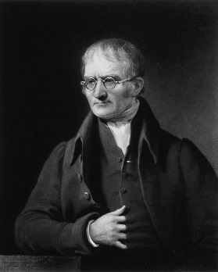
the word atom comes from atomos an ancient greek word meaning indivisible the Greek philosopher demokritos (460-370 BC) stated that all matter could be divided and sub-divided into smaller and smaller units and eventually there would be a tiny particle that could not be divided any further - an atom

although the concept of the atom dates back to the ideas of democritus the english chemist john dalton formulated the first modern description of it as the fundamental building block of chemical structures dalton developed the law of multiple proportions by studying and expanding upon the works of Antoine Lavoisier and Joseph Proust

Dalton proposed that each chemical element is composed of atoms of a single unique type and though they cannot be altered or destroyed by chemical means they can combine to form more complex structures (chemical compounds) since dalton reached his conclusions by experimentation and examination of the results in an empirical fashion, this marked the first truly scientific theory of the atom
The main points of daltons atomic theory are
1. Everything is composed of atoms which are the indivisible building blocks of matter and cannot be destroyed
2. All atoms of an element are identical
3. The atoms of different elements vary in size and mass
4. Compounds are produced through different whole-number combinations of atoms
5. A chemical reaction results in the rearrangement of atoms in the reactant and product compounds
atomic theory has been revised over the years to incorporate the existence of atomic isotopes in addition the discovery of subatomic particles has shown that atoms can be divided into smaller parts However daltons importance in the development of modern atomic theory has been recognised by the designation of the atomic mass unit as a Dalton

______/15
Questions
What is an atom?

What is an element?

How have sub-atomic particles changed the Dalton model of the atom?
The Atom Today
What makes up an atom:
1 |  | 2 |  | 3

Draw a fully labelled diagram of a lithium atom. (3 protons, 4 neutrons and 3 electrons).
Include the following labels: electron, neutron, proton, positive (+), no charge, negative (-), nucleus, shells.

Imagine that we could make a model of an atom that were the size of Wembley stadium. How big would you make the nucleus?

Complete the following table:

Sub Atomic Particle | Mass | Charge | Position in atom

The periodic table gives us information about the numbers of protons, neutrons and electrons present. E.g.

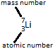
The mass number is equal to the combined number of protons and neutrons. This is because electrons have virtually no mass. The atomic number is sometimes called the proton number because it is equal to the number of protons present. Atoms are neutrally charged so the number of positive charges (________________) is exactly balanced by the number of negative charges (________________).

Use the information above to calculate the number of protons neutrons and electrons present in Lithium.
Protons ______________________
Neutrons ______________________
Electrons ______________________

The numbers of which subatomic particle are unique to atoms of a given element?

Why are the numbers of protons and electrons in an atom the same?

Now complete the following table for the blanks choose 2 elements from the periodic table:
Atom
Protons
Neutrons
Electrons

All the atoms in the table above are from different elements; now look at the table below which contains 5 examples but only 2 different elements.
Atom
Protons
Neutrons
Electrons

What is similar about the 2 carbon atoms?
What is different about the 2 carbon atoms?

What is similar about the 3 hydrogen atoms?

What is different about the 3 hydrogen atoms?

Where you have different atoms of the same element they are called isotopes. What is the definition of an isotope?

Now define these:

Atomic Number

Mass Number

Where would you find the vast majority of the mass of an atom?

Relative Atomic Mass

Blank Pages for Notes
Calculate the relative atomic mass of an element from the
relative masses and abundances of its isotopes

Some naturally occurring elements like chlorine are made of 2 or more isotopes, this will result in the relative atomic mass of the sample not being a whole number. If you know the percentage and the atomic mass of each sample, it is possible to calculate the mass of the sample using the following formula:

What do the brackets mean in the formula above?

Example
Naturally occurring chlorine is comprised of 75% ³⁵Cl and 25% ³⁷Cl. What is the relative atomic mass of naturally occurring chlorine?

Questions
Calculate the relative atomic masses of the following elements:

- A sample of Boron containing 20% of Boron-10 and 80% Boron-11

- A sample of Bromine containing 50% of Bromine-79 and 50% Bromine-81

- Copper is made of two naturally occurring isotopes: copper-63 (69%) and copper-65 (31%). Calculate the relative atomic mass of copper.

- A sample of Magnesium containing 79% of Magnesium-24, 10% of Magnesium-25 and 11% of Magnesium-26.

- The table below gives information about the naturally occurring isotopes in a sample of rubidium.
Isotope | Number of protons | Number of electrons | Number of neutrons | Percentage of isotope in sample
1 | 37 | 37 | 48 | 72
2 | 37 | 37 | 50 | 28
Use this information to calculate the relative atomic mass of rubidium.

- Naturally occurring Neon has a relative atomic mass of 20.18, it is made from 2 isotopes, one is 91% Neon-20 and can you calculate the mass number of the other.

Explain why the relative atomic mass of chlorine is 35.5 and is not a whole number?

Periodic table - Dimitri Mendeleev

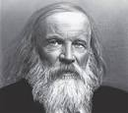
"I saw in a dream a table where all elements fell into place as required. Awakening, I immediately wrote it down on a piece of paper, only in one place did a correction later seem necessary."

Literacy Exercise – please add the necessary punctuation and change the errors in the passage below. Also take note of the information in the passage because you need to answer the questions that follow.

In 1869 Dimitri Mendeleev published a periodic table of the elements Mendeleev arranged the elements in order of increasing atomic mass as he did this he noticed that elements along the line had similar properties so he cut the line and placed these elements underneath each other in groups he was not the first scientist to do this a previous English scientist called John Newlands had done much the same thing where Mendeleev was different was that he realised that not all the elements had been discovered so he left gaps and used the properties of the other members of the group and there compounds to predict the property of the undiscovered element at the time other scientists were sceptical of mendeleevs table that was until the discovery of gallium in 1875 when the other scientists realised that mendeleevs table was basically accurate and they should of trusted it earlier.
______/15

How did Mendeleev order the elements in his table?

How did Mendeleev then group his elements?
1)
2)

What made other scientists trust Mendeleev’s table of the elements?

Look carefully at the periodic table, the elements are not arranged in order of atomic mass, what order are they arranged in?

Now look at groups 6 and 7, find a pair of elements that would be in the wrong places if they were arranged in order of atomic mass?

Mendeleev spotted this problem and broke his rules here because he realised that the properties of the elements didn’t match the groups they were in so he swapped them around. It was only after the discovery of atomic numbers that it was proven he was correct to do this.

Why is it possible for an element with a higher atomic number to have a mass number that is lower than an element with fewer protons?

Draw and label on the outline of the periodic table below where the metal and non-metal divide is.

Also on the outline above can you clearly label the groups numbers and period numbers.

Are groups horizontal or vertical? ______________________

Are periods horizontal or vertical? ______________________

Do elements in the same groups or periods have similar properties? ________________
Periodic Table Showing the Electronic Configuration of the first 20 elements
- Label the groups and the periods

The first shell holds __________ electrons
The second shell holds __________ electrons
The third shell holds __________ electrons
The fourth shell holds __________ electrons
Transition Metals go here.
Label each box with:
- Element symbol and atomic number (this will need to be small and in a corner!)
- Draw a diagram for each element showing the arrangement of the electrons.
- Under the diagram write the electronic configuration (use a . to signify a new electron shell (energy level))
- What is the pattern between the electronic configuration and the group number?
- What is the pattern between the electronic configuration and the period number?

Ionic Bonding

Atoms form bonds to other atoms because they want a full outer shell of electrons. The formation of these bonds gives rise to different compounds.

Question:
Why do atoms form bonds with other atoms?

Look at the atoms below, how can they both get a full outer shell of electrons. Also can you draw the resulting ion and state the charge on it. The first is done for you.
Atom | What happens | Ion diagram | Charge on ion
 | Gains 1 electron |  | Cl⁻

What is the definition of an ion?

What is a Cation?

What is an Anion?

Now go back to the table on the last page and label all the ions as cations or anions. What trend can you notice?

Can you make up a helpful little phrase to help you remember the difference between cations and anions.

When an atom gains or loses an electron it has to come from and go to another atom(s). Therefore, we really have to think about this with 2 or more atoms some gaining and some losing electrons.

In the diagram below look at the 2 atoms and decide how they come to an arrangement with their electrons. Draw an arrow to show the movement of the electron(s) that start at the electron and finish where they are going. Then write the charge on the ions formed and give the formula and name of the resulting compound.
Atoms | ₁₁Na and ₁₇Cl
Diagram (with arrows showing electron movement)
Ions
Name of compound
Formula of compound
Atoms | ₃Li and ₉F
Diagram (with arrows showing electron movement)
Ions
Name of compound
Formula of compound

Atoms | ₁₂Mg and ₈O
Diagram (with arrows showing electron movement)
Ions
Name of compound
Formula of compound

Atoms | ₁₂Mg and ₉F
Diagram (with arrows showing electron movement)
Ions
Name of compound
Formula of compound

Atoms | ₃Li and ₈O
Diagram (with arrows showing electron movement)
Ions
Name of compound
Formula of compound

This one will not be on the exam but is good practice anyway.
Atoms | ₁₃Al and ₁₇Cl
Diagram (with arrows showing electron movement)
Ions
Name of compound
Formula of compound

This one comes with a health warning, it’s only for fun and shouldn’t be revised at exam time. – Enjoy
Atoms | ₁₃Al and ₈O
Diagram (with arrows showing electron movement)
Ions
Name of compound
Formula of compound

What is the difference between compounds that end in –ide and compounds that end in –ate.

Look at the following formulae, then give the names of the compounds.

Formula | Name
KCl
CuSO₄
FeS
Na₂CO₃
NaHCO₃
AlN
Al(NO₃)₃

Working out the formula for ionic compounds

Can you look at the charge on the ions above and then label the periodic table below?

Number of electrons on outer shell
Charge on ion
 | Group 1 |  |  |  |  |  |  |  |  |  |  | Group 0
 |  | Group 2 |  |  |  |  | Group 3 | Group 4 | Group 5 | Group 6 | Group 7

What is the trend for metallic ions in groups 1 and 2?

What is the trend for non-metallic ions in groups 6 and 7?
The table below gives you charges on common ions:

Cations | Formula |  | Anions | Formula
Sodium | Na⁺ |  | Oxide | O²⁻
Calcium | Ca²⁺ |  | Chloride | Cl⁻
Ammonium | NH₄⁺ |  | Sulphide | S²⁻
Iron (II) | Fe²⁺ |  | Fluoride | F⁻
Iron (III) | Fe³⁺ |  | Hydroxide | OH⁻
 |  |  | Nitrate | NO₃⁻
 |  |  | Carbonate | CO₃²⁻
 |  |  | Sulfate | SO₄²⁻

Example: What is the formula of magnesium chloride?
Magnesium chloride is made of Mg²⁺ ions and Cl⁻ ions. If the formula was MgCl the overall charge would be unbalanced and this is not allowed. The overall charge of an ionic compound must be neutral. So in this case we need 2 chloride ions to balance the 2+ charge on the Magnesium ion so the formula is MgCl₂

Use the charges of the cations and the anions in the table above to work out the formula for the compounds shown.
Sodium Fluoride | Lithium oxide | Calcium oxide | Ammonium chloride
Iron (II) oxide | Iron (III) oxide | Sodium nitrate | Magnesium nitrate
Sodium Carbonate | Aluminium sulfate | Lithium Hydroxide | Magnesium hydroxide
Copper (II) nitrate | Aluminium Chloride | Magnesium Sulfate | Magnesium Carbonate

The lattice structure of ionic compounds.

When electrons are donated and accepted between atoms they become charged ions like the poles of a magnet. The opposite charges all attract each other and because there are literally billions of ions involved they all end up sticking together. Only opposite charges attract so you end up with a regular arrangement of oppositely charged ions called a lattice.

Complete the diagram showing the regular lattice arrangement of Na⁺ and Cl⁻ ions in sodium chloride. You need to do this by putting the correct ion at each node in the cube below.

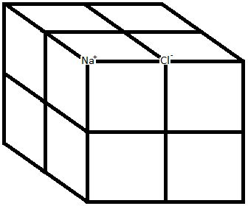
Do you think ionic substances like sodium chloride have high or low melting points, explain your answer?

Define: a current of electricity.

Look closely at the ionic lattice above and explain whether solid sodium chloride can conduct electricity.
How could you turn solid sodium chloride into the liquid state?

- __________________________ 2) __________________________

Explain whether sodium chloride in the liquid state can conduct electricity.
Calculate the number of protons, neutrons and electrons in:
Atom
Protons
Neutrons
Electrons

Blank Pages for Notes
Covalent Bonding
Why to atoms join together to form compounds?

In one sentence describe how ionic bonding works?

How else could atoms come to an arrangement over their electrons?

Describe a covalent bond.

Fluorine molecules (F₂) are formed from 2 fluorine atoms (₉F) covalently bonded together. The diagram below shows 2 fluorine atoms, then beneath that the same atoms are shown overlapping without their electrons. Can you draw the electrons onto the second diagram using dots and crosses to show the electrons and which atom they have come from?

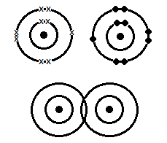

Clearly label on the diagram above where and what the covalent bond is.

Use the same logic to draw (atomic numbers ₁H, ₁₇Cl,):

- Hydrogen molecule (H₂)

- Hydrogen chloride (HCl)

Nitrogen bonds to hydrogen covalently. (Atomic numbers ₇N, ₁H) the diagram below shows the overlapping electron shells. Can you add the electrons?
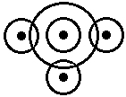
How many electrons were needed to fill the outer shell of Nitrogen? ___________

How many covalent bonds are formed? ___________

What is the rule to knowing how many covalent bonds an atom will form?

Now draw the molecule formed from:

hydrogen and oxygen (₁H, ₈O)

Carbon and Hydrogen (₁H, ₆C)

For the next 2, you need to know that it is possible to share more than 1 pair of electrons.

Draw the oxygen molecule (₈O)

Draw the molecule formed from carbon and oxygen (₆C, ₈O)

What is it called when you share 2 pairs of electrons between 2 atoms? ____________________
These ones are not on the specification so they are optional, do not learn them, but they’re good for a little extra practise:
Draw diagrams to show the bonding in:

Chlorine molecule (₁₇Cl)

Chlorine and oxygen (₁₇Cl, ₈O)

Nitrogen molecule (₇N)

Ethane molecule, C₂H₆ (₆C, ₁H)

Ethene molecule, C₂H₄ (₆C, ₁H)

Propene molecule, C₃H₆ (₆C, ₁H)

Physical properties of Simple Molecular Substances
Melting and Boiling Point
In the box below draw how the molecules of methane will be arranged at room temperature:

Do simple molecular substances like methane have a high or low melting and boiling points? Then explain your answer.

Melting Point | Explanation

Are covalent bonds weak or strong? _________________________

What is weak in the box showing methane above?

Electrical Conductivity

What is a current of electricity?

Explain if simple molecular substances are charged?

Explain if electrons are free to move in simple molecular substances?

Are simple molecular substances good or poor conductors of electricity? ______________________

Giant Molecular Structures

In simple molecules the covalent bonds only link a finite number of atoms. Whereas, with giant molecules the covalent bonds can link to a never ending number of atoms.
Carbon can provide 2 examples for this:

- Carbon diamond.
- Carbon graphite.
What group of the periodic table is carbon in and how many bonds would you expect it to form?

Group _________

Number of bonds _________

Carbon - Diamond
In diamond each carbon atoms forms 4 covalent bonds to 4 different carbon atoms. These bonds involve ever greater numbers of carbon atoms and the molecule becomes extremely large.
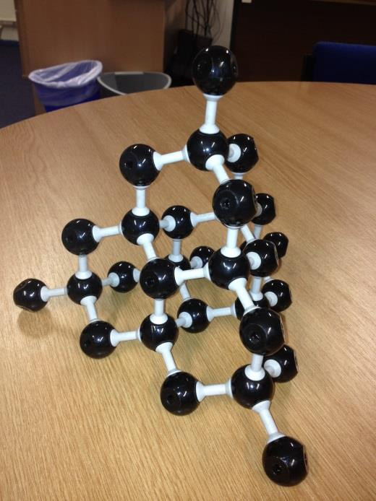
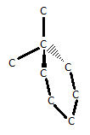

Are covalent bonds strong or weak? ___________________

Explain whether diamond has a high or low melting point.

Explain if there are there any charged particles that can move in diamond?

Explain whether you would expect diamond to conduct electricity

Carbon - Graphite
In graphite each carbon atoms forms 3 covalent bonds to 3 different carbon atoms. These bonds involve ever greater numbers of carbon atoms and the molecule becomes extremely large.
Draw a diagram showing the giant molecular structure of graphite.

How many bonds would you expect carbon to form? ____________

What is left over? __________________

Where does this particle go? __________________________________________________________

Is it free to move? ____________

Explain if graphite conducts electricity.

Now by comparing the structures of diamond and graphite;

Explain why, although they are both forms of carbon and giant molecular substances, graphite is used to make electrodes and as a lubricant, whereas diamond is used in cutting tools.

Fullerenes (C₆₀) and Graphene
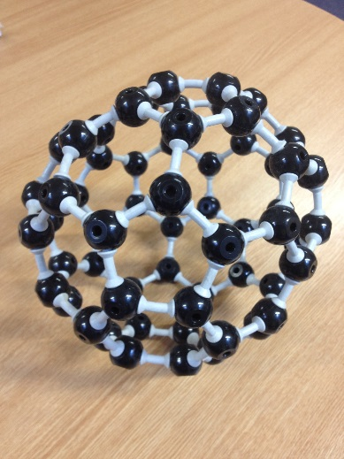
Look at the structure of Buckminster fullerene opposite and then state what type of structure it is (ionic, simple molecular, giant molecular) and explain your answer.

Structure | Explanation

Graphene has an identical structure to graphite, the only difference being it is just one layer thick. Draw in the space below a diagram showing the structure of graphene.

What is the structure of graphene? _______________________________________

Complete the table below to compare and contrast the structures and properties of Buckminster fullerene and graphene.

 | Buckminster fullerene | Graphene
Structure
Melting point
Electrical conductivity
Uses

Polymers and Poly(e)thene
Polymers are basically very long hydrocarbon molecules. They are made when lots of small double bonded hydrocarbon molecules are heated and pressurised. This causes the double bond to open which then joins to the other molecules creating one very long chained molecule.
Complete the following equation:
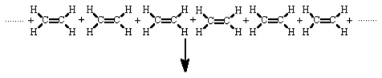

Shorthand equation

It would take too long to write an equation like the one above because the polymer chains often contain 30 000 to 40 000 carbon atoms so instead we use the letter ‘n’ which means lots to help create a shorthand version.

Have a go at completing the 2 shorthand equations below, in the first I would like you to show 1 repeating unit of the polymer and in the second I would like you to show 2 repeating units of the polymer; your teacher will need to help you:
1) | 2)

Problems with diagrams.
Draw a dot and cross diagram showing the bonding in water:

Do you think a water molecule actually looks like this? What are the advantages and disadvantages of showing a water molecule in this way as opposed to a 3D diagram?
Metallic Bonding
Complete the table below giving properties of metallic and non-metallic elements.
Property | Metals | Non-metals
Shiny
Melting/boiling points
Electrical conductivity
Density

The structure of metals can be described as follows:

- A regular arrangement of positive ions surrounded by a sea of delocalised electrons.

Draw in the space below a diagram that shows the structure of a metal.

Look at the diagram above and explain why metals conduct electricity.

If a metal is hit with a hammer it does not shatter but bends. Draw a before and after picture for this scenario and explain in your own words why the metal behaves in this way.

Before | After

Bonding Summary
 | Ionic | Covalent |  |  | Metallic
Description
Atoms Involved
Example
Charges
Formula
Name
Structure |  | Simple Molecular | Giant Molecular
 |  |  | Diamond | Graphite
Melting Point
Electrical Conductivity
Solubility in water

Blank Pages for Notes
Calculating Relative Formula Mass
Step 1: Count the atoms
Example – Give details of the type and number of atoms in CuSO₄
Hint 1 – Each capital is a new element
Hint 2 – if there is no number present then it is a 1, so the example above could read Cu₁S₁O₄.
Answer: 1 x Cu, 1 x S, 4 x O

Step 2: Find the Relative Atomic Masses (A_{r}) and substitute into the answer from step 1.
Example: Cu = 64, S = 32, O = 16
Answer: (1 x 64) + (1 x 32) + (4 x 16)
64+ 32 + 64 = 160
Now calculate the Relative Formula Masses (M_{r}) of:
- H₂O (A_{r} H = 1, O = 16)

- O₂ (A_{r} O = 16)

- CH₄ (A_{r} C = 12, H = 1)

- C₂H₄ (A_{r} C = 12, H = 1)

- CaCO₃ (A_{r} Ca = 40, C = 12, O = 16)

- LiOH (A_{r} Li = 7, O = 16, H = 1)

- Ca(OH)₂ (A_{r} Ca = 40, O = 16, H = 1)

- Fe₂O₃ (A_{r} Fe = 56, O = 16)

- C₃H₈ (A_{r} C = 12, H = 1)

- H₂SO₄ (A_{r} H = 1, S = 32, O = 16)
If you finish that can you name all the substances above?
- ______________________ 2) ______________________
- ______________________ 4) ______________________
- ______________________ 6) ______________________
- ______________________ 8) ______________________
- ______________________ 10) ______________________
Time for the mole!
The mole in Chemistry is the name given to a certain number. For example, a dozen is the name given for the number ________. In the same way the mole is the number: 602000000000000000000000 or 6.02 x 10²³.
Questions around the ‘dozen’
- How many eggs are there in a box containing 2 dozen? (dozen = 12)

- Over time the eggs are used up, after a few days only half a dozen remain. How many eggs are left? (dozen = 12)

Questions around the ‘mole’
- There are 2 moles of water in a beaker, how many molecules are there in total? (Avogadro constant = 6.02 x 10²³)

- Over time most of the water evaporates and 0.5 mole remains. How many molecules of water are in the beaker now? (Avogadro constant = 6.02 x 10²³)

- In a pot of salt there are 8 moles of sodium chloride (NaCl). How many sodium ions are present? Give this answer to 3 significant figures. (Avogadro constant = 6.02 x 10²³)

- In another pot of salt there are 1.3846 x 10²³ ions of sodium. How many moles are present? (Avogadro constant = 6.02 x 10²³)

- How many atoms are present in 2 moles of hydrogen gas (H₂)? (Avogadro constant = 6.02 x 10²³)

- How many atoms are present in 2 moles of methane (CH₄)? (Avogadro constant = 6.02 x 10²³)

How many moles are present in each of the following? (Avogadro constant = 6.02 x 10²³)
- 1.505 x 10²³ atoms of lead

- 3.5518 x 10²³ molecules of petrol

- 7.525 x 10²² particles of potassium hydroxide

- 5.93572 x 10²⁵ atoms of silver

- 4.515 x 10²² particles of ammonium nitrate

- 3.4615 x 10²³ molecules of ethanoic acid

The number of moles of an element can be calculated using the following equation:

What is A_{r} _____________________________________________

The number of moles of a compound is calculated in exactly the same way other than instead of using the relative atomic mass you use the relative formula mass. Write out the equation that you would use to find the number of moles of a compound:

Calculate the number of moles of particles in:
- 24g of Carbon (A_{r} C = 12)

- 19.5g of potassium (A_{r} K = 39)

- 108g of H₂O (A_{r} H = 1, O = 16)

- 4.5625g of HCl (A_{r} H = 1, Cl = 35.5)

- 1428g of Al₂O₃ (A_{r} Al = 27, O = 16)

Put the moles equation into a formula triangle.

Calculate the mass of:
- 2.5 moles of copper (A_{r} Cu = 63.5)

- 7 moles of gold (A_{r} Au = 197)

- 0.25 mole of CH₄ (A_{r} C = 12, H = 1)

- 5 moles of C₂H₅OH (A_{r} C = 12, H = 1, O = 16)

- 82 moles of Mg(NO₃)₂ (A_{r} Mg = 24, N = 14, O = 16)

Can you use the Avogadro constant and the mole equation to work out the number of particles present in? (Avogadro constant = 6.02 x 10²³)
- 90g of H₂O (A_{r} H = 1, O = 16)

- 68g of NH₃ (A_{r} N = 14, H = 1)

- 8g of O₂ (A_{r} O = 16)

- 240g of CH₄ A_{r} C = 12, H = 1)

- 20g of Fe₂O₃ (A_{r} Fe = 56, O = 16)

Can you use the Avogadro constant and the mole equation to work out the mass, in grams, of each of the following? (Avogadro constant = 6.02 x 10²³)
- 1.806 x 10²³ molecules of Cl₂ (A_{r} Cl = 35.5)

- 1.806 x 10²³ particles of LiOH (A_{r} Li = 7, O = 16, H = 1)

- 3.01 x 10²¹ particles of MgO (A_{r} Mg = 24, O = 16)

- 5.719 x 10²⁴ particles of CaCO₃ (A_{r} Ca = 40, C = 12, O = 16)

- 1.3545 x 10²⁴ molecules of CO₂ (A_{r} C = 12, O = 16)

Now try these!
- What is the mass, in grams, of 1 Magnesium atom? (A_{r} Mg = 24, Avogadro constant = 6.02 x 10²³)

- What is the mass, in grams, of 1 oxygen atom? (A_{r} O = 16, Avogadro constant = 6.02 x 10²³)

- What is the mass, in grams, of 1 oxygen molecule? (A_{r} O = 16, Avogadro constant = 6.02 x 10²³)

Calculate Empirical Formulae
What is an empirical formula?

How can it be calculated?

Example 1
28 g of lithium reacts with 32 g of oxygen. What is the empirical formulae of Lithium oxide?
Use the equation

Calculate the number of moles of Lithium and of Oxygen
Lithium | Oxygen
Mass of Li = 28 g | Mass of Oxygen = 32 g
A_{r} = 7 | A_{r} = 16
Moles = 4 | Moles = 2
Divide the number of moles by the smallest answer to find the empirical numbers

Formula = Li₄O₂ However this is not the simplest (empirical formula) because it can be simplified. For example in maths you would not report a fraction as:
Therefore the empirical formulae is: Li₂O

Example 2
An oxide of Magnesium has a mass of 80 g, this was formed from 48 g of Magnesium. What is the empirical formula of the oxide?
The only difference between this example and the last one is you are not directly told the mass of the oxygen used. Instead you have to calculate it by subtracting the mass of the magnesium from the oxide.
Magnesium | Oxygen
Mass of Mg = 48 g | Mass of Oxygen = Mass Magnesium oxide – Mass of magnesium  80 – 48 = 32 g
A_{r} = 24 | A_{r} = 16
Moles = 2 | Moles = 2

Formula = Mg₂O₂
Empirical Formulae = MgO

Questions:

What is the empirical formula of?

- C₂H₄

- C₅H₁₀

- C₃H₆O₂

- C₂H₄Br₂

- C₄H₈O₂

- Fe_{0.2}O_{0.4}

- Cu_{0.00174}O_{0.00087}

- Fe_{0.006}O_{0.008}

- An oxide of carbon contains 24 g of carbon and 32 g of oxygen. What is its empirical formula?

- A compound of copper and chlorine contains 158.75 g of copper and 177.5 g of chlorine. What is its empirical formula?

- A compound of iron and oxygen contains 1.12 g of iron and 0.64 g of oxygen. What is its empirical formula?

- A compound of iron and oxygen contains 0.23 g of iron and 0.0986 g of oxygen. What is its empirical formula?

- 6 g of carbon reacted with excess oxygen to make 22 g of a compound. What is the empirical formula of the compound?

- A 2.5 g sample of a titanium chloride contained 0.7775 g of titanium. Calculate the empirical formulae.

- 0.348 g of a compound of iron and chlorine contains 0.12 g of iron. What is the empirical formula of the compound?

Blank Pages for Notes
Calculating a molecular formula of a compound from its empirical formula and its relative formula mass.
- A hydrocarbon has the empirical formula CH₂ and a relative formula mass of 70. What is its molecular formula?

- A hydrocarbon has the empirical formula CH₂ and a relative formula mass of 42. What is its molecular formula?

- A hydrocarbon has the empirical formula CH₂ and a relative formula mass of 112. What is its molecular formula?

- A hydrocarbon has the empirical formula CH₂ and a relative formula mass of 252. What is its molecular formula?

- A compound has the empirical formula C₅H₁₀O₂ and a relative formula mass of 102. What is its molecular formula?

- A compound has the empirical formula C₅H₁₀O₂ and a relative formula mass of 306. What is its molecular formula?

- A compound has the empirical formula CH₂Cl₂ and a relative formula mass of 255. What is its molecular formula?

Experiment to determine the empirical formula of Magnesium oxide
Draw a diagram of the apparatus used.

Design a results table for this experiment:

What mass of magnesium reacted with the oxygen? __________________

What mass of oxygen reacted with the magnesium? __________________

Calculate the empirical formula of magnesium oxide.

The law of the conservation of mass

What is the law of the conservation of mass?

Look at the 3 experiments below. In each experiments state whether the mass goes up, down or stays the same?
Mass
Reason

Calculating Quantities of Masses and Products
Example:
How many grams of sodium oxide are made from 11.5 grams of sodium? (²³Na, ¹⁶O) Assume the oxygen is present in excess.
4Na + O₂ = 2Na₂O
Step 1: Calculate formula mass or find atomic mass
Atomic mass of Na = 23

Step 2: Convert to moles
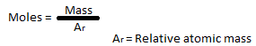
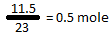

Step 3: Use reaction equation
4Na + O₂ = 2Na₂O
4 moles of sodium react to make 2 moles of sodium oxide
This is a halving relationship
Therefore 0.5 Moles of sodium must make 0.25 moles of sodium oxide

Step 4: Calculate formula mass or find atomic mass
Na₂O = Na + Na + O
23 + 23 + 16 = 62
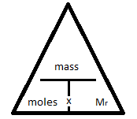
Step 5: Convert moles to mass

Mass = moles x M_{r}
0.25 x 62 = 15.5g

If it helps the next page shows this in a little more detail.

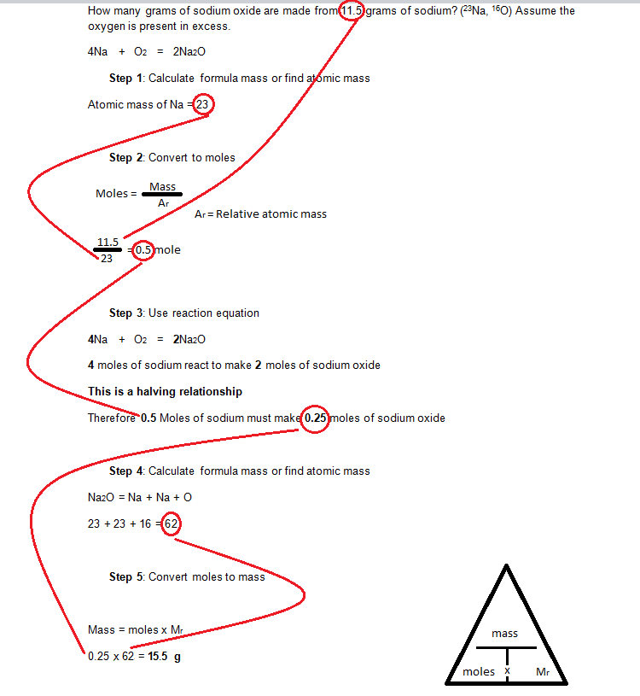

Questions
- How many grams of calcium oxide are made from 160 grams of calcium and excess oxygen? (⁴⁰Ca, ¹⁶O)
2Ca + O₂ 2CaO

- How many tonnes of ammonium nitrate are made from 110.5 tonnes of ammonia and excess nitric acid? (¹⁴N, ¹⁶O,¹H)
NH₃ + HNO₃ NH₄NO₃

- How many grams of ammonia are made from 56 grams of nitrogen and excess hydrogen (assuming a 100% conversion)? (¹⁴N, ¹H)
N₂ + 3H₂ ⇌ 2NH₃

- How many tonnes of ammonia are made from 56 tonnes of nitrogen and excess hydrogen? (assuming a 100% conversion)? (¹⁴N, ¹H)
N₂ + 3H₂ ⇌ 2NH₃

- How many tonnes of copper are made from 397.5 tonnes of copper oxide and excess carbon? (^{63.5}Cu, ¹²C, ¹⁶O)
2CuO + C 2Cu + CO₂

- How many tonnes of iron are made from 909 440 tonnes of iron oxide and excess carbon monoxide? (⁵⁶Fe, ¹⁶O)
Fe₂O₃ + 3CO 2Fe + CO₂

- How many tonnes of aluminium are made from 0.01275 tonnes of aluminium oxide? (²⁷Al, ¹⁶O)
2Al₂O₃ 4Al + 3O₂

- What mass of chlorine is needed to produce 25.4g of iodine? (¹²⁷I, ^{35.5}Cl)
Cl₂ + 2 KI 2 KCl + I₂

- Railway lines are welded together by the Thermite reaction, which produces molten iron. How much iron oxide, in Kg, is needed to produce 1kg of iron? Answer to 3 significant figures. (⁵⁶Fe, ¹⁶O)
Fe₂O₃ + 2 Al 2 Fe + Al₂O₃

- What mass of copper oxide is needed to produce 15.875 tonnes of copper? (^{63.5}Cu, ¹⁶O)
CuO + H₂ Cu + H₂O

Questions 1-7 above have 1 reactant in excess. What does this mean and why is important to know this when calculating the amount of product produced?
excess
important
Stoichiometry
Stoichiometry is a section of chemistry that involves using relationships between reactants and/or products in a chemical reaction to determine desired quantitative data. In Greek, stoikhein means element and metron means measure, so stoichiometry literally translated means the measure of elements.
- Methane will burn in oxygen to make carbon dioxide and water. Use the reaction equation to work out how many moles of oxygen will be needed to react with 2 moles of methane and how many moles of carbon dioxide and water will be made?
CH₄ + 2O₂ → CO₂ + 2H₂O
Moles oxygen ______ Moles carbon dioxide______ Moles water_______
- Methane will burn in oxygen to make carbon dioxide and water. Use the reaction equation to work out how many moles of oxygen will be needed to react with 0.5 moles of methane and how many moles of carbon dioxide and water will be made?
CH₄ + 2O₂ → CO₂ + 2H₂O
Moles oxygen _______ Moles carbon dioxide_______ Moles water_______
- Methane will burn in oxygen to make carbon dioxide and water. Use the reaction equation to work out how many moles of oxygen will be needed to react with 8 moles of methane and how many moles of carbon dioxide and water will be made?
CH₄ + 2O₂ → CO₂ + 2H₂O
Moles oxygen _______ Moles carbon dioxide_______ Moles water_______
- Aluminium oxide can be electrolysed to produce Aluminium and oxygen. Use the reaction equation to work out how many moles of aluminium oxide would be needed to make 10 moles of aluminium. Also, state how much oxygen would be produced.
2Al₂O₃ → 4Al + 3O₂
Moles aluminium oxide _______ Moles oxygen _______
- Aluminium oxide can be electrolysed to produce Aluminium and oxygen. Use the reaction equation to work out how many moles of aluminium oxide would be needed to make 0.5 moles of aluminium. Also, state how much oxygen would be produced.
2Al₂O₃ → 4Al + 3O₂
Moles aluminium oxide _______ Moles oxygen _______
- 28 g of Lithium (Li) reacts with 72 g of water (H₂O) to make 96 g of lithium hydroxide (LiOH) and 4 g of hydrogen (H₂). What is the stoichiometry of this reaction? (A_{r} Li = 7, H = 1, O =16)

_____ lithium + _____ water → _____ lithium hydroxide + _____hydrogen
- 250 g of calcium carbonate (CaCO₃) thermally decomposes on heating to make 140 g of calcium oxide (CaO) and 110 g of carbon dioxide (CO₂). What is the stoichiometry of this reaction? (A_{r} Ca = 40, C = 12, O =16)

_____ calcium carbonate → _____ calcium oxide + _____ carbon dioxide
Calculating Concentration of solutions in g dm⁻³
What is a decimetre (dm)? ___________

How many cm³ would you fit in a dm³? ______________________________

How do you convert cm³ into dm³? ____________________________________

Convert each of these into dm³
cm³ | dm³
25
270
3254
2.2
 | 9.3

Example
What is the concentration (in g dm⁻³) of sodium hydroxide solution made from 25 g of NaOH and 250 cm³ of distilled water.

Step 1 – convert the cm³ into dm³ by dividing by 1000.

Step 2 – divide the mass of NaOH by the volume of water
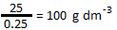
Questions
Work out the concentration of each of the following solutions in g dm³
- 50 g of sodium chloride in 0.5 dm³ of distilled water.

- 2564 g of calcium hydroxide in 2.6 dm³ of distilled water.

- 20 g of barium chloride in 50 cm³ of distilled water.

- 250 g of silver nitrate in 5000 cm³ of distilled water.

- 145 g of potassium hydroxide in 300 cm³ of distilled water.

- 2.5 g of potassium nitrate in 850 cm³ of distilled water.

- 2.75 kg of sodium hydroxide in 3000 cm³ of distilled water.

Blank Pages for Notes

Topic 2, States of matter and mixtures – Checklist
 | Content | Understand it | Learnt it
1 | Be able to draw a diagram and describe the arrangement particles in a solid, liquid and gas. Know about the relative energy of particles in each
2 | Know the names given to the changes of state and that these are physical changes. Be able to recognise a physical or chemical change.
3 | Explain the changes in arrangement, movement and energy of particles during changes of state.
4 | Use melting and boiling point data to predict whether a substance will be a solid, liquid or gas.
Solids, Liquids and Gases
Complete the diagram below with particle diagrams in the boxes (try and make the particles the size of the one in the solid box), names of the change of state on the curved arrows and whether the substance is heated or cooled on the hollow arrow.
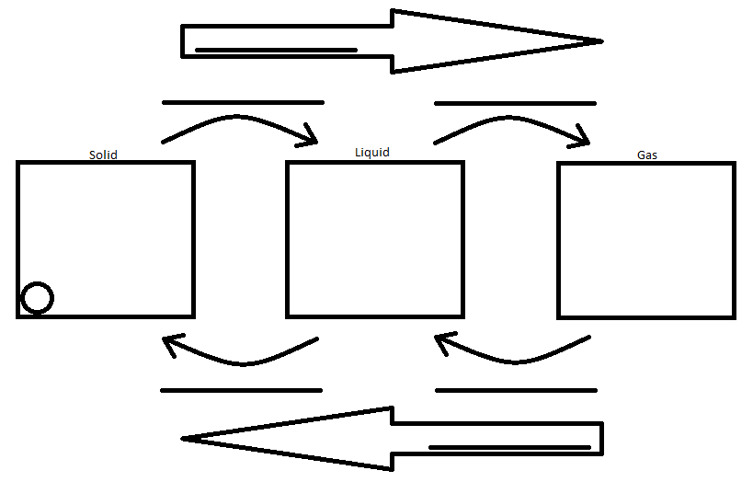
Classify each of the following changes as physical or chemical by putting a tick in the correct box.
Change | Physical | Chemical
Snow melting
Petrol burning
Paint drying
Plants photosynthesising
Salt dissolving in water
Glass breaking

Explain in your own words how the particles move in the solid state and how an energy change can bring about the change to the liquid state.

Explain in your own words how the particles move in the liquid state and how an energy change can bring about the change to the gaseous state.

Explain in your own words how the particles move in the gaseous state and how an energy change can bring about the change to the liquid state.

Explain in your own words how the particles move in the liquid state and how an energy change can bring about the change to the solid state.

Use the melting points and boiling points of the following elements to state whether they are in the solid, liquid or gas for the stated temperature.
Element | Temperature (ºC) | Melting point (ºC) | Boiling point (ºC) | Physical state
Argon | 20 ºC | -189.35 ºC | -185.85 ºC
Bromine | 20 ºC | -7.2 ºC | 52 ºC
Iron | 1537 ºC | 1538 ºC | 2861 ºC
Calcium | 900 ºC | 842 ºC | 1484 ºC
Oxygen | -217 ºC | -218.79 ºC | -182.95 ºC
Mercury | -40 ºC | -38.83 ºC | 356.73 ºC

A solid substance is heated at a constant rate and its temperature is taken every minute. The results have been plotted on the graph below:
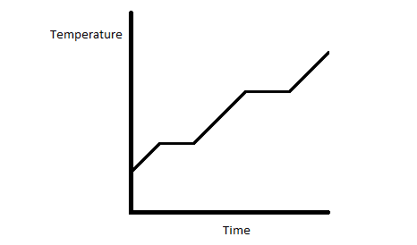
Label the graph to show where the substance is:
- Solid
- Liquid
- Gas
- Melting
- Boiling
Fill in the blanks:
When the solid substance is heated the temperature ______________. The temperature stops rising and stays constant when the solid starts __________________. The substance is still being heated, but the energy is making the particles _______________ away from their fixed arrangement.
Continue this explanation in your own words for the rest of the graph.

Blank Pages for Notes
Topic 2, Methods of separating and purifying substances – Checklist
 | Content | Understand it | Learnt it
1 | Explain the difference between a pure substance and a mixture
2 | Understand that mixtures melt over a range of temperatures whereas pure substances have very sharp melting points. You must be able to recognise this in data.
3 | For each of the following separating techniques you must know: 1) what they are used for. 2) The apparatus used.  - Simple distillation  - Fractional distillation  - Filtration  - Crystallisation  - Paper chromatography.
4 | Be able to identify the correct separating technique for the correct mixture.
5 | Be able to explain that paper chromatography can separate a mixture of soluble substances by running a solvent (mobile phase) through the mixture on the filter paper (stationary phase), which causes the substances to move at different rates over the paper.
6 | Look at the results of paper chromatography and:  - Identify whether the substance was pure or a mixture.  - Identify substances by comparison with other known substances.  - Calculate and use R_{f} values to identify substances.
7 | Describe how ground water found outside can be made safe to drink (potable) using: 1) sedimentation, 2) filtration, 3) chlorination.  Describe how sea water can be made potable by simple distillation.  Understand that water used in analysis must not contain any dissolved salts.

What is the difference between a pure substance and a mixture?

Look at the following melting ranges and tick the box to show whether the substance is likely to be a mixture or a pure substance?
Substance | Starts melting (ºC) | Finishing melting (ºC) | Pure | Mixture
A | 99.1 | 100.4
B | 0 | 0.1
C | 1532.2 | 1532.4
D | -186.2 | -183.8

The graph below shows 2 substances melting (A and B). One is a pure substance and the other is a mixture. Which is which?
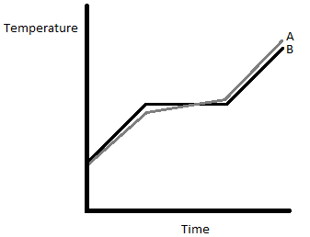
Pure
Mixture

Chromatography
A separating technique used for _________________________________________
It can also be used to identify specific components of mixtures, including colouring agents in foodstuffs. This is done by calculating the R_{f} Value of the component which are unique.

R_{f} Formula
R_{f} = distance moved by the component
distance moved by the solvent

Work out which food dye in the chromatograms below (a, b, or c) is the same:
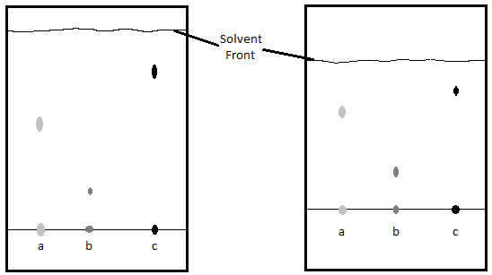
Sample | R_{f} |  | Sample | R_{f}
A | 3.1 = 0.53  5.9 |  | A
B |  |  | B
C |  |  | C

Which sample is the same in both experiments? _______________________

What is the solvent and is this the stationary or mobile phase? _______________________________

Where is the stationary phase found? ___________________________________________________

Explain in your own words how paper chromatography separates a mixture of different liquids.

Look at the next chromatograph and answer the questions:
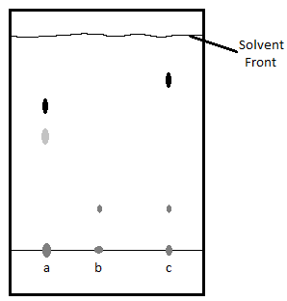
Which is a pure substance and which is a mixture? Tick the correct box
Substance | Pure | Mixture
A
B
C

Two of the dyes contain a substance that is identical. Circle this substance on the diagram.

Core practical 1: Investigating the composition of inks

Why is it important to draw the lines and write labels on the chromatography paper in pencil and not in ink?

Why should the spots of ink be above the level of the solvent in the beaker?

What is meant by the term ‘solvent front’?

What would happen if you used permanent ink instead of water soluble ink?

Which is the mobile phase?

Which is the stationary phase?

Results – what different dyes make up each ink and calculate their R_{f} values.

R_{f}

Which ink(s), if any, contain one dye?
Which ink(s) are mixtures of dyes?

Which inks contain the same dye?
Simple Distillation
What is simple distillation used for?

Label the apparatus for simple distillation.
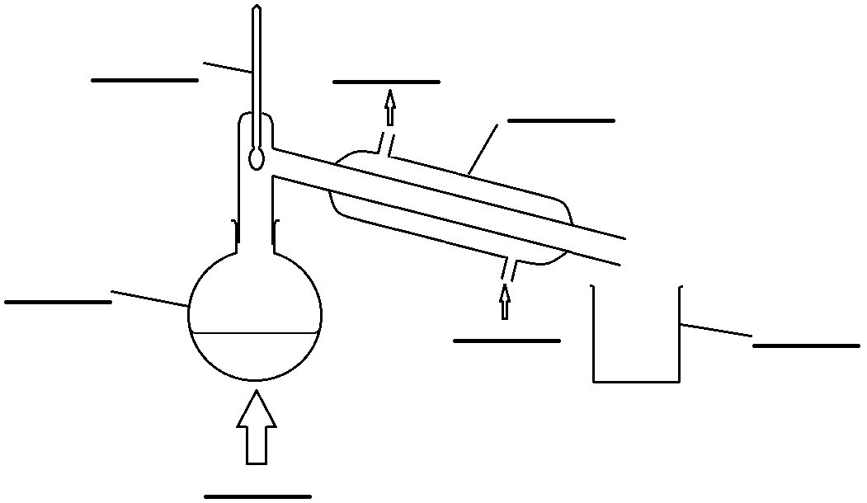

Explain how simple distillation works.

Core practical 1: Investigating the composition of inks
The apparatus drawn below can be used to separate the water from ink. Label the apparatus in the spaces provided.

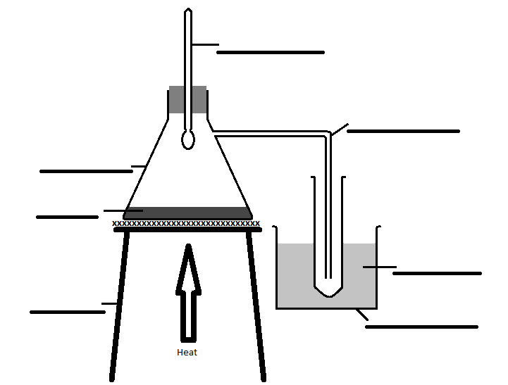
What is the temperature on the thermometer when the water is distilling off?

Why does the collection tube need to be surrounded by crushed ice?

Describe what you see when the ink is heated?

How can you improve the procedure?

What are the risks in this practical?

Suggest how to manage these risks.
Fractional Distillation
What is fractional distillation used for?

Label the apparatus for fractional distillation.

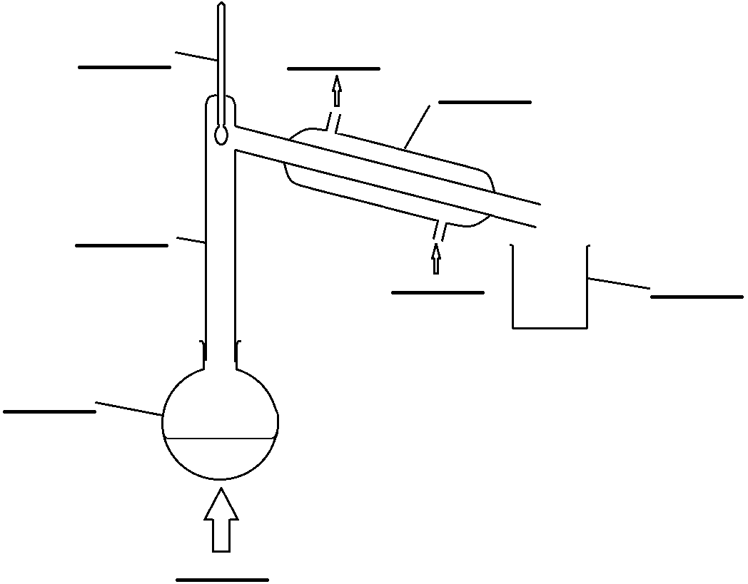
Explain how fractional distillation works.

How do you know when to change the beaker collecting the distillate?
Filtration
What is filtration used for?

Label the apparatus for filtration.
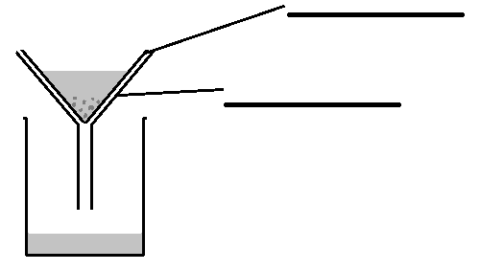

Crystallisation
There are 3 stages for crystallisation shown in the diagram below. Label the apparatus.
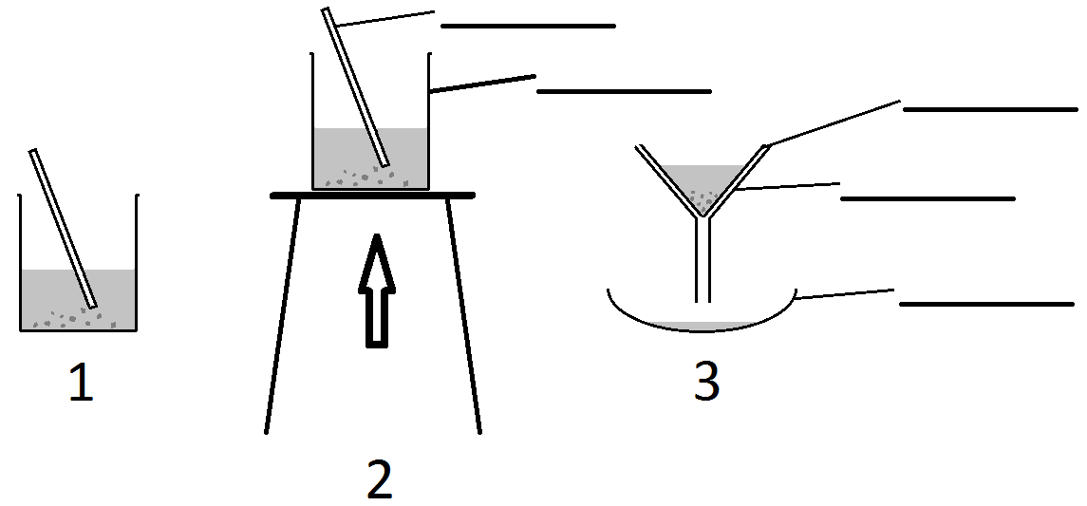
What is happening in each of the 3 stages?
Stage | Explanation of what is happening
1
2
3
Using Separating Techniques
Why is it not advisable to drink river water?

How can water from a river be made safe for drinking?

Why would sea water have to be treated differently to river water to make it safe for drinking?

How can water from the sea be made safe for drinking?

Why must water used in analysis not contain any other dissolved salts?

How could you get the dissolved salts out of water to ensure it is pure for analysis?

Blank Pages for Notes

Topic 3, Chemical change: Acids - Checklist
 | Content | Understand it | Learnt it
1 | Learn that acids are sources of hydrogen ions and alkalis are sources of hydroxide ions.
2 | Learn that pH solutions with a pH of 1-6 are acidic, 7 are neutral and 8-14 are alkali.
3 | Learn the colour changes of the following indicators with acid and alkali:  - Litmus  - Methyl orange  - Phenolphthalein
4 | Learn the link between hydrogen ion concentration and pH. The higher the concentration of hydrogen ions the lower the pH. Also know that the higher the concentration of hydroxide solutions the higher the pH.
5 | Learn that as the hydrogen ion concentration increases by a factor of 10, the pH of the solution decreases by 1.
6 | Know how the pH changes when powdered calcium hydroxide is added a bit at a time to hydrochloric acid.
7 | Know the meanings of the words: dilute, concentrated. Talk about the amount of particles in solution.
8 | Know the meaning of the phrases: strong acid, weak acid. Be able to talk about the degree of dissociation into ions.
9 | Know what a base is and that it will react with an acid to make a salt and water.
10 | Know that an alkali is a base that is soluble in water.
11 | Write equations for acids with:  - Metals  - Metal oxides  - Metal hydroxides  - Metal carbonates  Know that in each case that these are neutralisation reactions and a salt is always produced.
12 | Know the tests for:  - Hydrogen  - Carbon dioxide
13 | Know what a neutralisation reaction is.
14 | Know that in an acid alkali neutralisation reaction hydrogen (H⁺) ions from the acid react with hydroxide (OH⁻) ions from the alkali.
15 | Know that when you prepare a soluble salt from an acid an insoluble reactant why:  - Excess insoluble reactant is added.  - The excess reactant is removed  - The solution remaining is only salt and water
16 | Know that when you prepare a soluble salt from an acid and a soluble reactant why:  - Titration must be used  - The acid and the soluble reactant are mixed in the correct proportions  - The solution remaining at the end will only be salt and water.
17 | Know exactly what apparatus and the procedure used to prepare a pure dry sample of copper sulfate from acid and copper oxide.
18 | Know exactly what apparatus and indicator to use to carry out an acid alkali titration to prepare pure crystals of sodium chloride.
19 | Learn which salts are soluble:  - All common sodium, potassium and ammonium salts are soluble.  - All nitrates are soluble.  - Common chlorides are soluble except those of silver and lead.  - Common sulfates are soluble except those of lead, barium and calcium.  - Common carbonates and hydroxides are insoluble except those of sodium, potassium and ammonium.
20 | Use the solubility rules to predict whether a salt produced in a chemical reaction will be soluble.
21 | Be able to write a method detailing how to prepare a pure, dry sample of an insoluble salt.
Which ion in solution are acids a source of? __________
Has hydrogen gained or lost electrons in forming the hydrogen ion? _____________
Which ion in solution are alkalis a source of? __________
Can you draw a dot and cross picture of the hydroxide ion (OH⁻)? This is very unlikely to be on a GCSE paper so is just for fun and no need to revise. Draw outer electrons only. (₁H, ₈O)

What is the name for a reaction between an acid and a base? __________________________

What do you think is made when the ions from acids and alkalis react? Write an ionic equation to show this:
Substance made
Ionic equation

Complete the following table about the pH scale.
pH | 1 | 2 | 3 | 4 | 5 | 6 | 7 | 8 | 9 | 10 | 11 | 12 | 13 | 14
Acid or alkali
Strong or weak
Colour
Hydrogen ion concentration  (moles dm⁻³) | 0.1  1x10⁻¹ | 0.01  1x10⁻²

What is the link between the hydrogen ion concentration and pH?

Complete and colour the table to show what effect acids and alkalis have on the following indicators.
Indicator | Acid | Alkali
Litmus
Methyl orange
phenolphthalein

When a base reacts with an acid what is always produced? _______________________________

Write a common equation for the reaction for an acid and a base.
_______________ + _______________ → _______________ + _______________

What type of reaction is this? ________________________
What is an alkali?

Core practical 2: Investigating pH
You are going to react 50 cm³ of hydrochloric acid (1 M) with calcium hydroxide monitoring the pH as you add each spatula of calcium hydroxide?
What would you expect the graph of pH versus the quantity of calcium hydroxide to look like?
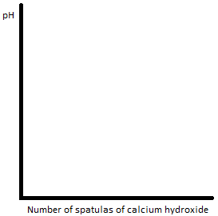
What volume of hydrochloric acid are you using? _____________________________

What is the best piece of apparatus to measure the volume of hydrochloric acid?

Why is that the best piece of apparatus?

Why is it necessary to stir the mixture when the calcium hydroxide powder is added?

What are the risks in this practical?

Suggest how to manage these risks

Complete the results table as you do the experiment.
Number of spatulas of calcium hydroxide |  | 0 | 1 | 2 | 3 | 4 | 5 | 6 | 7
pH | Experiment 1
 | Experiment 2
 | Experiment 3
 | Average

Plot a graph of the results.
What are the main errors in this experiment?

How could you improve the method?

How do you know when the hydrochloric acid is exactly neutralised?
Neutralisation
Neutralisation occurs when __________ react with ___________ to produce __________ and ___________. Metals also react with acids to make salts.
You need to know the salts that are produced from the 3 common acids, these are:
Acid |  | Salt
Name | Formula | Name | Formula
Hydrochloric Acid | HCl | Chloride | Cl⁻
Sulfuric Acid | H₂SO₄ | Sulfate | SO₄²⁻
Nitric Acid | HNO₃ | Nitrate | NO₃⁻

You need to know about 4 general reactions of acids.
- Acid + Metal oxide = Salt + Water
Hydrochloric acid + cobalt oxide = cobalt chloride + water
- Acid + Metal hydroxide = Salt + Water
Sulfuric acid + potassium hydroxide = potassium sulfate + water

- Acid + Metal carbonate = Salt + Water + Carbon dioxide
Nitric acid + zinc carbonate = zinc nitrate + water + carbon dioxide

- Acid + Metal = Salt + Hydrogen

Hydrochloric acid + magnesium = magnesium chloride + hydrogen

Acid + Metal oxide = Salt + Water
Write word and balanced symbol equations for the reaction of the following:
Hydrochloric acid + Magnesium oxide (MgO) =
Word
Symbol | → ___ MgCl₂

Nitric Acid + Zinc oxide (ZnO) =
Word
Symbol | → ___ Zn(NO₃)₂

Sulfuric acid + Copper (II) oxide (CuO) =
Word
Symbol | → ___ CuSO₄

Hydrochloric acid + Iron (III) oxide (Fe₂O₃) =
Word
Symbol | → ___ FeCl₃

Acid + Metal hydroxide = Salt + Water
Hydrochloric acid + sodium hydroxide (NaOH) =
Word
Symbol | → ___ NaCl

Nitric Acid + Magnesium hydroxide (Mg(OH)₂) =
Word
Symbol | → ___ Mg(NO₃)₂

Sulfuric acid + lithium hydroxide (LiOH)=
Word
Symbol | → ___ Li₂SO₄

Acid + Metal carbonate = Salt + Water + Carbon dioxide
Hydrochloric acid + calcium carbonate =
Word
Symbol | → ___ CaCl₂

Nitric Acid + sodium carbonate =
Word
Symbol | → ___ NaNO₃

Sulfuric acid + copper (II) carbonate =
Word
Symbol | → ___ CuSO₄

Acid + Metal = Salt + Hydrogen
Write word and balanced symbol equations for the reaction of the following (In these examples the formula of the salt is not given, go back to the work on bonding and work out the formulae from the charges on the ions):

Hydrochloric acid + Aluminium =
Word
Symbol | →

Nitric Acid + Calcium =
Word
Symbol | →

Sulfuric acid + Lithium =
Word
Symbol | →

Pick 6 acids, and 6 other reactants (a mix of metal oxides, metal hydroxides, metal carbonates and metals) and write word and symbol equations for each.
1 | Word
 | Symbol
2 | Word
 | Symbol
3 | Word
 | Symbol
4 | Word
 | Symbol
5 | Word
 | Symbol
6 | Word
 | Symbol

Complete the following table to show how we can test for carbon dioxide and hydrogen.
 | Hydrogen | Carbon Dioxide
Test
Apparatus
Result

Preparing pure samples of soluble salts
1 – Using an insoluble reactant. Core practical 3: Preparation of a copper salt
Use copper(II) oxide and sulfuric acid to prepare a pure sample of the soluble salt. Copper(II) oxide is insoluble.
What salt is produced and write a word equation for the reaction.
Salt produced
Word equation

Why was it necessary to warm the sulfuric acid?
Why is it essential to use an excess of copper(II) oxide?

What does excess mean? ________________________________
How is the excess copper oxide removed? _____________________________
What observations can you make of this reaction?

What is left after the excess copper oxide has been removed? _______________________________
How do you now get just the salt?

What is the filtrate in this experiment? ________________________________

What is the residue in this experiment? ________________________________
What safety precautions should you take when carrying out this experiment and why?

Why is a water bath used to evaporate the water from the copper sulfate solution instead of heating the evaporating basin directly with a Bunsen burner?

Why should you not evaporate all of the water from the copper sulfate solution?

2 – Using 2 soluble reactants
Use sodium hydroxide and hydrochloric acid to produce a pure sample of the soluble salt.
What salt is produced and write a word equation for the reaction.
Salt produced
Word equation

Why can one of the reagents not be used in excess in this scenario?

Write a method and draw diagrams to fully explain how to carry out an acid base titration to produce a pure sample of the salt.
The following apparatus and chemicals must be used:

- Burette
- Pipette
- White tile
- Conical flask
- Funnel
- Phenolphthalein
- Sodium hydroxide
- Hydrochloric acid

Diagram

Method

Why is it necessary to do the first titration with indicator and the second titration without?

Once the second titration is complete what is in the conical flask?

How do you now get just the salt?

Salt Solubility I’m afraid you just have to learn this.

Dissolves in Water (soluble) | Doesn’t dissolve in water (insoluble)
all common sodium, potassium and ammonium salts are soluble
all nitrates are soluble
common chlorides are soluble | except those of silver and lead
common sulfates | except those of lead, barium and calcium
except those of sodium, potassium and ammonium | common carbonates
except those of sodium, potassium and ammonium | Common hydroxides

It is possible to prepare an insoluble salt by starting with specific reagents. Once an insoluble salt has been prepared the precipitate can be obtained from the solution by filtration, washing with distilled water and drying. Draw diagrams to show the stages:

Precipitation | Filtration | Washing | Drying

Summary of preparation of pure, dry salts
Type of reaction
Example
Method

Precipitation Reactions
Reaction 1 Silver Nitrate with Sodium Chloride

- Measure 10 cm³ of Sodium Chloride solution and pour into test tube.
- Add a few drops of nitric acid.
- Add 10-15 drops of Silver Nitrate solution to the test tube.

Is there a precipitate? Yes / No Colour of precipitate _____________________

Write the word equation for this reaction:

Reaction 2 Iron Sulfate with Sodium Hydroxide

- Measure 10cm³ of Iron Sulfate solution and pour into test tube.
- Add 10-15 drops of Sodium Hydroxide solution to the test tube.

Is there a precipitate? Yes / No Colour of precipitate _____________________

Write the word equation for this reaction:

Reaction 3 Barium chloride with Hydrochloric Acid

- Measure 10 cm³ of Barium Chloride solution and pour into test tube.
- Add 10-15 drops of Hydrochloric Acid solution to the test tube.

Is there a precipitate? Yes / No Colour of precipitate _____________________

Write the word equation for this reaction:

Reaction 4 Copper Sulfate with Sodium Hydroxide

- Measure 10 cm³ of Copper Sulfate solution and pour into test tube.
- Add 10-15 drops of Sodium Hydroxide solution to the test tube.

Is there a precipitate? Yes / No Colour of precipitate _____________________

Write the symbol equation for this reaction:

One of the reactions did not produce any precipitates. Explain why.

Blank Pages for Notes

Topic 3, Chemical change: Electrolytic processes – Checklist
 | Content | Understand it | Learnt it
1 | Learn that for electrolysis to happen you must have an electrolyte. The electrolyte is a molten or dissolved ionic substance.
2 | Learn that electrolysis is a chemical reaction that is occurring because electrical energy from direct current supply is being passed through an electrolyte. This causes the electrolyte to decompose.
3 | Understand and explain that during electrolysis:  - The positively charged ions (cations) move to the negatively charged electrode (cathode).  - The negative charged ions (anions) move to the positively charged electrode (anode).
4 | Learn the products of the following electrolysis reactions, using inert electrodes.  - Molten lead bromide  - Water (acidified with sulfuric acid).  - Copper chloride solution  - Sodium chloride solution  - Sodium sulfate solution
5 | Learn the rules for what products are likely to be produced in electrolysis reactions and use them to predict what products might be formed.
6 | Be able to write half equations for the reactions that take place at the anode and the cathode in electrolysis.
7 | Learn that oxidation is loss of electrons and reduction is gain of electrons.
8 | Learn that reduction occurs at the cathode and oxidation occurs at the anode.
9 | Explain how electrolysis can be used to purify copper by using copper electrodes and a solution of copper sulfate.
10 | Investigate what happens to the mass of the anode and the cathode when copper sulfate is electrolysed using copper electrodes.

Electrolysis

What is electrolysis?

Do ionic or covalent substances undergo electrolysis? _________________________

What happens to a substance undergoing electrolysis?

Is lead (II) bromide ionic or covalent? ______________________

How do you know?

What is lead (II) bromide’s formula? ____________________________

Explain whether it conducts electricity at room temperature.

Conducts | Explanation
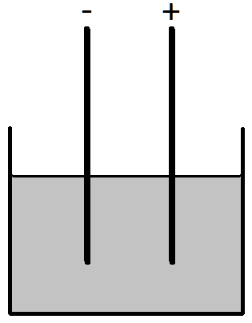
Molten lead(II) bromide will conduct electricity, label this apparatus that could be used for electrolysis with the following:

- Anode
- Cathode
- Pb²⁺
- Br⁻
- Cation
- Anion
- Electrolyte
- Carbon
- Pb
- Br₂

Explain what happens when the electric current is turned on:

Why are carbon electrodes used?

What travels towards the anode? _____________________________
What is made at the anode? _____________________________

What travels towards the cathode? _____________________________
What is made at the cathode? _____________________________
Write equations for the reactions at the cathode and the anode:
anode
cathode

Oxidation – Reduction

What is the definition for oxidation and reduction that involves gaining and losing electrons? Remember OILRIG

Oxidation
Reduction

In the electrolysis of lead bromide what is oxidised and what is reduced?

Oxidised
Reduced

Electrolysis of Solutions

This is a little more complex because although water is a covalent molecule it does ionise to a small extent. So in aqueous solutions of a salt there are also hydrogen (H⁺) ions and hydroxide (OH⁻) ions.
However, only one substance can be produced at an electrode and this is mainly influenced by the reactivity of the ions.

Electrolysis of acidified water
Water acidified with sulphuric acid can be electrolysed to produce hydrogen and oxygen at the electrodes, label the apparatus with the following:
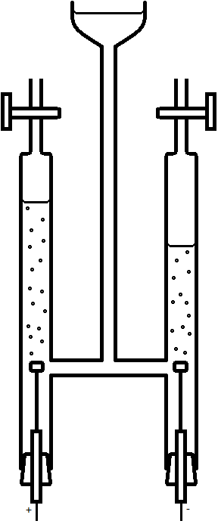
- OH⁻
- H⁺
- Water
- Carbon
- O₂
- H₂
- Anode
- Cathode
- Anion
- Cation
- Electrolyte

What travels towards the anode? ______________
What travels towards the cathode? ______________

Write equations for the reactions at the cathode and the anode:
anode
cathode

In the electrolysis of water what is oxidised and what is reduced?

Oxidised
Reduced

Predicting the products of electrolysis of solutions.
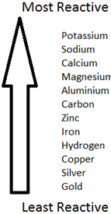
At the negative electrode

If the metal is less reactive than hydrogen, then it will be produced.
If the metal is more reactive than hydrogen, then hydrogen gas will be produced.

At the positive electrode

Negative ion in solution | Element given off at the electrode
Chloride, Cl⁻ | Cl₂
Bromide, Br⁻ | Br₂
Iodide, I⁻ | I₂
Sulfate, SO₄²⁻ | O₂
Hydroxide, OH⁻ | O₂

Electrolysis of sodium chloride (aq)
Sodium chloride solution can be electrolysed to produce hydrogen and chlorine at the electrodes, label the apparatus with the following:
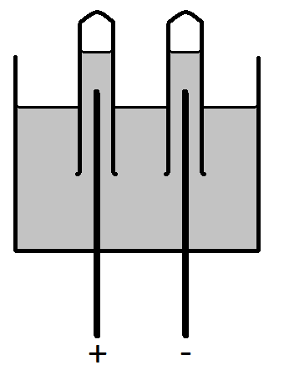
- Na⁺
- Cl⁻
- OH⁻
- H⁺
- Sodium chloride(aq)
- Carbon
- Cl₂
- H₂
- Anode
- Cathode
- Anion
- Cation
- Electrolyte

What travels towards the anode?
_____________________________
What travels towards the cathode?
_____________________________
Why is hydrogen produced and not sodium?
What is the solution that is produced as a result of this electrolysis?

____________________________________
Write equations for the reactions at the cathode and the anode:
anode
cathode

In the electrolysis of sodium chloride what is oxidised and what is reduced?

Oxidised
Reduced

Electrolysis of Copper (II) chloride (aq)

What are the ions present in copper chloride solution?
1)_________ 2) _________ 3) _________ 4) _________
State what the 3 products are and fully label the diagram for this reaction?

- ____________________ 2) ____________________ 3) ____________________

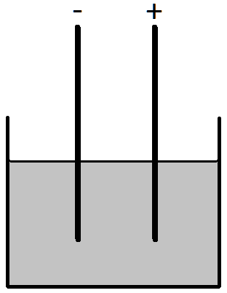

What travels towards the anode? _____________________________
What travels towards the cathode? _____________________________
Write equations for the reactions at the cathode and the anode:
anode
cathode

In the electrolysis of lead bromide what is oxidised and what is reduced?

Oxidised
Reduced

Electrolysis of Sodium Sulfate (aq)

What are the ions present in sodium sulfate solution?

- _________ 2) _________ 3) _________ 4) _________

Fully label the following diagram, you must include a label for what is produced at the anode and the cathode:

What travels towards the anode? _____________________________
What travels towards the cathode? _____________________________

Write equations for the reactions at the cathode and the anode:
anode
cathode

In the electrolysis of sodium sulfate what is oxidised and what is reduced?

Oxidised
Reduced

Core practical 4: Electrolysis Part 1

Aim: Investigate the electrolysis of copper sulphate solution with inert electrodes.

Investigate the mass change of the anode and cathode when copper sulphate is electrolysed using 0.2A, 0.3A, 0.4A and 0.5A.

Do this experiment first by using inert electrodes.

Draw a circuit diagram for this experiment.

What are the ions present in solution?

- _________ 2) _________ 3) _________ 4) _________

What are the products at the anode and the cathode?

Anode
Cathode

Design a results table for this experiment.
What other observations can you make?

Draw a graph of the results.
Can you explain the trends shown on the graph and the other observations that you made? Include, half equations for the reactions at the electrodes.

Electrolytic purification of copper

Copper is fairly low down the reactivity series, it is beneath carbon but above gold and silver. How would you expect to find copper in the earth?

___________________________________________________________________________
How would you produce copper metal?

___________________________________________________________________________
The copper produced in this metal is not pure enough for use in electrical wiring. To achieve this level of purity electrolysis is used. The diagrams below show the lab apparatus that could be used for the electrolytic purification of copper.
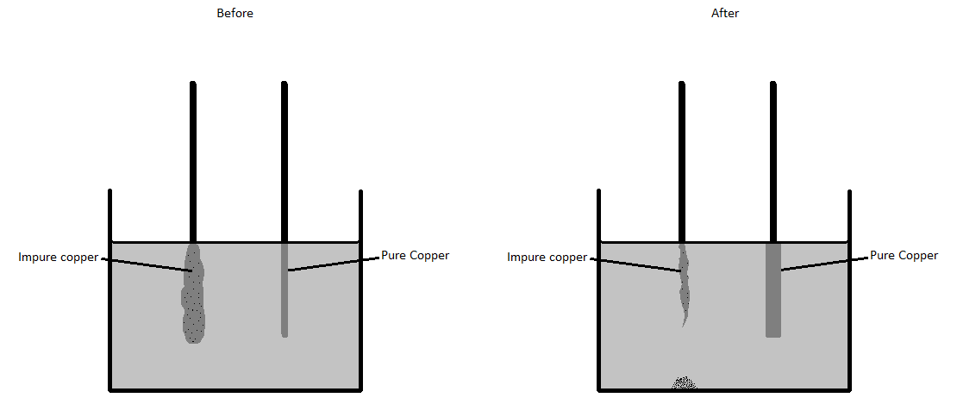
Label the diagrams with the following labels

- Anode
- Cathode
- Negative (-) electrode
- Positive (+) electrode
- Copper sulfate (aq)
- Cu
- Cu
- Cu²⁺
- Impurities
What is the electrolyte? _____________________________________

What happens to the impurities?

Explain how pure copper is produced in this process?

Write equations for the reactions at the cathode and the anode:
anode
cathode
In the electrolytic purification of copper, what is oxidised and what is reduced?

Oxidised
Reduced

The electrolytic purification of copper was set up and the following mass readings were taken at the start and end of the experiment. Predict the missing data.

Cathode mass (g) END | Anode mass (g) START | Impurity mass (g) END
 | 3.27 | 0
23.10 |  | 1.65
 | 12.65 | 0.54

Draw a diagram and explain how this process could be used to gold plate a piece cheap Jewellery?

Give 2 reasons why objects may be electroplated and give examples.

Electrolyte | Ions | Cathode product | Anode product
Lead Bromide (l)
Lithium bromide (aq)
Silver chloride (aq)
Copper iodide (aq)
Sodium Sulphate (aq)

Core practical 4: Electrolysis Part 2

Aim: Investigate the electrolysis of copper sulphate solution with copper electrodes

Investigate the mass change of the anode and cathode when copper sulphate is electrolysed using 0.2A, 0.3A, 0.4A and 0.5A.

Draw a circuit diagram for this experiment.

Design a results table for this experiment.

What other observations can you make?

Draw a graph of the results.
Can you explain the trends shown on the graph and the other observations that you made? Include, half equations for the reactions at the electrodes.

Blank Pages for Notes

Topic 4, Obtaining and using metals – Checklist
 | Content | Understand it | Learnt it
1 | Construct a reactivity series of metals by looking at their reactions with water, acids and displacement reactions with salt solutions.
2 | Understand that displacement reactions are redox reactions. Also explain what is oxidised and reduced.
3 | Explain the reactivity series of metals (potassium, sodium,  calcium, magnesium, aluminium, (carbon), zinc, iron,  (hydrogen), copper, silver, gold) in terms of the reactivity of  the metals with water and dilute acids and that these  reactions show the relative tendency of metal atoms to form  cations.
4 | Learn that: 1) most metals are extracted from ores that are found in the Earth’s crust. 2) Unreactive metals like gold are found in the Earth’s crust as the uncombined elements (if you’re lucky enough).
5 | Learn that oxidation is defined as the loss of electrons and reduction is defined as gaining electrons.
6 | Learn that extraction of metals involves the reduction of ores.
7 | Be able to explain that the method of extraction used to obtain a metal is related to its position in the reactivity series and the cost of the process. For example iron and aluminium.
8 | Learn the advantages and disadvantages of alternative methods of metal extraction. For example bacterial and phytoextraction.
9 | Predict a metals resistance to oxidation by looking at its position in the reactivity series.
10 | Evaluate the advantages of recycling metals, including  economic implications and how recycling can preserve both  the environment and the supply of valuable raw materials
11 | Learn about ‘life time assessment’ of a product. This involves evaluating the effect on the environment of obtaining the raw materials, manufacturing the product, using the product and disposing of it when it is no longer useful.
12 | Look at data of a life time assessment of a product and use it to answer questions about the product.

What is a Reactivity Series?
How would you expect a metal to react with substances like water and acids if it is at the top of the series?
Look at a student’s observations of two different metals reacting, one is reacting with water and the other hydrochloric acid 1M. which do you think is the more reactive metal?
Metal | Reaction with water | Reaction with hydrochloric acid
A | Metal bubbles slowly and the test tube became warm
B |  | Bubbles form on the metal quickly and the test tube becomes hot.

Displacement
What is the rule for displacement reactions?

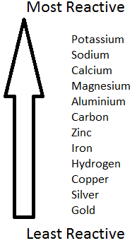
Look at the reactivity series and the reactions below, where there is a reaction complete the equation.
Reactants | Products if a reaction will happen?
Zinc + copper sulphate
Magnesium + zinc nitrate
Copper + zinc chloride
Sodium sulphate + magnesium
Aluminium + silver nitrate

Displacement Practical
Take 50 cm³ of copper sulphate and pour it into a beaker. Add 3-4 lumps of zinc and stir the mixture continuously for 5 minutes. Note and explain your observations.
Observations
1
2

Reaction Equation

Explanation

Look at the reactivity series and match each metal to the reactions of metals a-j in the table.
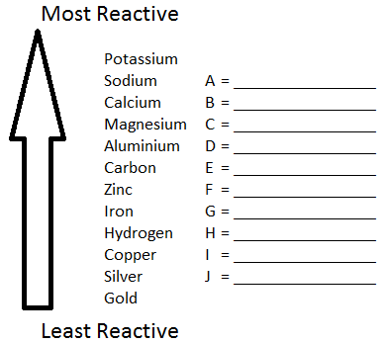
Metal | Reaction with water | Reaction with acid | Reaction with silver nitrate | Reaction with gold sulphate
A | No reaction | No reaction | Yes | Yes
B | Extremely small bubbles seen slowly appearing on the metals surface | Bubbles quickly and the test tube gets hot | Yes | Yes
C | No reaction | No reaction | No reaction | No reaction
D | Metal reacts vigorously at once, it melts and moves around the surface of the water rapidly giving off a gas. |  | Yes | Yes
E | Bubbles quickly form on the metal and the test tube gets hot to the touch | A very vigorous reaction is observed with gas rapidly being produced and the test tube gets very hot. | Yes | Yes
F | No reaction | No reaction | No reaction | Yes
G | No reaction | Extremely small bubbles can be seen slowly appearing on the surface of the metal. | Yes | Yes
H | No reaction | No reaction initially observed but on revisiting 1 hour later very small bubbles were observed on the metal. | Yes | Yes
I | Metal reacts immediately moving around the surface of the water. It gets so hot the gas given off starts burning with a lilac flame. |  | Yes | Yes
J | No reaction | Bubbles form slowly on the surface of the metal | Yes | Yes
Literacy Exercise - Correct the spelling, punctuation and grammar errors below, then answer the questions that follow.

Metals are very useful we find them in the earths crust as metal ores ores are naturally occuring rocks that contane metal or metal compounds in sufficent amounts to make it economic to extract the metal for example iron or is used to make iron and steel copper is easily extracted but Ores rich in copper are becoming more difficult to find most everyday metals are mixtures called alloys
the earths crust contains metals and metal compounds such as gold iron oxide and aluminium oxide but when found in the Earth these are often mixed with other substances to be useful the metals have to be extracted from whatever they are mixed with the method used to extract metals from the ore in which they are found depends on the reactivity of the metal for example reactive metals such as sodium are extracted by electrolysis while a less reactive Metal such as led may be extracted by reduction with carbon or carbon monoxide
thus the method of extraction of a metal from it’s ore depends on the metals’ position in the reactivity series

Where do we find metals? ______________________________________________________

Name an element the metals are joined when they are found? _________________________
What is an alloy? _____________________________________________________
Copper is a hugely useful metal; how can we get around the problem of the Earth’s natural reserves of copper running out?

What does the method used to extract a metal from its ore depend upon?

Part of a reactivity series is shown below:
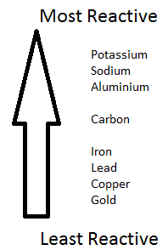
Elements higher up the table will always react with metal ores lower down the table.
Which of the following will react?
Reactants | Will a reaction happen?
- Potassium + Copper ore
- Lead + Aluminium ore
- Sodium + Aluminium ore
- Carbon + Iron oxide
- Carbon + Aluminium oxide
Extracting metals by heating with carbon is cheap because carbon is widely available. Therefore, any metal ores that will react with carbon are extracted in this way.
Why is gold not extracted by heating with carbon?
Name another metal that exists like gold in the earth’s crust.
1)

Name 3 metals from the reactivity series above that are extracted by heating with carbon?
1) | 2) | 3)

Metals more reactive than carbon are extracted using electrolysis. This method would also work for metals like iron and lead, why is it not used?

Name 3 metals from the reactivity series above that are extracted using electrolysis?
1) | 2) | 3)

Complete word and symbol equations for:
- Heating iron oxide (Fe₂O₃) with carbon.
Word
Symbol

- The electrolysis of aluminium oxide (Al₂O₃).
Word
Symbol

Given a choice would you rather recycle aluminium or steel drinks cans? Explain your answer.

Why would it be ideal to recycle both aluminium and steel drinks cans?

There are other biological methods of metal extraction, for example. Some plants absorb copper compounds through their roots and they can concentrate these compounds as a result of this. The plants can then be burnt to produce an ash that contains copper compounds which copper can be extracted from. This method of extraction is called phytomining.
Some bacteria absorb copper compounds. They then produce solutions called leachates, which contain copper compounds. This method of extraction is called bioleaching.
What do you think the pros and cons are of this method of obtaining copper?

Which metal in the reactivity series would be most susceptible to corrosion and which would be least susceptible to corrosion?
Most | Least
What factors need to be taken into consideration when considering a ‘life time assessment’ of the impact of a product on the environment?

Oxidation and Reduction
In its simplest terms what is an oxidation reaction and what is a reduction reaction?

Oxidation
Reduction

The table below shows a variety of oxidation and reduction reactions. Label each one correctly.

Reaction | Oxidation or Reduction?
Magnesium + oxygen → Magnesium oxide | The magnesium is
Aluminium oxide → Aluminium + Oxygen | The aluminium oxide is
CH₄ + O₂ → CO₂ + H₂O | The methane is
Plants turning carbon dioxide into oxygen | The carbon dioxide is
Any metal being extracted from its ore. | The metal is
Any combustion. | The fuel is
Any metal corroding. | The metal is
Iron oxide being heated with carbon | The iron oxide is
Iron oxide being heated with carbon | The carbon is

The last example in the table showing carbon displacing iron is both reduction and oxidation. Chemists call this type of reaction a redox reaction.
A better definition of oxidation and reduction involves gaining and losing electrons. The phrase OIL RIG can help you remember the definition and hopefully work it out.

What is a definition for oxidation and reduction that includes electrons?

Oxidation
Reduction

Blank Pages for Notes

Topic 4, Reversible reactions and equilibria - Checklist
 | Content | Understand it | Learnt it
1 | Know that some chemical reactions are reversible and where this is the case the following symbol is used: ⇌
2 | Learn the definition of dynamic equilibrium.
3 | Learn how ammonia is formed from nitrogen (from the air) and hydrogen (obtained from natural gas) and understand that it is a reversible reaction and that it can reach a dynamic equilibrium.
4 | Learn how changing:  - Temperature  - Pressure  - Concentration  Can change the position of a dynamic equilibrium.
The Haber Process – Making Ammonia
Chemical fertilisers can be manufactured from ammonia. What is the formula of ammonia?

What are the raw materials for the manufacture of ammonia and where are they found?

Raw material | Sourced from

Write a balanced word and symbol equation for the production of ammonia
Word | ⇌
Symbol | ⇌

What does this symbol mean ⇌ ?

What is a dynamic equilibrium?

Apparatus - Label the diagram of the Haber process

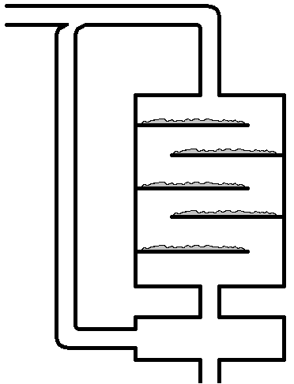

Temperature and pressure also affect the dynamic equilibrium and that equilibrium can shift.
Temperature
In equilibrium reactions one reaction is exothermic and one reaction is endothermic.

Define exothermic and endothermic and state which gives off and which takes in heat.

 | Definition | Hot or cold
Exothermic
Endothermic

In the Haber process the forward reaction is exothermic and the reverse reaction is endothermic. Label the equation accordingly:

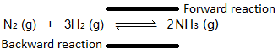
Dynamic equilibrium reactions move to oppose the change in conditions i.e. if you heat it up it will move in the ____________________direction. Does increasing the temperature increase or decrease the yield of ammonia? And why?

Increase or decrease? | Reason

Pressure

If you increase the pressure on an equilibrium reaction the equilibrium will shift to reduce the pressure. To work out which way this is you need to count the gas molecules on each side of the arrow.

N₂ (g) + 3H₂ (g) ⇌ 2NH₃ (g)

How many gas molecules are there on the left of the haber process? ___________

How many gas molecules are there on the right of the haber process? ___________

Does increasing the pressure increase or decrease the yield of ammonia? And why?
Increase or decrease? | Reason

In reality a medium temperature of ~450 ºC and a high pressure of 200 atm is used. Can you explain these conditions?

If the reactants were solutions, then concentration would also effect the dynamic equilibrium. How would increasing the concentration of a reactant effect the position of the equilibrium?

Blank Pages for Notes

Glossary
acid | a family of chemicals that can give off hydrogen ions in solution.
acid rain | rain water that is acidic because sulfur dioxide given off from coal burning power stations has dissolved in the moisture in clouds to form sulfuric acid.
alkali | a family of chemicals that can give off hydroxide ions in solution.
alkane | a hydrocarbon family where the carbon atoms are joined together with carbon to carbon single bonds only. Alkanes are known as saturated hydrocarbons.
alkene | a hydrocarbon family where 2 carbon atoms are joined together with a carbon to carbon double bond. Alkenes are known as unsaturated hydrocarbons.
alloy | a mixture of 2 or more metals.
anion | a negatively charged ion.
aqueous | the name given to the state when a substance is dissolved in water.
atmosphere | the gases that surround a planet.
atom | the smallest particle that has the properties of a chemical element.
atomic number | the number of protons in an element, this is unique for every element.
Avogadro constant | 6.02 x 1023 particles. Also see the definition of the mole.
basalt | an intrusive igneous rock, formed when lava cools quickly outside of the earth’s crust, it has small crystals.
base | a substance that will react with an acid to make a salt and water.
biofuel | a fuel that is created from growing plants, once the plant is harvested more are planted leading to a renewable fuel.
bitumen | a long chain alkane found in crude oil used to surface roads and roofs.
boiling | changing from a liquid to a gas, this occurs at the substances boiling point.
boiling point | the temperature needed to turn a substance from the liquid state to the gaseous state, this is different for all substances and if the substance is pure it happens at a very clear temperature.
bromine water | used as a test for unsaturation; bromine water is decolourised by alkenes.
carat | a scale used to indicate the purity of a sample of gold.
carbon monoxide | formula: CO - a colourless and odourless toxic gas formed from the incomplete combustion of fuels.
cation | a positively charged ion.
chalk | a sedimentary rock made of calcium carbonate.
chemical change | a permanent change bought about by a chemical reaction.
chlorination | adding small quantities of chlorine to drinking water to kill bacteria.
chromatography | a separating technique used to separate and identify a mixture of liquids e.g. different ink colours that make up a felt tip pen.
complete combustion | where a fuel burns with plenty of oxygen and the products are carbon dioxide and water.
compound | a substance made up of 2 or more different atoms chemically joined together.
concentration | this is a measure of how much of a substance is dissolved in the solvent.
condensation | a gas changing back to a liquid.
conductor | a substance that allows either electricity or heat to pass through it. Metals are good at both but some other substances like carbon graphite are good electrical conductors but not good thermal conductors.
conservation of mass | a basic law of chemistry that states in a chemical reaction matter is neither created or destroyed therefore the overall mass of the reactants is the same as the mass of the products.
corrosion | a metal reacting with oxygen in the atmosphere.
covalent bond | the bond formed when non-metals share a pair or pairs of electrons.
cracking | an example of thermal decomposition; a long chain alkane is heated and it decomposes into a shorter chain alkane and an alkene.
crude oil | a mixture of hydrocarbons belonging to the alkane family.
crystallisation | forming a solid by evaporating the liquid from a solution.
d.c. supply | a direct current supply is an electrical supply in which the current always flows in the same direction.
displacement | a type of chemical reaction in which a more reactive element displaces a less reactive one from its compound.
dissociation | the splitting of a molecule into ions e.g. water dissociating into H⁺ and OH⁻ ions
dissolved | a substance is taken and mixed with a solvent which changes it from the solid state into a solution.
dissolving | when a solid or a gas completely mixes with a liquid to make a solution.
earth's crust | the relatively thin layer of solid rock that surrounds the earth.
electrolysis | a reaction which involves electricity and results in the decomposition of the compound undergoing electrolysis.
electron | a sub atomic particle found in shells surrounding nucleus, this particle is negatively charged and has a mass of 1/1837 (Almost zero).
electronic configuration | the arrangement of electrons in shells around the nucleus.
electrostatic forces of attraction | the name given to the attractive forces present between oppositely charged ions.
element | a substance made up of the same type of atom.
empirical formuale | the formula that gives the proportions of the elements that make up a compound, note: it does not give the actual formula.
evaporating | changing from a liquid to a gas beneath the liquids boiling point.
excess | when you have too much of one reactant.
excess | when there is too much of one reactant. We use this to ensure all of the other reactant is used up.
filtration | a separating technique used to separate an insoluble solid and a liquid.
fossil | an imprint of an ancient plant or animal left in sedimentary rock.
fossil fuel | a carbon based fuel (coal, oil or gas) formed from ancient plants or animals.
fractional distillation | a separating technique used to separate a mixture of different liquids e.g. crude oil.
freezing | changing from a liquid to a solid.
fuel oil | a long chain alkane found in crude oil used as a fuel for ships and some power stations.
fullerene | a form of elemental carbon that forms simple molecules that can act as super conductors.
giant molecular structure | a covalent structure where the bonds spread throughout the entire structure e.g. carbon diamond, carbon graphite, silicon dioxide.
granite | an intrusive igneous rock, formed when magma cools slowly in the earth’s crust, it has big crystals.
group | a vertical column on the periodic table where the elements that comprise it have similar properties.
hazard symbols | pictures found on chemical bottles that warn of the dangers of the substance.
hydrocarbon | a compound containing only hydrogen and carbon.
hydrochloric acid | a commonly occurring lab acid with the formula HCl, also found in human stomachs to help digestion and kill bacteria.
igneous rock | rock formed when hot magma cools and solidifies.
incomplete combustion | where a fuel burns with insufficient oxygen which can lead to products which include carbon monoxide or carbon (soot).
ion | a charged atom or group of atoms.
ionic bond | the name given to the type of bond formed when a metal gives an electron(s) to an non-metal.
ionic lattice | the name given to the structure that is formed when many oppositely charged ions attract each other.
isotope | 2 or more atoms of the same element with the same number of protons but a different number of neutrons.
kerosene | an alkane found in crude oil used as a fuel for jet engines.
lava | molten rock outside the earth's crust.
limestone | a sedimentary rock made of calcium carbonate.
limewater | a solution of calcium hydroxide that is used to test for the presence of carbon dioxide gas.
litmus | an indicator that turns red in acid and blue in alkali.
magma | molten rock inside the earth's crust.
malleable | a substance that can bend without breaking e.g. metals.
mass number | the mass of an atom, this is equal to the number of protons and neutrons in the nucleus.
melting | changing from a solid to a liquid.
melting point | the temperature needed to turn a substance from the solid state to the liquid state, this is different for all substances and if the substance is pure it happens at a very clear temperature.
metallic structure | a lattice arrangement of metal cations surrounded by a sea of delocalised electrons.
metamorphic rock | rock formed by the heating and pressurising of existing rock. Example is when limestone is heated and pressurised it forms marble.
methyl orange | an indicator that goes orange in acid and yellow in alkali.
mole | the unit in chemistry that details the amount of a substance. 1 mole of a substance is said to contain the Avogadro constant. 1 mole always contains 6.02 x 10²³ particles.
molecule | a particle made of non-metals only where the bonding is covalent. We never use the word molecule to refer to anything ionic or metallic.
neutralisation | an acid reacting with a base to make a salt and water.
neutron | a sub atomic particle found in the nucleus, this particle is neutrally charged and has a mass of 1.
nitinol | a shape memory alloy made from nickel and titanium.
non-biodegradable | a material that does not naturally breakdown in the environment e.g. plastics.
non-renewable fuels | fuels that when burnt cannot be replaced examples include fossil fuels (coal, oil and gas).
nucleus | the area at the centre of the atom that contains all the protons and neutrons
ore | a type of rock that contains important elements like metals. These elements can be extracted from the ore.
oxidation | the basic definition is: a reaction in which oxygen is added. However a better definition is when a substance loses electrons.
particle | a term that is used to describe a small amount of matter.
period | a horizontal row on the periodic table.
periodic table | a list of all the elements.
phenolphthalein | an indicator that turns pink in alkali but is colourless in acid.
photosynthesis | the chemical reaction that takes place in plants to enable them to make their own food. The plant takes in carbon dioxide and water and makes glucose and oxygen.
physical change | a change of state e.g. a liquid boiling and turning into a gas. These can be undone by changing the conditions.
phytoextraction | a process where pants remove elements or compounds from soil or water.
polymerisation | a reaction involving unsaturated molecules joining together to make extremely long molecules called polymers.
polymers | very large molecules that have carbon as the backbone of the molecule.
proton | a sub atomic particle found in the nucleus, this particle gives the atom its identity, is positively charged and has a mass of 1.
PVC | polyvinylchloride is a polymer used to make window frames.
reactivity series | a list of elements in order of reactivity, the most reactive is at the top and the least reactive at the bottom.
redox | a reaction where a reduction process and an oxidation process can be identified. Reduction involves the gain of electrons and oxidation is the loss of electrons.
reduction | the basic definition is: a reaction in which oxygen is lost. However a better definition is when a substance gains electrons.
relative atomic mass | the mass of the atom relative to 1/12 mass of a carbon - 12 atom.
renewable fuels | fuels that when used can be replaced examples include biofuels.
salt | a family of compounds of neutral pH formed by the reaction of acids with metal oxides, metal hydroxides or metal carbonates. A salt contains a metal and a non-metal.
saturated | a hydrocarbon family like the alkanes where the carbon to carbon bonds are all single.
sedimentary rock | a rock formed from sediment building up at the bottom of lakes and oceans over a long period of time.
sedimentation | leaving a mixture of an insoluble solid and a liquid to settle. This results in the solid falling to the bottom and the liquid can be poured off. Used as part of the water treatment process for drinking water.
shape memory alloy | an alloy that will return to its initial shape after it has been deformed, useful for spectacle frames and stents.
simple distillation | a separating technique used to separate a mixture of a solid dissolved in a liquid or two liquids with very different boiling points.
simple molecular structure | a covalent structure where the bonds are contained within the molecule e.g. H₂O, CO₂, O₂, C₆₀
solution | a liquid mixture.
solvent | a substance that can dissolve others e.g. water.
state symbols | symbols that indicate the physical state of the reactants and products in symbol equations (s) = solid, (l) = liquid, (g) = gas, (aq) = aqueous (dissolved in water).
stent | a small expandable tube that can be inserted into a blocked blood vessel.
stoichiometry | this is the name given to the big numbers in reaction equations that show the proportions of reactants used and products made.
sulfur dioxide | a polluting gas formed when coal burns. Coal naturally contains some sulfur which oxidises on burning.
symbol equation | a way of summarising a chemical reaction by writing the chemical formulae of the reactants and products.
thermal decomposition | a reaction where you heat the reactant and it breaks down into 2 or more products.
titration | a common lab method of quantitative analysis. We use it to measure exactly how much of one reactant is needed to react with a known volume of another.
unsaturated | a hydrocarbon family like the alkenes where there is a carbon to carbon double bond.
viscosity | how thick a liquid is.
word equation | a way of summarising a chemical reaction by writing the names of all reactants and products.

Essential Knowledge Questions
Learn the answers to each of these:
 | Question | Answer
1 | What is an atom? | The smallest particle that has the properties of a chemical element.
2 | Describe the structure of an atom. | A nucleus containing protons and neutrons, surrounded by electrons in shells.
3 | What are the relative charges and masses of protons, neutrons and electrons. | Protons: mass 1, charge +1  Neutrons: mass 1, charge 0  Electrons: mass almost zero, charge -1.
4 | Why do atoms contain the same number of protons and electrons? | Atoms are neutrally charged so they must have the same number of positive particles (protons) as negative particles (electrons)
5 | How would you describe the size of the nucleus relative to the rest of the atom? | Very small
6 | Where is most of the mass of the atom found? | In the nucleus.
7 | What is the mass number of an element? | The total number of protons and neutrons.
8 | What is the atomic number of an element? | The number of protons.
9 | The number of which particle is unique to an element and gives it its identity? | Protons
10 | If an atom contains 12 protons, how many electrons will it have? | 12.
11 | If an atom has a mass number of 23 and an atomic number of 11, how many protons, neutrons and electrons does it contain? | 11 protons  11 electrons  23-11 = 12 neutrons
12 | What is an isotope? | Two or more atoms of the same element (the same number of protons) but with a different number of neutrons.
13 | What is the relative atomic mass, (A_{r})? | The relative mass of an atom compared to the one twelfth mass of an atom of carbon-12.
14 | Why do some elements have a relative atomic mass that is not a whole number. | The relative atomic mass is an average mass of all the isotopes that make up the element.
15 | What is the formula for calculating relative atomic mass of an element from the relative mass and abundance of its isotopes?
16 | How did Mendeleev arrange the elements known at the time into a periodic table? | By using the mass number and the properties of the elements and the properties of their compounds of the elements.
17 | How did Mendeleev use his table? | To predict the existence and properties of some elements that were still to be discovered.
18 | Why does Mendeleev’s method of organising elements in order of increasing atomic mass not always work? | The relative abundancies of some elements isotopes means they can be placed in the wrong place.
19 | How are elements in the modern periodic table arranged? | In order of increasing atomic number in rows called periods and elements with similar properties are placed in the same vertical columns called groups.
20 | Where are the non-metals found in the periodic table? | At the top on the right hand side.
21 | What do all elements in the same row of the periodic table have in common? | They have the same number of shells of electrons.
22 | What do all elements in the same column of the periodic table have in common? | They have the same number of electrons in their outer shell (and therefore have similar chemical properties).
23 | What is an ion? | A charged atom or group of atoms.
24 | Describe how an ionic bond is formed. | A metal loses electron(s) to a non-metal. This results in the metal becoming a positively charged ion (cation) and the non-metal a negatively charged ion (anion). These oppositely charged ions then attract.
25 | Is a cation positively or negatively charged? | Positive
26 | Is a anion positively or negatively charged? | Negative
27 | What charge do the ions have when formed from elements in group:  - 1  - 2  - 6  - 7 | - +  - 2+  - 2-  - -
28 | What do the compound endings:  - ide  - ate  mean? | - ide – a compound of only the named substances  - ate – a compound of the named substances and oxygen
29 | What is the formula of the compounds formed from:  - Mg²⁺ and Cl⁻  - Na⁺ and O²⁻? | - MgCl₂  - Na₂O
30 | Describe the structure of ionic substances. | Ionic substances are a regular arrangement of oppositely charged ions held together in a lattice structure by strong electrostatic forces.
31 | How many electrons does Mg²⁺ have? Mg has an atomic number of 12 | 10
32 | Describe what happens in covalent bonding? | Two non-metals overlap their outer electron shells and share at least one pair of electrons.
33 | What does covalent bonding result in the formation of? | molecules
34 | Name and explain two physical properties of ionic compounds. | - They have high melting and boiling points because there are strong electrostatic forces holding the oppositely charged ions in place, therefore a lot of energy is needed to separate the ions.  - They can conduct electricity when molten or in aqueous solution (dissolved in water) because the ions are free to move and carry their charge.
35 | Name and explain two physical properties of covalent, simple molecular compounds. | - They have low melting and boiling points because there are weak intermolecular forces of attraction between molecules.  - They do not conduct electricity because the molecules are not charged.
36 | Describe the structures of:  - Diamond  - Graphite | - Each carbon atom is held in place by 4 strong covalent bonds to other carbon atoms. This arrangement is replicated throughout the whole structure creating a giant structure.  - Each carbon atom is held in place by 3 strong covalent bonds. This creates flat layers of carbon atoms which stack on top of each other. The unused outer electron on each carbon atom sits between these layers and is delocalised (free to move).
37 | Why is diamond used in cutting tools? | Diamond is very hard because all the carbon atoms are joined by 4 strong covalent bonds.
38 | Why does diamond have such a high melting point? | In diamond each carbon atom is held in place by 4 strong covalent bonds and it takes a lot of energy to break these bonds.
39 | Why does graphite conduct electricity? | In graphite each carbon forms 3 bonds, this leaves one electron left over from each carbon atom which sits between the graphite layers and is free to move and carry a charge.
40 | Why can graphite act as a lubricant? | The layers of carbon atoms in graphite are only very weakly joined and are therefore free to slide past each other.
41 | What are fullerenes? Explain its properties in terms of its structure and bonding. | C₆₀ is one example where 60 carbons bond together covalently making a structure that looks like a football. These are simple molecules and behave as such. It is possible to ‘dope ‘ the C₆₀ with metal atoms and it then becomes a superconductor.
42 | What is graphene? Explain its properties in terms of its structure and bonding. | Graphene is like graphite, just 1 layer thick. It therefore conducts electricity and for its thickness is very strong.
43 | Describe polythene’s structure | Polythene is an example of a polymer. It is a large molecule containing chains of carbon atoms surrounded by hydrogen.
44 | Describe the bonding in metals? | All metals form positive ions and their outer electrons are delocalised and sit between the metal ions (forming a ‘sea of electrons’).
45 | Why do metals conduct electricity? | There are free electrons in the metallic structure that can move.
46 | Why are metals malleable? | They bend because the ions can slide over one another.
47 | Why is it difficult to represent models of compounds on paper? | Compounds are normally 3 dimensional and contain different sized atoms. This can give them particular shapes that are hard to draw clearly in 2 dimensions (on paper).
48 | What are the properties of most metals? | Shiny solid, high melting points, high density and good conductors of electricity.
49 | What is an empirical formula? | The simplest ratio of the elements in a compound.
50 | What is the law of conservation of mass? | During any chemical reaction no particles are created or destroyed. So the overall mass of the reactants must equal the mass of the products.
51 | What unit do we use for concentration? | g dm⁻³ (grams per decimetre cubed)
52 | What is 1 mole of particles? | The Avogadro constant (6.02 x 10²³ particles).
53 | What is the formula to calculate moles? | Moles = Mass/Relative formula mass
54 | What are the 3 states of matter? | Solid, liquid and gas
55 | Name the interconversion between the:  - Solid to the liquid state  - Liquid to the gaseous state  - gaseous state to the liquid state  - Liquid to the solid state | - Melting  - Evaporating (or if heated to boiling point – Boiling)  - Condensing  - Freezing
56 | Describe how the particles arrangement, movement and energy changes during melting. | The particles energy increases on heating causing the vibrations between particles to increase to an extent that they break free from their regular arrangement and start moving over one another.
57 | Describe how the particles arrangement, movement and energy changes during condensing. | The particles energy decreases on cooling causing the particles to slow down and become attracted to other particles.
58 | What is the difference between a pure substance and a mixture? | A pure substance is made of just one thing whereas a mixture is made of more than one substance which are not chemically joined.
59 | What type of mixtures can be separated by each of these techniques?  - Simple distillation  - Fractional distillation  - Filtration  - Crystallisation  - Paper chromatography | - A dissolved solid where you want to keep the liquid or 2 liquids with very different boiling points.  - A large sample of a mixture of liquids with similar boiling points  - An insoluble solid and a liquid.  - A dissolved solid where you do not want the liquid.  - A small sample of a mixture of liquids.
60 | What is Chromatography? | A separating technique used to separate mixtures of soluble substances by running a solvent (mobile phase) through the mixture on the paper (stationary phase) which causes the substances to move at different rates over the paper.
61 | How can you use paper chromatography to identify a substance? | Each substance will run a specific distance up the paper and have its own unique R_{f}.
62 | In chromatography, define the R_{f} value. | R_{f} = distance moved by the component  distance moved by the solvent
63 | How can ground water be made potable? | Sedimentation, filtration and chlorination
64 | How can sea water be made potable? | Distillation.
65 | Why must water used in analysis not contain any dissolved salts? | Dissolved salts could cause an analysis to give a false positive result. In other words you might get a positive result for something that isn’t really there.
66 | What are acids and alkalis sources of? | Acids – hydrogen ions  Alkalis – hydroxide ions
67 | What are the colour changes of?  - Litmus  - Methyl orange  - Phenolphthalein  With acid and alkali? | Acid Alkali  Litmus red blue  Methyl orange red yellow  Phenolphthalein colourless pink
68 | What is the link between hydrogen ion concentration and pH? | The higher the concentration of hydrogen ions the lower the pH (a stronger acid). As the hydrogen ion concentration increases by a factor of 10, the pH of the solution decreases by 1.The higher the concentration of hydroxide solutions the higher the pH.
69 | When calcium hydroxide is added slowly to hydrochloric acid the pH of the resulting solution changes. What would the graph of this look like?
70 | What pH could a concentrated acid have? | Anything between 1 and 6. Acid concentration refers to the dilution with water. A strong acid can still have a lot of hydrogen ions in solution even when it is of a weak concentration.
71 | Which would have a pH of 1?  - 0.25M Sulphuric acid (a strong acid)  - 10M Ethanoic acid (a weak acid) | Strong acids will always have low pH regardless of the concentration.
72 | What is a base? | It is a substance that can react with an acid to make a salt and water.
73 | What is an alkali? | A soluble base.
74 | What type of reaction is it when an acid reacts with a base? | Neutralisation
75 | What are the products of the following neutralisation reactions?  - Metal + acid =  - Metal oxide + acid =  - Metal hydroxide + acid =  - Metal carbonate + acid = | - Salt + hydrogen  - Salt + water  - Salt + water  - Salt + water + carbon dioxide
76 | What is the chemical test for?  - Hydrogen  - Carbon dioxide | - Lit splint gives a squeaky pop.  - Bubbling carbon dioxide through limewater turns it milky.
77 | Explain why water is produced when an acid reacts with an alkali? | The hydrogen ions (H⁺) from the acid react with the hydroxide ions (OH⁻) from the alkali to form water (H₂O).
78 | When preparing a soluble salt from an acid an insoluble reactant how do you ensure the salt is pure? | - Use excess insoluble reactant to neutralise all the acid.  - Filter the resulting mixture to remove the excess reactant.
79 | How do you prepare a soluble salt when both the reactants are soluble? | Titration is used to ensure the reactants are mixed in the correct proportions.
80 | How would you prepare a sample of pure, dry hydrated copper sulfate crystals starting from copper oxide. | - Add excess copper oxide to sulfuric acid and place in a water bath to gently heat.  - Filter the mixture to remove excess copper oxide.  - Evaporate the mixture, this can be heated to start with but it must be left to evaporate at room temperature to produce hydrated crystals.
81 | How do you carry out an acid-alkali titration, using burette, pipette and a suitable indicator, to prepare a pure, dry sample of sodium chloride? | - Fill a burette with hydrochloric acid.  - Measure 25 cm³ of sodium hydroxide using a pipette and place in a conical flask.  - Add a few drops of phenolphthalein indicator.  - Place the conical flask on a white tile underneath the burette.  - Run in hydrochloric acid fairly quickly at first whilst continually stirring.  - When the neutralisation point is approaching start to add the acid drop wise.  - Stop adding the acid the moment the indicator goes clear.  - Repeat the titration 2 further times and average results.  - Carry out titration one final time, this time without indicator to ensure the salt produced is pure. Stop adding acid when the average quantity previously identified has been added.
82 | Are the common sodium, potassium and ammonium salts soluble or insoluble? | Soluble
83 | Are nitrates soluble or insoluble? | Soluble
84 | Are common chlorides soluble or insoluble? And what is the exception to the rule? | Soluble, except silver chloride and lead chloride.
85 | Are common sulfates soluble or insoluble? And what is the exception to the rule? | Soluble, except lead sulphate, barium sulphate and calcium sulphate.
86 | Are common carbonates and hydroxides soluble or insoluble? And what is the exception to the rule? | Insoluble, except sodium, potassium and ammonium.
87 | What is a precipitate? | A solid formed from two reacting solutions.
88 | What is the name of the insoluble precipitate formed when lead nitrate reacts with potassium chloride? | Lead chloride
89 | How do you prepare a pure, dry sample of an insoluble salt? | Mix reacting solutions together in order to get the precipitate, then filter the precipitate out of the solution, wash it with distilled water and dry it.
90 | What is an electrolyte? | An ionic compound in either the molten state or dissolved in water.
91 | What is electrolysis? | A chemical process that decomposes an electrolyte using electrical energy from a direct current (DC) supply.
92 | What are positively charged ions called? | Cations
93 | What are negatively charged ions called? | Anions
94 | What is the positive electrode called? | Anode
95 | What is the negative electrode called? | Cathode
96 | How do the ions move during electrolysis? | The cations migrate to the cathode.  The anions migrate to the anode.
97 | What products are formed in the electrolysis of the following electrolytes:  - Copper chloride solution  - Sodium chloride solution  - Sodium sulphate solution  - Water acidified with sulphuric acid  - Molten lead bromide | Anode Cathode Left in solution  1 Chlorine Copper  2 Chlorine Hydrogen Sodium hydroxide  3 Oxygen Hydrogen  4 Oxygen Hydrogen  5 Bromine Lead
98 | What is the cathode half equation when water is electrolysed? | 2H⁺ + 2e⁻ → H₂
99 | What is the anode half equation when water is electrolysed? | 2O²⁻ → O₂ + 4e⁻
100 | Define oxidation and reduction. | Oxidation is loss of electrons and reduction is gain of electrons.
101 | When water is electrolysed are the hydrogen ions oxidised or reduced? | Reduced
102 | Does oxidation happen at the anode or cathode? | Anode
103 | When purifying copper using electrolysis would you make the impure copper the anode or the cathode? | Anode
104 | Write the half equation for the formation of copper at the cathode. | Cu²⁺ + 2e⁻ → Cu
105 | Magnesium produces small bubbles of gas when placed in water; it reacts rapidly with steam and acid. Lithium bubbles fizzes on the surface of water. Which is more reactive? | Lithium.
106 | What is a displacement reaction? | A redox reaction in which a more reactive element displaces a less reactive element from its compound. Both metals and non-metals take part in displacement reactions.
107 | In metal displacement reactions, is the reactive metal oxidised or reduced? | Oxidised
108 | Where are most metals obtained from? | Ores found in the Earth’s crust.
109 | Name a metal that is not extracted from an ore and explain why. | Gold because it is so unreactive it doesn’t combine with oxygen in the environment.
110 | When metals are extracted are ores oxidised or reduced? | Reduced
111 | Describe how iron is extracted from its ore. | Iron ore (iron oxide) is heated with carbon (the carbon displaces the iron. The iron is reduced – loses its oxygen to the carbon).
112 | Describe how aluminium is extracted from its ore. | Aluminium is extracted by electrolysis.
113 | Explain why aluminium is extracted in this way, and not by simply heating it with carbon. | Aluminium is a reactive metal.  Reactive metals bond strongly to the other elements in their ores. It requires a lot of energy to break these chemical bonds. Electrolysis can provide large amounts of electrical energy to separate the metal from the other elements in the ore.  All reactive metals have to be extracted by electrolysis. The disadvantage is that this method is expensive.
114 | Why is iron not extracted from its ore using electrolysis? | It is cheaper to displace it with carbon.
115 | How does the phyto extraction of copper work? | Some plants absorb copper compounds through their roots, the plant is then burnt and the copper extracted from the ash.
116 | What is bioleaching? | A method of extracting copper that involves bacteria absorbing copper compounds. The bacteria then produce solutions called leachates which contain copper compounds from which the copper can be extracted.
117 | Would you expect a metal low down the reactivity series to be susceptible to oxidation? | No, unreactive metals are much less likely to react with oxygen.
118 | Why do we recycle scrap metal? | - It can often be cheaper to recycle rather than extract new metal from its ore.  - Recycling cuts waste which could otherwise harm the environment.  - Preserves the remaining raw materials on the planet.
119 | What does a lifetime assessment of a product involve? | Evaluating the effect on the environment of:  - Manufacturing  - Using  - Disposing
120 | What does this symbol mean?  ⇌ | It shows a reaction is reversible
121 | What is meant by the term ‘dynamic equilibrium’? | A reversible reaction is said to be in dynamic equilibrium when the rate of the forward reaction is equal to the rate of the backward reaction.
122 | How can you change the equilibrium of a reversible reaction? | By changing the conditions, for example temperature and pressure.
123 | What is the equation for the Haber process? | N₂ (g) + 3H₂ (g) ⇌ 2NH₃ (g)
124 | Where are the reactants obtained from in the Haber process? | The nitrogen is extracted from air and the hydrogen is obtained from natural gas.
125 | What is the chemical formula for ammonia? | NH₃
126 | What are the conditions used in the Haber process? | - temperature 450 °C  - pressure 200 atmospheres  - iron catalyst
127 | How does increasing the temperature affect the yield of ammonia? | The production of ammonia is exothermic so increasing the temperature reduces the yield.
128 | If increasing the temperature reduces the yield of ammonia why is a temperature of 450 ºC used? | 450 ºC is a compromise, the temperature is raised to increase the rate of reaction even though it decreases the yield.
129 | How does increasing the pressure affect the yield of ammonia? | 4 molecules of reactants are needed to make 2 molecules of ammonia. If the pressure is raised more ammonia is produced because that would reduce the number of particles present.
130 | How does adding a catalyst affect the yield of ammonia? | It does not affect the yield it just increases the rate.
131 | How would the position of a dynamic equilibrium be affected by?  - temperature?  - pressure?  - concentration? | - Increasing the temperature will move the dynamic equilibrium in the direction of the endothermic reaction.  - Increasing the pressure will move the dynamic equilibrium towards the side where there are less gas molecules.  - Increasing the centration of a substance will move the equilibrium to reduce the concentration of that substance.

Homework – 1
What is the chemical formula of each of the following substances? Use the internet to help you.
Substance | Formula | Substance | Formula
Oxygen |  | Nitric acid
Nitrogen |  | Iron (III) oxide
Carbon dioxide |  | Iron (II) oxide
Chorine |  | Copper (I) oxide
Iron |  | Copper (II) oxide
Aluminium |  | Aluminium oxide
Copper |  | Sodium chloride
Ammonia |  | Sodium hydroxide
Hydrochloric acid |  | Copper sulfate
Sulfuric acid |  | Calcium carbonate

Total _________/20
Homework – 2

Write balanced symbol equations for the following.

- Calcium reacting with oxygen to make calcium oxide (CaO)
3
- Hydrogen reacting with oxygen.
3
- Sodium reacting with chlorine.
3
- Iron reacting with chlorine to make iron (III) chloride (FeCl₃)
3
- Propane (C₃H₈) burning in air to make carbon dioxide and water.
3

Total _________/15
Homework – 3

The Basics – a review of Key Stage 3 and a bit more.
- Atoms
  - What is an atom
(1)
  - What makes up an atom?

(1)
  - Draw a fully labelled diagram of an atom.

(1)
- Elements
  - What is an element?
(1)
  - Where is a list of all the elements?
(1)
  - If you had to put all the elements into 1 of 2 different groups. What would be the name of the groups?
(1)
- Mixtures
  - What is a mixture?
(1)
  - Can you separate it, if so how?

(1)
- Compounds
  - What is a compound?
(1)
  - Can you separate It, if so how?
(1)
- Give the formulae of the 7 elements that exist as diatomic molecules.
1 |  | 2 |  | 3 |  | 4 |  | 5 |  | 6 |  | 7
(7)
- Write a balanced symbol equation for hydrogen reacting with oxygen to make hydrogen peroxide (H₂O₂)
(3)
Total _________/20
Homework – 4
- For each of the following pictures you need to state whether they are depicting an atom, element, mixture, compound or molecule. (Some pictures are more than 1 answer)
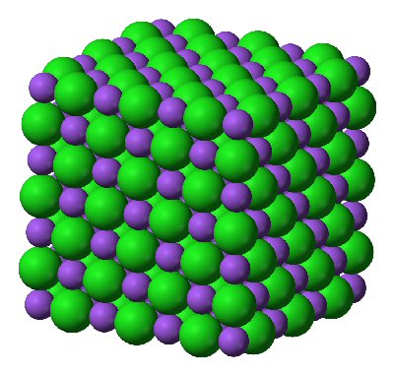
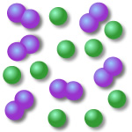

Write a balanced symbol equation for potassium reacting with oxygen to make potassium oxide (K₂O)
(3)

Limestone rock is calcium carbonate (CaCO₃), it will neutralise acids, like hydrochloric to make a solution of calcium chloride (CaCl₂), water and carbon dioxide.
- Write a balanced symbol equation for this reaction.
- Add state symbols for every substance.

(8)
- What 2 things would you observe if you carried out this reaction. (Clue - Look at the state symbols)
1
2
(2)

How many atoms are in Al(NO₃)₂? ___________________
(1)
Total _________/22
Homework – 5

An atom of zinc has an atomic number of 30 and a mass number of 65. How many protons, neutrons and electrons are there in this atom of zinc?
Particle | Number
Proton
Neutron
Electron
(3)

What period is zinc in on the periodic table? _____________
(1)

How many electron shells would you expect zinc to have? _______________
(1)

Zinc exists as isotopes. What is an isotope?
(2)
Copper also exists as isotopes. A sample of copper contains 70% of copper – 63 atoms and 30% of copper – 65 atoms. Use this information to calculate the relative atomic mass of copper in this sample.

(3)

Describe how Mendeleev arranged the elements in his version of the periodic table and state how they are arranged differently in the modern periodic table.
(3)

What group of the periodic table is carbon in? ______________
(1)
What period of the periodic table is chlorine in? ______________
(1)
An element is in period 3 and group 4. How many outer electrons and shells does it have?

Number of electrons on outer shell
Number of electron shells.
(2)
One of the stages in the production of sulfuric acid is reacting sulfur dioxide with oxygen to make sulfur trioxide (SO₃). Write a balanced symbol equation for this reaction.

(3)
Which sub atomic particle is unique to every element? ____________________________
(1)

Total _________/21

Homework – 6

The formula of calcium phosphate is Ca₃(PO₄)₂

How many calcium atoms are there in calcium phosphate? ___________
(1)
How many phosphorus atoms are there in calcium phosphate? ___________
(1)
How many oxygen atoms are there in calcium phosphate? ___________
(1)

Sodium reacts with sulfur to form the compound sodium sulfide. Sodium sulfide is ionic, complete the table below to show whether sodium and sulfur are metals or non-metals.
Element | Metal or non-metal
Sodium
Sulfur
(2)

Describe, in terms of electron transfer, how sodium reacts with sulfur atoms to form sodium sulfide.
Your description should include the charges on the ions formed. (₁₁Na , ₁₆S)

Hint - A famous person once said, ‘a picture is worth a thousand words’.

(4)
The table shows the formulae of several ions, use them to work out the formulae of the following compounds.
Name of ion | Formula of ion
Lithium | Li⁺
Calcium | Ca²⁺
Aluminium | Al³⁺
Nitrate | NO₃⁻
Hydroxide | OH⁻
Sulfate | SO₄²⁻

Lithium sulphate ______________________
Calcium hydroxide ______________________
Aluminium nitrate ______________________
(3)

Sulfur is made of two naturally occurring isotopes: sulfur-32 (95%) and sulfur-34 (5%). Calculate the relative atomic mass of sulfur.

(3)

Sodium will react with chlorine to make sodium chloride. Write a balanced symbol equation for this reaction?
(3)

Total _________/18
Homework – 7
Describe, in terms of electron transfer, how calcium reacts with fluorine atoms to form calcium fluoride. (₂₀Ca , ₉F)
Your description should include the charges on the ions formed.

(4)

The following table gives information about the atoms and ions of magnesium and chlorine. Complete the table.
 | Symbol of |  | Number of electrons in
 | atom | ion | atom | ion
Chlorine | Cl | Cl⁻ | 17
Magnesium | Mg |  |  | 10
(3)
Draw a diagram to show apparatus that could be used to test the electrical conductivity of sodium chloride solution.
(1)
This apparatus was then used to test the conductivity of solid sodium chloride and sodium chloride solution. The results are in the following table. Explain these results by referring to the structure of sodium chloride.
Substance | Conducts electricity
Solid sodium chloride | No
Sodium chloride solution | yes

(6)
Potassium is made of two naturally occurring isotopes: potassium-39 (93%) and potassium-41 (7%). Calculate the relative atomic mass of potassium.

(3)
Total _________/17
Homework 8
Carbon bonds to oxygen to form carbon dioxide, CO_{2.} What type of bonding is this and describe how it is formed?

Type of bond | Description
(3)
What is the electronic configuration of oxygen? _______________
(1)

Draw a dot and cross diagram of a molecule of carbon dioxide. Show outer electrons only.
(2)
Does carbon dioxide have a high or low boiling point? Explain your answer.
Boiling point | Explanation
(2)
Antinomy (Sb) is made of two naturally occurring isotopes: antinomy-121 (57%) and antinomy-123 (43%). Calculate the relative atomic mass of antinomy.

(3)
What charge would the magnesium ion form? _____________________
(1)

Are magnesium carbonate and magnesium nitrate examples of ionic or covalent bonding?

_________________________
(1)

Magnesium carbonate is insoluble in water whereas magnesium nitrate is soluble. Explain what difference, if any, there is in the ability of these substances when mixed with water to conduct electricity.
Substance | Electrical conductivity | Reason
Magnesium nitrate
Magnesium carbonate
(6)
What type of bonding is present within the water molecule and is water a good or poor conductor of electricity?
 | Type of bonding | Good or Poor conductor | Reason
Water
(4)
Total _________/23
Homework 9
Compound | Melting point (ºC) | Boiling point (ºC) | Solubility in water | Conductivity of liquid
Copper sulfate | 200 | decomposes | Soluble | High
Hexane | -95 | 69 | Insoluble | Poor
Octane | -57 | 126 | Insoluble | Poor
Silicon (IV) oxide | 1610 | 2230 | Insoluble | Poor
Sodium chloride | 801 | 1413 | soluble | High

Which compound or compounds in the table are liquids at room temperature (25 ºC)
(1)
Look at the data in the table and decide on the type of bonding in each compound.
Compound | Type of bonding
Copper sulfate
Hexane
Octane
Silicon (IV) oxide
Sodium chloride
(5)
Why does silicon (IV) oxide have such a high melting point?
(3)
Why does octane have a low melting point?
(3)
Why does copper sulfate solution conduct electricity?
(3)
Octane (C₈H₁₈) is also known as petrol and is burnt in car engines. Write a balanced symbol equation for the complete combustion of octane. The products of the reaction are carbon dioxide and water.
(3)
Complete the following table:
Atom or ion | Mass number | Atomic number | Number of
 |  |  | protons | neutrons | electrons
Mg
Cl
Al³⁺
O²⁻
(20)

Total _________/38
Homework – 10

What is the relative formula mass (M_{r}) of? (A_{r}: K – 39, Mn – 55, O – 16, Ca – 40, P – 31, Al – 27, H – 1, Cu – 63.5, N – 14)
- KMnO₄

- Ca₃(PO₄)₂

- Al(OH)₃

- Cu(NO₃)₂

(4)
How many moles of the following are present? (A_{r}: C – 12, O – 16, Ca – 40, H – 1)
- 23g of ethanol (C₂H₅OH)

- 425 g of calcium carbonate (CaCO₃)

(2)
How many molecules of the following are present? (A_{r}: C – 12, O – 16, H – 1 Avogadro constant 6.02 x 10²³)
- 64 g of oxygen (O₂)

- 42 g of ethene (C₂H₄)

(2)
How many moles of the following are present? (A_{r}: C – 12, O – 16, Cu – 63.5,)
- 11 g of carbon dioxide (CO₂)

- 397.5 g of copper(II) oxide (CuO)

(2)
What is the mass, in grams, of? (A_{r}: C – 12, Cl – 35.5, H – 1 Avogadro constant 6.02 x 10²³)
- 6.02 x 10²² molecules of hydrogen chloride (HCl)

- 5.418 x 10²⁴ molecules of ethane (C₂H₆)

(2)
Ammonia (NH₃) is neutralized with sulfuric acid in the production of ammonium sulfate (NH₄)₂SO₄ fertiliser. Write a balanced symbol equation for the formation of ammonium sulfate.
(3)
Iron oxide has the formula Fe₂O₃. Use this to deduce the charge on the Fe ion?

Charge on the Fe ion _______________
(1)

Give the electronic configurations of the ions formed when lithium reacts with oxygen. (₃Li, ₈O).

Lithium ion _____________________
(1)
Oxygen ion _____________________
(1)
Total _________/18
Homework 11

- What is the law of Conservation of Mass?
(1)

- A chemical reaction takes place on a top pan balance and as the reaction takes place the balance shows the mass of the flask is decreasing. What can you conclude?
(1)
- A chemical reaction takes place on a top pan balance and as the reaction takes place the balance shows the mass of the flask is increasing. What can you conclude?

(1)
- In an experiment 2.8 g of iron reacted with 7.1 g of chlorine to form iron chloride. What is the empirical formula of iron chloride?
(A_{r}: Fe – 56, Cl – 35.5)

(3)
- A compound of lead and oxygen was found to contain 0.621 g of lead and 0.096 g of oxygen. Calculate the empirical formula of lead oxide.
(A_{r}: Pb – 207, O – 16)

(3)

- Ammonia has the formula NH₃. Calculate the mass of hydrogen in 50 g of ammonia. Give your answer to 3 significant figures. (A_{r} N = 14, H = 1)

(3)
- How many atoms are present in 2 moles of Aluminium atoms? (Avogadro constant = 6.02x10²³)

(2)
- What is the mass of 2 moles of Aluminium atoms? (²⁷Al)

(1)
- What is the mass, in grams, of 1 Aluminium atom? (Avogadro constant = 6.02x10²³, ²⁷Al)

(2)
Total _________/17

Homework 12

When calcium carbonate (CaCO₃) is heated calcium oxide and carbon dioxide are formed. What is the maximum mass of calcium oxide that can be formed from 50 g of calcium carbonate?
CaCO₃ → CaO + CO₂
(A_{r}: Ca – 40, C – 12, O – 16)

(3)
Magnesium reacts with oxygen to make magnesium oxide.
2Mg + O₂ → 2MgO
(A_{r}: Mg – 24, O – 16)
How many grams of magnesium are required to make 10 g of Magnesium oxide?

(3)
Potassium reacts with oxygen to make potassium oxide.
4K + O₂ → 2K₂O
(A_{r}: K – 39, O – 16)
How many kilograms of potassium oxide are made from 19.5 Kg of potassium?

(3)
40 tonnes of iron oxide (Fe₂O₃) is displaced by 21 tonnes of carbon monoxide (CO) to make 28 tonnes of iron and 33 tonnes of carbon dioxide. What is the stoichiometry of this reaction? (A_{r} Fe = 56, C = 12, O =16)

_____ iron oxide + _____ carbon monoxide → _____ iron + _____ carbon dioxide
(2)
A compound contains 39.7% of copper and 20% of sulphur by mass, the rest being oxygen.
Use this information to show that the empirical formula of the compound is CuSO₄ (A_{r} Cu = 63.5, S = 32, O = 16)

(3)
Complete the following table:
Atom or ion | Mass number | Atomic number | Number of
 |  |  | protons | neutrons | electrons
Li
Ar
Mg²⁺
N³⁻
(20)

Total _________/34
Homework 13

Explain how distillation can be used to obtain a sample of drinking water from salt water. As part of your explanation include:
- A labelled diagram.
- A description of how the particle movement changes with the change of state.
(6)

Draw a diagram of the apparatus used for chromatography. Explain why when using chromatography to analyse the different inks that make up a felt tip pen colour:
- The filter paper needs to be marked up in pencil first.
- The solvent front needs marking with a pencil line once the filter paper is taken out of the water.
Include labels: stationary phase, mobile phase
(6)
The table shows the formulae of several ions, use them and the periodic table to work out the formulae of the following compounds.
Name of ion | Formula of ion
Nitrate | NO₃⁻
Hydroxide | OH⁻
Sulfate | SO₄²⁻

Calcium sulfate ______________________
Sodium sulfide ______________________
Aluminium hydroxide ______________________
Iron (III) nitrate ______________________
(4)
How many atoms are present in 2 moles of hydrogen gas (H₂). (Avogadro constant = 6.02x10²³)

(2)
How many molecules are present in 2 moles of hydrogen gas (H₂) (Avogadro constant = 6.02x10²³)

(2)
What is the mass, in grams, of 2 molecules of hydrogen gas (H₂) (Avogadro constant = 6.02x10²³, Ar H = 1)

(2)
What is the mass, in grams, of 1 hydrogen atom? (Avogadro constant = 6.02x10²³, Ar H = 1).

(2)

Total _________/24

Homework 14

Acids can react with:

- Metal
- Meal oxides
- Metal hydroxides
- Metal carbonates

In each case state the products of the reaction:

Metal + acid →
Metal oxide + acid →
Metal hydroxide + acid →
Metal carbonate + acid →
(4)

The reactions above are examples of ________________________
(1)
Complete the following equations:

Zinc + sulfuric acid →
Copper oxide + nitric acid →
Magnesium hydroxide + hydrochloric acid →
Calcium carbonate + sulfuric acid →

(4)

Sketch a graph showing how the pH of hydrochloric acid would change as calcium oxide were added to it. Explain why the pH doesn’t rise in a proportional manner.
(6)

What mass of carbon dioxide is produced from burning 3200 g of methane (CH₄)? (A_{r} C = 12, O = 16, H = 1)
CH₄ + 2O₂ CO₂ + 2H₂O
(3)
An ink spot ran 34 mm on a filter paper, the solvent ran exactly 6 cm. Calculate the R_{f} of this ink to 2 decimal places.
(3)

What is the formula of the compound made of iron (III) ions and hydroxide ions.

(2)

Total _________/23
Homework 15

List all the equipment needed for a titration.

(2)

When titrating an acid with an alkali to make a soluble salt explain clearly how the alkali will be measured out.
(2)

Write a detailed method for how once the apparatus has been set up a pure sample of sodium chloride can be produced from hydrochloric acid and sodium hydroxide.

(6)
Magnesium carbonate, by mass, contains 22.22% magnesium, 11.11% carbon and 44.44% oxygen. What is the empirical formula of magnesium carbonate? (A_{r} Mr = 24, C = 12, O = 16).

(3)
How many atoms are present in 3 moles of carbon dioxide? (Avogadro constant = 6.02 x 10²³?

(3)
What mass of carbon dioxide is made when 26.5 g sodium carbonate is neutralised by excess nitric acid? (A_{r} Na= 23, C = 12, O = 16)
Na₂CO₃ + 2HNO₃ 2NaNO₃ + CO₂ + H₂O

(3)
Look at the solubility rules (these need learning) and state whether sodium carbonate and sodium nitrate are soluble or insoluble.
Soluble or insoluble
Sodium carbonate
Sodium nitrate
(2)

Total _________/21

Homework – 16
Copper carbonate is insoluble in water whereas copper nitrate is soluble. Describe how a pure dry sample of copper nitrate can be produced from copper carbonate.
(6)

Hydrochloric acid can be electrolysed using the following apparatus:
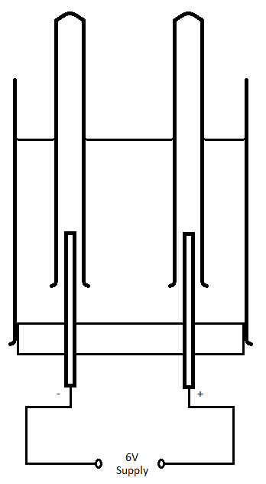
What happens during electrolysis?
(1)
Is the power supply direct current or alternating current? _________________
(1)
What are the names given to the positive and negative electrodes?
Positive electrode: _________________ Negative electrode: _________________ (1)
What gases are formed at the positive and negative electrodes?
 | Anode | Cathode
Gas
(2)

What mass of hydrogen gas is produced when 5 moles of hydrochloric acid are electrolysed? (A_{r} H = 1)
2HCl H₂ + Cl₂

(3)

Water can be electrolysed using the following apparatus:
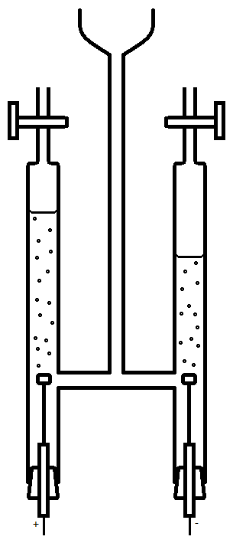
What gases are formed at the positive and negative electrodes and how would you test for them?
 | Positive electrode | Negative electrode
Gas
Test

(6)
Compare and use the reaction equations to explain the relative proportions of gases produced in the two experiments:
(4)

Total _________/24

Homework – 17

Copper can be displaced from its oxide by heating with sodium.
CuO + 2Na → Na₂O + Cu
In this reaction state what is oxidised and what is reduced.
Oxidised | Reduced
(2)
What mass of sodium is needed to produce 124 g of sodium oxide? (A_{r} Na = 23, O = 16)
(3)

Electrolysis and heating with carbon are 2 methods of reduction.

What is reduction?
(1)
Why is iron extracted from its ore by heating with carbon whereas aluminium is extracted using electrolysis?
(6)
When iron is extracted from iron oxide (Fe₂O₃) it is heated with carbon which forms carbon dioxide as well as the iron. Write a balanced symbol equation for this reaction.
(3)

What mass of iron is produced from 20 tonnes of iron oxide? (A_{r} Fe = 56, O = 16)
(3)
11 grams of another oxide of iron contains 7 g of iron. Calculate the empirical formulae of this compound (A_{r} Fe = 56, O = 16)
(3)

Total _________/21

Homework Scores:
Homework | Score | Knowledge Test | Score
1 | __________/20 | 1 | __________/5
2 | __________/15 | 2 | __________/5
3 | __________/20 | 3 | __________/5
4 | __________/22 | 4 | __________/5
5 | __________/21 | 5 | __________/5
6 | __________/18 | 6 | __________/5
7 | __________/17 | 7 | __________/5
8 | __________/23 | 8 | __________/5
9 | __________/38 | 9 | __________/5
10 | __________/18 | 10 | __________/5
11 | __________/17 | 11 | __________/5
12 | __________/34 | 12 | __________/5
13 | __________/24 | 13 | __________/5
14 | __________/23 | 14 | __________/5
15 | __________/21 | 15 | __________/5
16 | __________/24 | 16 | __________/5
17 | __________/21 | 17 | __________/5

