Year 11 Chemistry Workbook

- Section 1 – 5 quick questions Page 2

- Section 2 – Calculation License and Bonding Summary Page 21

- Section 3 - Course Content

  - Topic 6 – Groups in the periodic table Page 29
- Topic 7 – Rates of reaction Page 45
- Topic 7 – Heat energy changes in chemical reactions Page 70
- Topic 8 – Fuels Page 84
- Topic 8 – Earth and atmospheric science Page 109

- Section 4 – Glossary Page 119

- Section 5 – Essential Knowledge Questions and Answers to be learnt Page 125

- Section 6 – Homework Page 133
Homework is due once per fortnight and every question must be attempted. If you are stuck, you should watch the video or seek help from your teacher.

Exam Information (DOUBLE AWARD ONLY)

Paper | Duration | Topics Covered
1 | 1 hour and 10 minutes | Topics 0-4 (Book 1 (year 10 book) - all of year 10)
2 | 1 hour and 10 minutes | Topic 0 + 1 (Book 1. Pages 12-86)  Topics 6-8 (Book 2 – year 11) THIS BOOK

5 Quick Questions
Lesson 1
- What is the formula of chlorine?
- Write a balanced symbol equation for iron reacting with bromine to make iron (III) bromide.
- What type of bonding is present in the chlorine molecule?
- What type of bonding is present in iron (III) bromide?
- A sample of rubidium is comprised of 72% rubidium-85 and 28% rubidium-87, what is the relative atomic mass of this sample?

Lesson 2
- Describe an ionic bond.
- Describe a covalent bond.
- Describe a metallic bond.
- Describe giant molecular bonding.
- 0.115g of element X reacts with 0.04 g of element Y what is the empirical formula of the product? (A_{r} X = 23, Y = 16)

Lesson 3
- What is an isotope?
- Define relative atomic mass.
- Why does chlorine have a relative atomic mass (of 35.5) that’s not a whole number?
- Use a periodic table to calculate how many protons neutrons and electrons are in potassium?
- What is the percentage by mass of aluminium in aluminium oxide (Al₂O₃)? (A_{r} Al = 27, O = 16)
Lesson 4
- How many atoms present in Fe₂(SO₄)₃?
- How did Dimitri Mendeleev arrange his periodic table?
- Name an element in period 3 that isn’t in group 3.
- True or false; elements in the same period have similar properties.
- What is the concentration, in g dm⁻³, of copper sulfate solution formed when 40 g of copper sulfate is dissolved in 200 cm³ of water?

Lesson 5
- What are the charges of each sub-atomic particle?
- What is the mass of each sub-atomic particle?
- What is an ion?
- Use a periodic table to calculate the number of protons, neutrons and electrons in the Na⁺ ion.
- A hydrocarbon has an empirical formulae of CH₂ and a relative formula mass of 112, what is its molecular formula? (A_{r} C = 12, H = 1)

Lesson 6
- What is an isotope?
- What is the atomic number?
- What is the mass number?
- Write a balanced symbol equation for the Haber process.
- What is the mass, in grams, of 1 chlorine molecule? (A_{r} Cl = 35.5)

Lesson 7
Complete the next 2 sentences:
- All elements in the same group of the periodic table have the same …….
- All elements in the same period of the periodic table have the same …….
- Name a metal that forms an ion with a ²⁺ charge.
- What is the electronic configuration of an element in period 3 and group 2?
- Calculate the amount, in moles, of 185 g of calcium hydroxide, Ca(OH)₂. (A_{r} Ca = 40, O = 16, H = 1)

Lesson 8
- Draw the electronic configuration of the calcium ion and state the charge (₂₀Ca).
- Draw a diagram to show the bonding in lithium oxide (₃Li, ₈O).
- What is the formula of lithium oxide?
- Write a balanced symbol equation for the thermal decomposition of lead nitrate, Pb(NO₃)₂, to form lead oxide, PbO, nitrogen dioxide and oxygen.
- Calculate the empirical formula of lead chloride when 59.6 g of lead reacts with 40.4 g of chlorine. (A_{r} Pb = 207, Cl = 35.5)

Lesson 9
- What is the formula of magnesium oxide?
- Write a balanced symbol equation for the reaction of magnesium with oxygen.
- Calculate the amount, in moles, of 8 g of oxygen, O₂. (A_{r} O = 16)
- How many moles of magnesium oxide are formed when 8 g of oxygen reacts with an excess of magnesium?
- Calculate the mass of magnesium oxide formed when 8 g of oxygen reacts with an excess of magnesium.

Lesson 10
- What is the formula of lithium oxide?
- Write a balanced symbol equation for the reaction of lithium with oxygen.
- Calculate the amount, in moles, of 14 g of lithium. (A_{r} Li = 7)
- How many moles of lithium oxide are formed when 14 g of lithium reacts with an excess of oxygen?
- Calculate the mass of lithium oxide formed when 14 g of lithium reacts with an excess of oxygen.

Lesson 11
- What is the formula of magnesium chloride?
- What is the formula of Iron (III) carbonate. (Carbonate ion = CO₃²⁻)
- Draw a fully labelled diagram to show the bonding in magnesium chloride.
- Does magnesium chloride conduct electricity?
- Calculate how much magnesium chloride is made from 96 g of magnesium and excess chlorine. (A_{r} Mg = 24, Cl = 35.5) Mg + Cl₂ MgCl₂

Lesson 12
- Write a balanced symbol equation for the burning of hydrogen sulphide (H₂S) gas in air to form sulfur dioxide gas and water.
- Add state symbols to the equation.
- Draw a diagram to show the bonding in hydrogen sulphide.
- Why is hydrogen sulfide a gas at room temperature?
- Explain why hydrogen sulfide is a poor conductor of electricity.

Lesson 13
- What is an ionic bond?
- What is a covalent bond?
- How is a simple molecule different to a giant molecule?
- Explain why diamond has a high melting point.
- Explain why diamond is used in cutting tools.

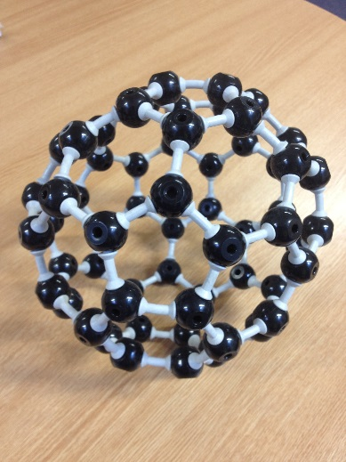
Lesson 14
- Why is graphite used in electrodes?
- Why is graphite used as a lubricant?
- What type of bonding is present in methane (CH₄), graphite and fullerenes (C₆₀)?
- Do fullerenes conduct electricity?
- Why do metals have a high melting point?

Lesson 15
- How many atoms are present in Ca(NO₃)₂?
- Explain if calcium nitrate (s) conduct electricity?
- Explain if calcium nitrate (l) conducts electricity?
- What is the charge on the calcium ion?
- 50g of calcium nitrate is dissolved in 400 cm³ of water, what is the concentration in g dm⁻³?

Lesson 16
Draw a diagram showing the bonding in: (₄Be, ₉F, ₈O, ₁H, ₆C)
- Beryllium fluoride.

- Methane

- Oxygen

- Carbon dioxide

- What is the name of the compound formed when aluminium reacts with nitrogen?

Lesson 17
- Describe the structure of a metallic substance.
- Calculate the relative formula mass of magnesium hydroxide, Mg(OH)₂ . (A_{r} Mg = 24, O = 16, H = 1)
- What is chromatography?
- In chromatography, what is the stationary phase?
- Calculate the R_{f} of an ink spot that runs 24mm when the solvent runs 5.6 cm. Give your answer to 2 significant figures.

Lesson 18
- How would you separate a mixture of liquids with similar boiling points?
- Is the separation of these liquids a chemical reaction?
- How would you make a sample of river water safe for drinking?
- Which ion in solution are acids a source of?
- A sample of copper contains 70% of copper – 63 atoms and 30% of copper – 65 atoms. Use this information to calculate the relative atomic mass of copper in this sample.

Lesson 19
- Which ion in solution are alkalis a source of?
- Write an ionic equation for neutralisation.
- An acid has a hydrogen ion concentration of 0.01 mol dm⁻³ and a pH of 2. The acid is diluted until it has a pH of 5, what is the concentration of hydrogen ions?
- What are the effects of acids and alkalis on litmus, methyl orange and phenolphthalein?
- What is the concentration, in g dm⁻³, of sodium hydroxide when 46 g is dissolved in 150 cm³ of water? Give your answer to 2 significant figures.

Lesson 20
- Copper (II) carbonate (CuCO₃) is a green powder. Write a balanced symbol equation when it reacts with sulfuric acid.
- Add state symbols to this reaction equation.
- Give 2 observations when this reaction is carried out.
- Sketch a graph of the pH changing as copper carbonate is slowly added to sulfuric acid.
- Heating 61.75 g of copper carbonate forms 22 g of carbon dioxide. What mass, in grams, of copper oxide is formed? CuCO₃ CuO + CO₂

Lesson 21
- Write a balanced symbol equation for the reaction of copper (II) oxide with sulfuric acid.
- Add state symbols to this reaction equation.
- Explain when preparing a pure dry sample of copper sulfate why an excess of copper oxide is used.
- How is the excess copper oxide removed from the copper sulfate solution?
- Copper can be obtained through phytoextraction. 12 g of copper can be obtained from 3.2 kg of plant material. What is the percentage by mass of copper in the plant material?

Lesson 22
- What is electrolysis?
- Draw and label the apparatus needed for the electrolysis of aqueous copper sulphate.
- What type of substances undergo electrolysis? Explain why.
- Write a half equation for the formation of copper from copper ions (Cu²⁺).
- Calculate the number of atoms in 3 moles of H₂O. (Avogadro constant = 6.02 x 10²³)
Lesson 23
- What is the difference between NaCl _{(l)} and NaCl _{(aq)}?
- What are the products of the electrolysis of NaCl _{(l)}?
- What are the products of NaCl _{(aq)}?
- Write a half equation for the formation of chlorine from the chloride ion.
- What mass of chlorine can be formed from 175.5 kg of sodium chloride? (A_{r} Na = 23, Cl = 35.5) 2NaCl 2Na + Cl₂

Lesson 24
- What are the products of the electrolysis of aqueous copper sulfate?
- Write a half equation for the formation of hydrogen from hydrogen ions.
- What is the electronic configuration of the oxide ion? (₈O)
- What is an isotope?
- How many moles of copper sulfate (CuSO₄) are needed to make 1 dm³ of a solution with a concentration of 39.875 g dm⁻³? (A_{r} Cu = 63.5, S = 32, O = 16)

Lesson 25
- Write a balanced symbol equation for the electrolysis of water.
- 72 g of water is used, how many moles is this? (A_{r} H = 1, O = 16)
- How many moles of oxygen are formed from the electrolysis of 72 g of water?
- How many grams of oxygen are formed from the electrolysis of 72 g of water?
- Draw a dot and cross diagram to show the bonding in oxygen. (₈O).

Lesson 26
- Is copper oxidised or reduced in the electrolysis of aqueous copper sulfate?
- Is sodium oxidised or reduced in the electrolysis of aqueous sodium chloride?
- How is iron extracted from its ore?
- How is aluminium extracted from its ore?
- How many tonnes of iron are produced from 80 tonnes of Fe₂O₃? (A_{r} Fe = 56, O = 16)

Lesson 27
- What is the relative atomic mass of a sample of iridium that is comprised 37% iridium-191 and 63% iridium-193?
- How did Mendeleev arrange the elements in his version of the periodic table?
- What element has the electronic configuration 2.8.7?
- Draw a diagram showing the bonding when ₄Be reacts with ₉F.
- What is the name of Al₂S₃?

Lesson 28
- How many atoms are present in 0.25 mole of Lithium oxide (Li₂O)? (Avogadro constant = 6.02 x 10²³)
- How many moles are present in 69g lithium oxide? (A_{r} Li = 7, O = 16)
- Does lithium oxide have a high or low melting point?
- Does lithium oxide conduct electricity?
- Write a balanced symbol equation for the reaction of lithium with oxygen.

Lesson 29
- How many molecules are present in 2 moles of carbon dioxide? (Avogadro constant = 6.02 x 10²³)
- How much, in grams, does 1 molecule of carbon dioxide weigh? ((Avogadro constant = 6.02 x 10²³, A_{r} C = 12, O = 16)
- Draw a dot and cross diagram to show the bonding in carbon dioxide.
- Explain why carbon dioxide has a low melting point.
- Explain why carbon dioxide is a poor conductor of electricity.

Lesson 30
- Write a balanced symbol equation for the Haber process?
- What is a, ‘dynamic equilibrium’?
- The forward reaction in the Haber process is exothermic, explain the effect of increasing the temperature on equilibrium.
- Where are the nitrogen and hydrogen for the Haber process obtained from?
- 266 g of nitrogen reacts with 19 g of hydrogen, use this information to prove the formula of ammonia is NH₃ (A_{r} N = 14, H = 1)

Lesson 31
- Why is the Haber process carried out at 200 atm of pressure?
- Under certain industrial conditions 1400 kg of ammonia are produced. If all the nitrogen and hydrogen were converted 8848 kg of ammonia could be formed. What is the percentage yield of these conditions? Give your answer to 2 significant figures.
- What is the effect of adding a catalyst to the equilibrium position?
- Ammonia has the formula NH₃, calculate the percentage by mass of hydrogen in ammonia. (A_{r} N = 14, H = 1).
- What is a covalent bond?
Lesson 32
- Use the periodic table to work out how many protons neutrons and electrons are in the Ca²⁺ ion?
- Write a balanced symbol equation for ammonia reacting with oxygen to make nitrogen monoxide and water.
- What mass of titanium chloride is needed to produce 12 g of titanium? (A_{r} Ti = 48, Cl = 35.5) TiCl₄ + 4Na Ti + 4NaCl
- What is the electronic configuration of the sodium ion? (₁₁Na)
- An element has the electronic configuration 2.8.4. What group and period of the periodic table is it found in?

Lesson 33
- Name the halogen in period 2.
- Name the noble gas in period 1.
- Name a metal that forms a ¹⁺ ion and state the name and number of the group it is found in.
- Name a non-metal in period 2 that forms a ²⁻ ion.
- 24 g of sodium hydroxide is added to 350 cm³ of water. What is the concentration, in g dm⁻³, of the solution? Give your answer to 2 significant figures.

Lesson 34
- Why is potassium more reactive than lithium?
- Write a balanced symbol equation for iron reacting with chlorine to make iron (III) chloride.
- Write a balanced symbol equation for sodium bromide (NaBr) reacting with chlorine.
- State what is oxidised in the reaction above (question number 3).
- Sodium thiosulfate contains 29.1% sodium, 40.5% sulphur, and 30.4% oxygen. What is the empirical formula of sodium thiosulfate? (A_{r} Na = 23, S = 32, O = 16)

Lesson 35
- Why are the noble gases inert?
- Antinomy (Sb) is made of two naturally occurring isotopes: antinomy-121 (57%) and antinomy-123 (43%). Calculate the relative atomic mass of antinomy.
- Aluminium carbonate is made from aluminium (Al³⁺) and carbonate ions (CO₃²⁻) what is its formula?
- Write a balanced symbol equation for the reaction of aluminium and iodine.
- Draw a fully labelled energy level diagram for an endothermic reaction.

Lesson 36
- Write a balanced symbol equation for the reaction of hydrogen and chlorine.
- What type of bonding is present in hydrogen?
- What is a definition of this type of bonding?
- Does hydrogen have a high or low boiling point?
- Use the following bond energies to calculate the nett energy transfer of this reaction and decide whether it is exothermic or endothermic. (H-H = 436 KJ mol⁻¹, Cl-Cl = 243 KJ mol⁻¹, H-Cl = 432 KJ mol⁻¹)

Lesson 37
- Why does increasing temperature speed up the rate of reaction?
- Why does increasing the concentration of a reactant speed up the rate of reaction?
- Why does using smaller pieces of a solid reactant speed up the rate of reaction?
- Why does adding a catalyst speed up the rate of reaction?
- Calculate the mass of aluminium hydroxide that must be heated in order to obtain 10 g of aluminium oxide? (A_{r} Al = 27, O = 16, H = 1) 2Al(OH)₃ Al₂O₃ + 3H₂O
Lesson 38
- What is a hydrocarbon?
- What is a homologous series?
- Draw propane
- Draw propene
- How many molecules of methane are present in 8 g. (A_{r} C = 12, H = 1. Avogadro constant = 6.02 x 10²³.)

Lesson 39
- What are the products of complete combustion of a hydrocarbon?
- What are the products of incomplete combustion of a hydrocarbon?
- Write a balanced symbol equation for the complete combustion of ethane.
- What is a fuel cell?
- Write a balanced symbol equation for the reaction of titanium oxide (TiO₂) with carbon and chlorine to make titanium chloride, carbon monoxide and carbon dioxide.

Lesson 40
- Why is carbon monoxide toxic?
- What were the first gases present in the earth’s atmosphere?
- How is carbon dioxide removed from the atmosphere?
- How is acid rain formed?
- How many tonnes of iron are required to produce 10 tonnes of copper? Give your answer to 3 significant figures. (A_{r} Fe = 56, Cu = 63.5)
Fe + CuSO₄ FeSO₄ + Cu

Blank Pages for Notes

Blank Pages for Notes

Blank Pages for Notes

Blank Pages for Notes

Calculation Licence.
You must answer each of these questions correctly before sitting your GCSE
Calculate the relative atomic mass.
A sample of silicon contains
92.2% of silicon-28 atoms
4.7% of silicon-29 atoms
3.1% of silicon-30 atoms.
Use this information to calculate the relative atomic mass of this sample of silicon.

Counting the number of atoms.
Count the number of atoms in Aluminium nitrate Al(NO₃)₃.

Calculate relative formula mass.
Calculate the relative formula mass of ammonium nitrate, NH₄NO₃.
(relative atomic masses: H = 1, N = 14, O = 16).

Calculating percentage
1 kg of spring water contains 66.2 mg of calcium ions. What is the percentage by mass of calcium ions in the water. Give your answer to 2 significant figures.

Empirical Formulae

A 46.4 g sample of iron oxide contains 33.6 g of iron. Calculate the empirical formulae of this oxide.

Empirical formulae and relative formula mass
A hydrocarbon contains 3 g of carbon and 0.5 g of hydrogen. The relative formula mass of this molecule is 56. Calculate the molecular formula of this hydrocarbon.
(relative atomic masses: H = 1, C = 12).

Calculating Quantities
The equation for the electrolysis of aluminium oxide is
2Al₂O₃ 4Al + O₂
Calculate the maximum mass of aluminium that can be obtained from 510 tonnes of aluminium oxide.
(relative atomic masses: O = 16, Al = 27).

Concentration (g dm⁻³)
Sodium chloride solution was prepared by dissolving 9.11 g of solid in water and making the volume up to 200 cm³.
Calculate the concentration of sodium chloride in g dm⁻³. Give your answer to 3 significant figures.

Using the Avogadro constant.
Calculate the number of molecules in 5 moles of glucose, C₆H₁₂O₆.
(Avogadro constant = 6.02 x 10²³)

A beaker of water contains 4.214 x 10²⁴ molecules. How many moles of water are present?
(Avogadro constant = 6.02 x 10²³)

Calculating Moles
How many moles of ammonia, NH₃ are present in a 51 g sample?
(relative atomic masses: H = 1, N = 14).

Avogadro constant and moles
How many molecules are present in a 23 g sample of ethanol, C₂H₅OH?

Stoichiometry
The equation for the production of ammonia is:
N₂ (g) + 3H₂ (g) ⇌ 2NH₃ (g)
How many moles of nitrogen would react with 12 moles of hydrogen?

Assuming a 100% yield, how many moles of ammonia would be produced from 12 moles of hydrogen?

Calculating R_{f}
In a chromatography experiment a coloured substance in a food dye moved 2.1 cm when the solvent front moved 2.6 cm.
Calculate the R_{f} value for this substance, giving your answer to 2 significant figures.

Law of Conservation of Mass
Copper oxide thermally decomposes on heating to form copper oxide and carbon dioxide.
CuCO₃ (s) CuO (s) + CO₂ (g)
61.75 g of copper carbonate was heated. 39.75 g of solid remained, calculate the mass of carbon dioxide produced.

Concentration (mol dm⁻³) (Triple science only)
Copper sulfate, CuSO₄ solution was prepared by dissolving 39.875 g of solid in water and making the volume up to 100 cm³.
Calculate the concentration of copper sulfate in mol dm⁻³. (relative atomic masses: Cu = 63.5, S = 32, O = 16).

Titrations (Triple science only)
Sodium hydroxide solution was titrated with dilute hydrochloric acid. The results of the experiment were:
Volume of sodium hydroxide solution = 25.0 cm³
Volume of 0.25 mol dm^{–3} hydrochloric acid used:
1st titration | 22.4 cm³
2nd titration | 23.7 cm³
3rd titration | 22.6 cm³
(i) State the volume of hydrochloric acid that must be used to calculate the concentration of sodium hydroxide solution.

Volume of hydrochloric acid = _______________ cm³
(ii) Use your answer to part (i) to calculate the concentration of sodium hydroxide solution, NaOH, in mol dm^{–3}.
NaOH + HCl → NaCl + H₂O

Percentage yield (Triple science only)
It is possible to turn ethene into ethanol by reacting it with steam. This is done in factories on an industrial scale, one such factory takes 2 tonnes of ethene and produces 2.97 tonnes of ethanol. Chemists at the factory have calculated that 2 tonnes of ethene should produce 3.28 tonnes of ethanol. What is the percentage yield of this reaction? Answer to 2 significant figures.

Atom economy (Triple science only)

Copper (II) oxide is reduced by smelting with carbon to produce copper. Calculate the atom economy of the production of copper.

2CuO + C 2Cu + CO₂
(relative atomic masses: Cu = 63.5, C = 12, O = 16).

Calculating the volume of gas produced. (Triple science only)
The hydrogen used in the Haber process is produced by reacting methane with steam.
CH₄ + 2H₂O CO₂ + 4H₂
What volume of hydrogen is produced from 10 dm³ of methane?

Calculations involving solutions and gases (Triple science only)
What volume of hydrogen is produced when 50 cm³ of 0.25 mol dm⁻³ nitric acid reacts with excess magnesium?
Mg + 2HNO₃ Mg(NO₃)₂ + H₂
1 mole of any gas at room temperature and pressure occupies a volume of 24 dm³

Blank Pages for Notes

Bonding Summary
 | Ionic | Covalent |  |  | Metallic
Description
Atoms Involved
Example
Charges
Formula
Name
Structure |  | Simple Molecular | Giant Molecular
 |  |  | Diamond | Graphite
Melting Point
Electrical Conductivity
Solubility in water

Topic 6 - Content and Checklist

For each content point put a tick next to it firstly when you understand it and secondly when you have learnt it. If you don’t understand a content point you must ask your teacher.

 | Content | Understand it | Learnt it
1 | Identify on the periodic table the position of: group 1 (the alkali metals), group 7 (the halogens), group 0 (the noble gases).
2 | Learn that alkali metals: are soft and have low melting points.
3 | Describe the reactions of lithium, sodium and potassium with water and learn the reaction equations.
4 | Use the observations of the reactions of lithium, sodium and potassium with water to predict the reactivity of the other alkali metals further down the group.
5 | Use the electronic configuration of lithium, sodium and potassium to explain the trend in reactivity.
6 | Learn the colours and physical states (solid, liquid or gas) of chlorine, bromine and iodine at room temperature.
7 | Know the pattern of melting/boiling point and colour intensity as you go down the halogen group. Can you use this trend to make predictions about a halogen with unknown data?
8 | Learn the chemical test for chlorine.
9 | Describe the reactions of the halogens (chlorine, bromine and iodine) with metals to form metal halides (be able to write balanced symbol equations). Use the pattern to predict the reactions of other halogens.
10 | Learn the equations for the reaction of hydrogen with chlorine, bromine and iodine to form hydrogen halides. Learn that when these hydrogen halides are added to water and an acidic solution is formed. This is also true for the other halogens.
11 | Learn the trend in reactivity within the halogen group. Understand this can be observed by the reactions of halogens with halide ions in aqueous solutions. Be able to use displacement theory to predict reactions of other halogens including astatine.
12 | Write balanced symbol equations for displacement reactions of halogens; then identify what is oxidised and reduced. Also say what gains electrons and what loses electrons. Use this information to explain why displacement reactions are redox reactions.
13 | Use the electronic configuration of fluorine and chlorine to explain the trend in reactivity of the halogen group.
14 | Use the electronic configuration of helium, neon and argon to explain why the noble gases are inert (don’t react with anything).
15 | Learn properties and uses of argon, neon and helium; use these properties to explain why the gas is suitable for a particular use. Properties to be included are inertness, low density and non-flammability.
16 | Use the physical properties of some noble gases and their position in the periodic table to predict the physical properties of other noble gases. Be able to identify the trend in the group from the physical properties.

Label the periodic table below by:

- Shading the alkali metals purple.
- Shading the halogens red.
- Shading the noble gases grey.

The Alkali Metals

In what group of the periodic table are the alkali metals? ________________________

What are the first 3 members of the group?

- __________________________
- __________________________
- __________________________

Are the alkali metals soft or hard and how do you know?
Soft or hard? | How do you know?

Do they have high or low melting points and how do you know?
Melting point | How do you know?

Describe what you see when lithium reacts with water (3 marks)

What is the pH of the resulting solution _______ and is it acid or alkali? _____________

What ion does an alkali produce in water? ________________

Does sodium react faster or slower? ___________________________

Describe what you see when potassium reacts with water (3 marks)

Complete the reaction equations:
Lithium + water | Word
 | Symbol
Sodium + water | Word
 | Symbol
Potassium + water | Word
 | Symbol

What is a test for hydrogen?
What is the pattern of reactivity in the alkali metal group?

How would you expect rubidium to react with water?

Draw the electronic configuration of lithium, sodium and potassium.
₃Li | ₁₁Na | ₁₉K
Use the diagrams showing the electronic configuration to explain why potassium is more reactive than lithium.

When lithium reacts with water it forms lithium hydroxide (LiOH) and hydrogen.
Use your knowledge from year 10 to draw diagrams to show the bonding in each substance.
 | Lithium | Water | Lithium hydroxide | Hydrogen
Type of bonding
Formula
Diagram
Melting Point

Year 10 revision.
Explain why sodium chloride (aq) will conduct electricity. What will be produced when this occurs? Where will the products be formed? Write half equations to explain a substance that is being oxidised and another that is being reduced.
Why NaCl(aq) conducts electicity.
Product 1
Product 2
Product 3
Oxidation half equation
Reduction half equation

The Halogens
In what group of the periodic table are the halogens? ________________

What is the test for chlorine?

Name (in order of atomic number) | Colour | Physical State | Colour intensity trend | Melting point trend | Reactivity trend
Fluorine (F)

Complete the following word and symbol equations for the reactions of metals with halogens.

Sodium + Chlorine | Word | ____________ + ____________ __________ ___________
 | Symbol
Magnesium + Fluorine | Word | ____________ + ____________ __________ ___________
 | Symbol
Formation of Copper (II) Chloride | Word | ____________ + ____________ __________ ___________
 | Symbol
Formation of Iron (III) Chloride | Word | ____________ + ____________ __________ ___________
 | Symbol

Complete the following word and symbol equations for the reactions of hydrogen with halogens:

Hydrogen + Fluorine | Word
 | Symbol
Hydrogen + Chlorine | Word
 | Symbol
Hydrogen + Bromine | Word
 | Symbol
Hydrogen + Iodine | Word
 | Symbol

Use your knowledge from year 10 to draw pictures to show the bonding in chlorine, magnesium fluoride and hydrogen chloride.
 | Chlorine | Magnesium fluoride | Hydrogen chloride
Type of bonding
Formula
Diagram
Melting Point
Electrical conductivity

Is hydrogen fluoride acidic or alkali when dissolved in water? ________________
Is hydrogen chloride acidic or alkali when dissolved in water? ________________
Is hydrogen bromide acidic or alkali when dissolved in water? ________________
Is hydrogen iodide acidic or alkali when dissolved in water? ________________

Displacement reactions of halogens

The most reactive halogen always takes the cation

Complete the halogen reactivity series
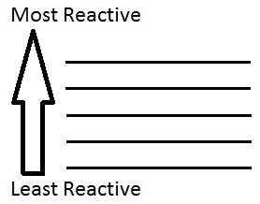
Label the reactants with the following labels:

- Most reactive halogen
- Least reactive halogen
- Cation

Sodium iodide + chlorine →

Now use the rule above and the halogen reactivity series to predict the products of the reaction

Sodium iodide + chlorine = ___________ ___________ + _____________
Now complete the following word and symbol equations, if there is no reaction state ‘no reaction’:
Potassium iodide + Chlorine | Word
 | Symbol
Lithium bromide + Chlorine | Word
 | Symbol
Sodium fluoride + Chlorine | Word
 | Symbol
Sodium bromide + Iodine | Word
 | Symbol
Calcium bromide + Fluorine | Word
 | Symbol

Oxidation – Reduction

What is the definition for oxidation and reduction that involves gaining and losing electrons? Remember OILRIG

Oxidation
Reduction

For the displacement reaction below state the type of bonding and the charges present for each substance.
Lithium chloride + fluorine → lithium fluoride + chlorine
Type of bond
Charges

Look at the way the charges have changed on each element and decide which elements have gained electrons and which elements have lost electrons.

Lost electrons
Gained electrons

Now use this information to say what is oxidised and what is reduced when lithium chloride reacts with fluorine.
Lithium chloride + fluorine → lithium fluoride + chlorine
oxidised
reduced

Write an explanation that details why displacement reactions are redox processes.

Go through the same process for each of the following displacement reactions. At the end you should state what is oxidised and what is reduced.
1
Lithium chloride + fluorine → lithium fluoride + chlorine
oxidised
reduced

2
Sodium bromide + chlorine → sodium chloride + bromine
oxidised
reduced

3
Potassium iodide + chlorine → .
oxidised
reduced

4
Potassium bromide + iodine → .
oxidised
reduced
Reactivity of halogens
Draw the electronic configuration of fluorine and chlorine.
₉F | ₁₇Cl
Use the diagrams showing the electronic configuration to explain why fluorine is more reactive than chlorine.

The noble gases
What is the group number of the noble gases? ______________________________
What are the members of the noble gas group?
- _______________________
- _______________________
- _______________________
- _______________________
- _______________________
- _______________________
Draw the electronic configuration of Helium, Neon and Argon.
₂He | ₁₀Ne | ₁₈Ar

What does the word inert mean? _________________________

Why are the noble gases inert?

Which noble gas would you use for filling air ships and why?

Why would noble gases be used in filament light bulbs?

Homework: Research why Argon is used in welding and Neon in lighting
Use the data in the table below to predict the boiling point and density of Argon by plotting a graph.
Property | Helium | Neon | Argon | Krypton | Xenon | Radon
Atomic number | 2 | 10 | 18 | 36 | 54 | 86
Density (g/dm³) | 0.1786 | 0.9002 |  | 3.708 | 5.851 | 9.97
Boiling point (Kelvin (K)) | 4.4 | 27.3 |  | 121.5 | 166.6 | 211.5

The graph of atomic number against density is has been drawn for you, use this to estimate the density of Argon.

Estimate the density of Argon _____________________________

To estimate the boiling point of Argon you will need to plot your own graph of atomic number against boiling point.

Blank Pages for Notes
Topic 7 – Rate of reaction

For each content point put a tick next to it firstly when you understand it and secondly when you have learnt it. If you don’t understand a content point you must ask your teacher.

 | Content | Understand it | Learnt it
1 | Know how to perform rate of reaction experiments which investigate the effects of changing the conditions of reactants by:  - Measuring the production of carbon dioxide when calcium carbonate reacts with hydrochloric acid.  - Watching the colour change in the reaction between sodium thiosulfate and hydrochloric acid
2 | Look at the reactants/products and the state symbols in a reaction equation and make a suggestion as to how the rate of reaction could be monitored.
3 | Learn that for a reaction to occur then:  - Particles must collide  - The collision must have enough energy.  Be aware that if you can increase either or both of these factors then the rate of reaction will increase.
4 | Explain using particle theory how:  - Concentration and pressure  - Temperature  - Surface area  - Catalyst  Affect the rate of a chemical reaction
5 | Be able to interpret (understand and explain) rate of reaction graphs when the reactants (or products) mass, volume or concentration is plotted against time.
6 | Learn that a catalyst is a substance that speeds up a chemical reaction without being changed itself. At the end of the reaction the catalyst will have the same mass and be chemically unchanged.
7 | Explain how a catalyst works. This explanation must include ‘activation energy’.
8 | Learn that enzymes are biological catalysts and that enzymes are used to produce alcoholic drinks.

Rate of Reaction

What is another word for rate? __________________________

Starter - name 2 very fast reactions and 2 very slow reactions.
Fast | Slow
1) | 1)
2) | 2)

Name a reaction that we might want to speed up and say why.

Name a reaction that we might want to slow down and say why.

Explaining Rate

For a reaction to occur 2 things must happen:

- _____________________________________________________________

- _____________________________________________________________
The speed of a reaction can be affected by 4 different factors (You must remember this!):
- Concentration (or pressure if the reactants are gases)
- Temperature
- Surface area (of solid reactants)
- Catalyst
For each of the factors that affect rate of reaction state whether it does this by mainly changing either the number of collisions or the energy of the collisions.
Factor | Number of collisions or energy of collisions
Concentration
Temperature
Surface area
Catalyst

1) Concentration
The following words are used when describing how concentration affects the rate of reaction. What do they all mean?
Aqueous (aq)
Solution
Dilute
Concentrated
Mol dm⁻³

In the 2 beakers below draw hydrogen ions (H⁺) to illustrate the difference in concentration between the 2 acids. To do this, imagine there are 5 acid particles in the 0.1M acid beaker. (Just to cover myself, there are in reality many, many more acid particles than this in 0.1M acid. This exercise is just designed to help you picture the difference between dilute and concentrated acids).
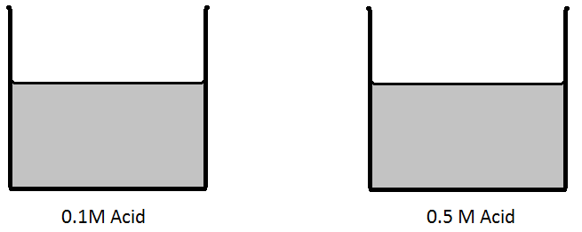
Magnesium reacts with acids to produce a salt and hydrogen gas. Write a word and balanced symbol equation (including state symbols) for the reaction of magnesium and hydrochloric acid.
Word
Symbol

In which of the beakers above would the magnesium react faster?
________________________________________

Explain with particle theory why magnesium reacts faster in this beaker.

You are now going to test this hypothesis, to do this you either need to monitor how quickly a reactant is used up or how quickly a product is produced. How could you monitor the rate of this reaction?

You will react 50 cm³ hydrochloric acid with 1 g of magnesium turnings. In this experiment the magnesium is present in excess, what does in excess mean and why is it desirable to have the magnesium present in excess?
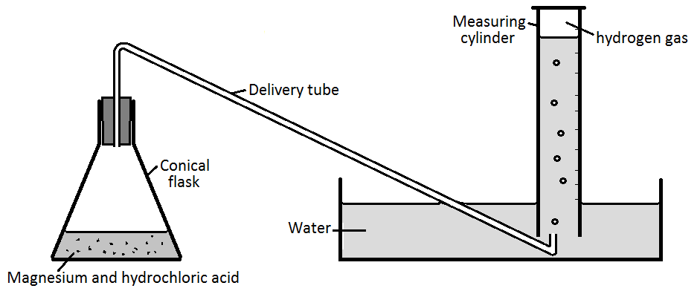

Complete the following table detailing the variables that need controlling for this experiment.
Variable | How is it controlled | Why does it need to be controlled
Mass of magnesium
Surface area of magnesium
Volume of acid
Temperature
Stirring

Assume each experiment will last for 4 minutes can you design a results table to collect the results. In the interests of time we will do each experiment only once.

Plot a graph showing how the rate changes with time for both experiments.

When is each reaction quickest? __________________________

When is each reaction slowest? __________________________

Use the graph to work out when each reaction stops – Show your working.

- 0.1M _______________________ s

- 0.5M _______________________ s
How does the curve of the reaction appear when the reaction is going quickly?

Use the graph calculate the rate of the 0.1 M and the 0.5 M experiments.

- 0.1M ___________________________________________ Unit ___________________

- 0.5M ____________________________________________ Unit ___________________

Why does the rate of both reactions change as time increases?

Conclusions
Things to consider:
Use scientific ideas to explain the conclusions you can draw from all your collected evidence.
Use your conclusion to explain if the hypothesis is correct.
Evaluation of conclusion
Things to consider:
State how well your evidence supports your conclusion.
Suggest what additional evidence could have been collected to provide stronger support for your conclusion.
Evaluation of method
Things to consider:
Describe the strengths and weaknesses in your method.
Explain how you would modify your method to improve the quality of your evidence.

Year 10 revision
1 dm³ of 0.5 mol dm⁻³ acid contains 0.5 mole of acid particles in 1 dm³ of water. (The Avogadro constant = 6.02 x 10²³)
- How many acid particles are present in 1 dm³ of 0.5 mol dm⁻³ acid?

- How many molecules are present in 2 dm³ of 0.5 mol dm⁻³ acid?

- How many molecules are present in 0.25 dm³ of 0.5 mol dm⁻³ acid?

Concentration Experiment II
The reaction between sodium thiosulfate and hydrochloric acid produces a precipitate of sulfur. The speed at which this precipitate forms could be used to monitor the rate of reaction. What will happen if we change the concentration of sodium thiosulfate solution?

Hypothesis

What is a precipitate? _______________________________________________________________

If this experiment were completed on a top pan balance would you expect the mass to go up, down or stay the same?
Hydrochloric acid + sodium thiosulfate → sodium chloride + sulfur dioxide + sulfur + water.
2HCl_{(aq)} + Na₂S₂O_{3(aq)} → 2NaCl_{(aq)} + SO_{2(g)} + S_{(s)} + H₂O_{(l)}

_________________________________

Method

1. Put 10 cm³ of sodium thiosulfate solution into the conical flask. Add 40cm³ of water.
2. Measure 5 cm³ of dilute hydrochloric acid into the test tube (using the small measuring cylinder).
3. Draw a small cross on a piece of paper and put the flask on top.
4. Pour the acid into the flask and start the clock. Briefly swirl the flask.
5. Time how long it takes for the cross to disappear (remember to time in seconds, not minutes).
6. Wash out the flask thoroughly. Repeat using the next volumes of thiosulfate and acid given in the table below.

Results
Volume of thiosulfate (cm³) | Volume of water (cm³) | Time (s)
10 | 40
20 | 30
30 | 20
40 | 10
50 | 0

Conclusion

1. Plot a graph of volume of thiosulfate (horizontal axis) against the time taken for the cross to disappear (vertical axis).
2. Which mixture of thiosulfate and water was the most concentrated and which was the least concentrated?

3. How then does the speed of a reaction vary with the concentration of reactants?

4. Do you think the rate also depends on the concentration of the acid and how would you change the experimental method to measure this?

5. Why do you think changing the concentration of the thiosulfate and the acid will change the rate of the reaction?

6. What other factors will alter the rate of reaction this reaction?

Year 10 revision
The sodium thiosulfate (aq) was prepared for this investigation by dissolving 12.6 g solid sodium thiosulfate in 200 cm³ distilled water
What is the concentration of this solution in g dm³?

Assuming all 12.6 g of sodium thiosulfate react, what mass of sulfur is produced in this reaction?
(A_{r} Na = 23, S = 32, O = 16)
Hydrochloric acid + sodium thiosulfate → sodium chloride + sulfur dioxide + sulfur + water.
2HCl_{(aq)} + Na₂S₂O_{3(aq)} → 2NaCl_{(aq)} + SO_{2(g)} + S_{(s)} + H₂O_{(l)}

2) Temperature
If you increase the temperature will it speed up or slow down the rate of reaction?

_________________________________________

Temperature Experiment

Potassium manganate (VII) reacts with glucose solutions, acid will also be used to help the reaction. We will measure the rate of reaction by timing how long it takes for the purple colour of the potassium manganate (VII) to disappear. Write below what you think will happen to the reaction when temperature is increased.

Hypothesis

Method
1. Use a syringe and the measuring cylinders to put 4cm³ of potassium manganate (VII), 25cm³ dilute sulphuric acid and 100cm³ of water into a beaker. Be careful here, the potassium manganite (VII) will stain your clothes.
2. Warm the beaker in the water bath until the temperature of the liquid is between 55⁰C and 60⁰C. Whilst you are waiting for that to heat up to the correct temperature, fill a test tube up to the brim with glucose solution and place it in the rack until needed.
3. Place the beaker on the white tile and note down its exact temperature in the results table.
4. Pour the glucose into the beaker and start the clock. Time how long it takes for the purple colour to disappear (in seconds) and write the results down in the results table.
5. Repeat the experiment (REMEMBERING TO WASH THE BEAKER THOROUGHLY, AND USING EXACTLY THE SAME QUANITITIES OF REACTANTS), but this time at a temperature that is 5⁰C cooler (i.e. between 50⁰C and 55⁰C).
6. Keep going until you have at least 6 different results.

Temperature (ºC) | Time taken for the purple colour to disappear (seconds)

Conclusion
Answer the following questions as a conclusion:
1. Plot a graph of temperature (vertical axis) against the time taken for the purple colour to disappear (horizontal axis).
2. What happens to the rate of reaction as the reactants cool down.
3. Use your graph to show how long the reaction would take (in seconds) at 52, 47 and 39⁰C (show your working on the graph paper).
Temperature (ºC) | Time (seconds)
52
47
39

4. If the colour took 45 seconds to disappear, what was the temperature of the liquid, remember to show your working.
Time (seconds) | Temperature (ºC)
45

5. Explain using particle theory why increasing the temperature speeds up the rate of reaction.

3) Surface Area
The class teacher will react two different sizes of marble chippings with hydrochloric acid (1M) to see which has the fastest rate of reaction. Write a balanced word and symbol equation for calcium carbonate reacting with hydrochloric acid, include state symbols.
Word
Symbol

Think back to year 10 – what type of reaction is this? __________________________________

The apparatus is shown below:
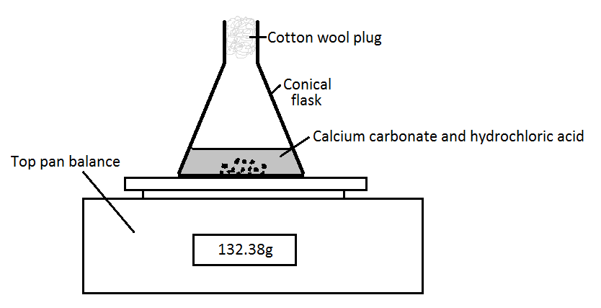

Explain how this apparatus can be used to monitor the rate of reaction. State clearly which reactant or product you are monitoring and what readings you will take.

What is the point of the cotton wool in the top of the flask?

Plot a graph of the results for this experiment. Use the results below if there wasn’t enough time in the lesson, or space in the table to collect your own.
Time (min and sec) | Large chips |  | Small chips
 | Your results | Sample results (g) | Your results | Sample results (g)
0 |  | 132.5 |  | 132.5
0:30 |  | 132.2 |  | 131.08
1:00 |  | 131.38 |  | 130.77
1:30 |  | 131.05 |  | 130.65
2:00 |  | 130.8 |  | 130.39
2:30 |  | 130.62 |  | 130.28
3:00 |  | 130.47 |  | 130.21
3:30 |  | 130.35 |  | 130.17
4:00 |  | 130.24 |  | 130.14
4:30 |  | 130.17 |  | 130.14
5:00 |  | 130.14 |  | 130.14

When is each reaction fastest? ___________________________________________

When is each reaction slowest? ___________________________________________

Can you explain using particle theory why the rate of both reactions changes with time?

Which reaction is quickest?

_____________________________________________________________

In the pictures below there is a 10 g lump of calcium carbonate and in the other 2 x 5 g lumps. Can you count the number of surfaces in both pictures?

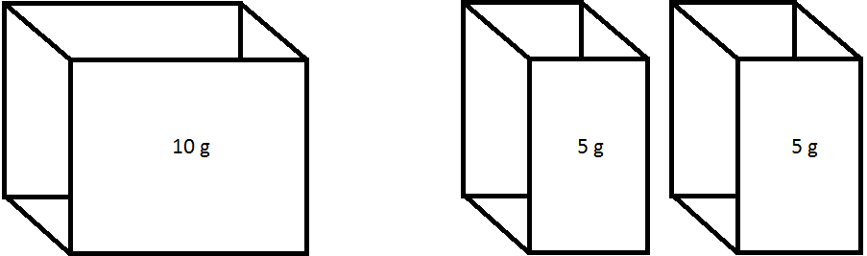
Number of surfaces
1 x 10 g lump | 2 x 5 g lumps

In which picture are there more surfaces for the acid particles to collide with?
________________________________________________________
Explain in your own words how you can increase the surface area of a solid and how and why this alters the rate of reaction?

Year 10 revision
Assuming all 10 g of calcium carbonate reacts with the hydrochloric acid, what mass of carbon dioxide would be produced? (A_{r} Ca =40, C = 12, O = 16)
CaCO₃ + 2HCl → CaCl₂ + H₂O + CO₂

Catalyst
What is a definition of a catalyst?

What is an enzyme?

Give examples of reactions where: 1) a catalyst and 2) an enzyme are used.

- ________________________________
- ________________________________

How does a catalyst work?
Look at the 2 pictures below, they show the two different routes people who live in a town have to take to get to a shop.

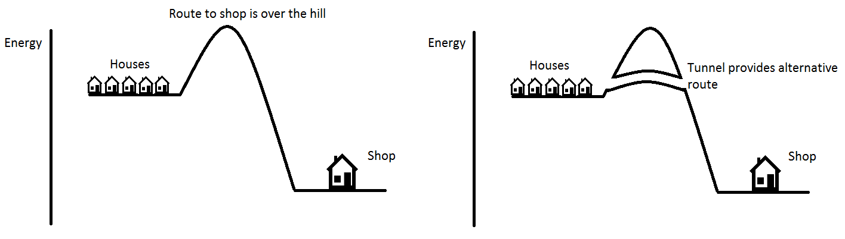
Which route requires the people to use less energy and is therefore quicker?

_____________________________________________________________________

Now look at the energy level diagram for a chemical reaction below and draw on it the reaction path for the reaction if a catalyst was added.
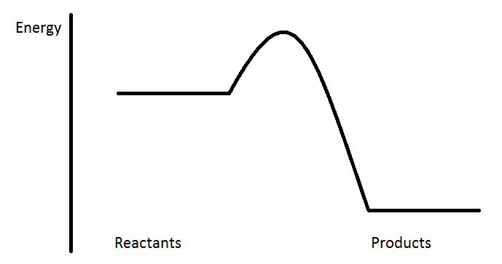

The graph below shows how quickly carbon dioxide is given off when 50 cm³ of 1 mol/dm³ hydrochloric acid is reacted with excess calcium carbonate powder.
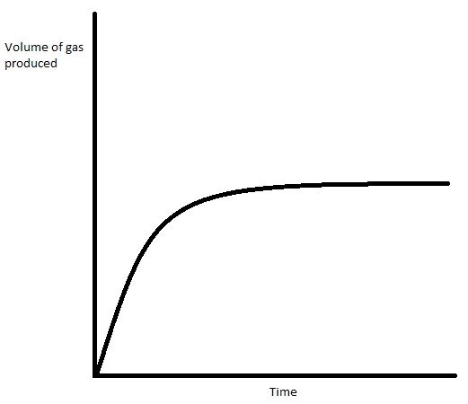

The experiment was repeated on several occasions changing one variable each time. For each different experiment, sketch the likely curve of carbon dioxide produced on the original graph.

- Exactly the same as the original experiment but with 50 cm³ of 2 mol/dm³ hydrochloric acid. Label this curve B. The calcium carbonate is still present in excess.
- Exactly the same as the original experiment but 10 ºC hotter. Label this curve C.
- Exactly the same as the original experiment but using calcium carbonate lumps (bigger pieces). Label this curve D
- Exactly the same as the original experiment but with a catalyst added. Label this curve E.

If this reaction were taking place on a top pan balance, what change would you notice on the balance display? Explain your answer.

Blank Pages for Notes

Topic 7 – Heat energy changes in chemical reactions

For each content point put a tick next to it firstly when you understand it and secondly when you have learnt it. If you don’t understand a content point you must ask your teacher.

 | Content | Understand it | Learnt it
1 | Learn that changes in heat energy accompany the following changes:  - Salts dissolving in water  - Neutralisation reactions  - Displacement reactions  - Precipitation reactions  Also know that when these reactions happen in solution the temperature changes can be measured.
2 | Learn the definition of an exothermic reaction: a reaction or change that gives out heat energy.
3 | Learn the definition of an endothermic reaction: a reaction or change that takes in heat energy.
4 | Understand that in all reactions the first change is the breaking of reactants bonds followed by the making of products bonds. Learn that breaking bonds is an endothermic process and making bonds is exothermic.
5 | Be able to explain that the overall heat energy change in a reaction is:  - Exothermic if more heat energy is released in forming bonds in the products than is needed to break the bonds in the reactants.  - Endothermic if more heat energy is needed to break the bonds in the reactants than is produced when new product bonds are made.
6 | Use the energies of bonds (in KJ mol⁻¹). These values are the energy required to make and break bonds to calculate the energy change in a reaction.
7 | Learn the meaning of the term: activation energy.
8 | Be able to draw and label an energy level diagram for both an exothermic and endothermic reaction. You must be able to label the axis and identify activation energy and state where bonds are being made and broken.

Exothermic and Endothermic reactions

Define Exothermic

What words can you think of that start with Ex..? What do you think Ex might mean?

What words can you think of that start with Therm…? What do you think Therm might mean?

Use the answers above to define exothermic

Now define Endothermic

You are going to investigate 2 changes. One is exothermic and one is endothermic. You need to design a results table to determine which is which.
Test 1 - Magnesium (1 spatula) and 0.5 M hydrochloric acid (5ml).
Test 2 - Urea (3 spatulas) and water (5ml).

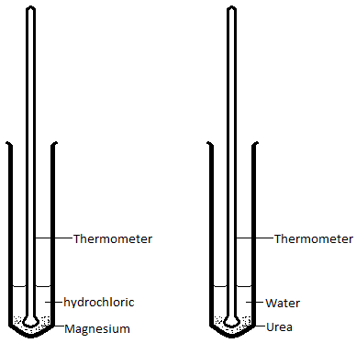

Will the endothermic reaction get hot or cold?
You are going to let the experiment run for 3 minutes and you want to see how the temperature of each reaction changes. What are the advantages of taking results continuously every 30 seconds as opposed to just at the start and end?

Method
- Collect 4 test tubes and place in a test tube rack. Add Magnesium to one and hydrochloric acid to another and in the other 2 place the urea and water.

- Collect a stopwatch and design a results table to record results over 3 minutes.

- Record the temperature of the acid and the water before the start of the experiment.

- When you are both ready, one needs to add the hydrochloric acid to the magnesium and the other needs to add the water to the urea and start the stopwatch.

- Record the results in the table.

Results

Design a table in the space below

Graph – Plot a graph of your results.

Which reaction went up in temperature and which went down?

Which was the endothermic change and which was the exothermic?
Endothermic
Exothermic

When looking at the graphs showing the temperature changes for both experiments you can see that the temperature both increases and decreases. Can you explain why the temperature both rises and falls or falls and then rises over the 5 minutes?

Conclusion

Words needed
- Rise 2) Fall 3) given out to 4) taken in from

In exothermic reactions you would expect to see the temperature ____________ because energy is being ___________ _______ _______ the surroundings.

In endothermic reactions you would expect to see the temperature ____________ because energy is being ___________ _______ _______ the surroundings.

Give 2 other examples of an exothermic reaction
- ___________________________
- ___________________________

Give 2 other examples of an endothermic reaction
- ___________________________
- ___________________________
Explaining Exothermic and Endothermic Energy Changes

In any chemical reaction you first have to the break bonds of the reactants and you then have to make the new bonds of the products.

The reaction below is methane burning, like in a Bunsen burner. Name the chemical bonds that first have to be broken and the new ones that are then made.
CH₄ + 2O₂ = CO₂ + 2H₂O

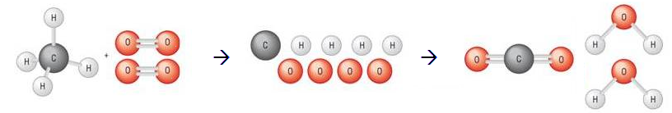

Bonds Broken |  | Bonds Made
Bond type | Number | Bond type | Number

Chemical bonds are a little bit like magnets.
If you had two magnets stuck to each other and you had to break them apart would you do this by putting energy in (using energy) or energy coming out (releasing energy)?

_________________________
When the magnets are separated but still close enough to attract each other you decide to let them go and they snap back together. When the magnets are let go and are accelerating towards each other, does the movement require energy to be put in or is it given out?

_________________________
Now complete the energy level diagram for burning methane. Draw on it a line showing how the energy in the system changes during the reaction and label where bonds are broken and made. Also label the activation energy.

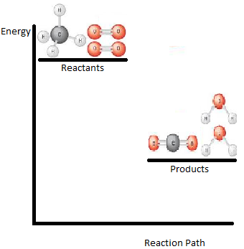
Now sketch out a fully labelled energy level diagram for the thermal decomposition of calcium carbonate (CaCO₃) which is an endothermic reaction. When the calcium carbonate decomposes it forms calcium oxide and carbon dioxide.
Year 10 revision: Quick reminder of bonding! Draw diagrams showing the bonding in carbon dioxide and calcium oxide. State whether the bonding is ionic or covalent, explain why the melting point is high or low and why they will or will not conduct electricity. (Atomic numbers: Ca = 20, O = 8, C = 6.
 | Calcium oxide | Carbon dioxide
Type of bonding
Diagram

Melting point
Electrical conductivity

Bond Energy Calculations

If you know the bond energy (the amount of energy needed to break a 1 mole of bonds of a substance or given out when 1 mole of new bonds is made) you can calculate the energy change of a reaction. Bond energy is measured in kilojoules per mole (kj mol⁻¹).

Use the table of bond energies to calculate the energy change when 1 mole of methane is burnt in excess oxygen.

Covalent bond | Bond energy (kj mol⁻¹)
C-H | 413
O=O | 498
C=O | 805
O-H | 464

CH₄ + 2O₂ = CO₂ + 2H₂O

Bonds Broken |  |  |  | Bonds Made
Bond type | Number | Bond energy | Total | Bond type | Number | Bond energy | Total
Total energy |  |  |  | Total energy

Energy change in the reaction = Bond breaking – bond making

Questions

Use the table of bond energies to answer the following questions:
Covalent bond | Bond energy (kj mol⁻¹) | Covalent bond | Bond energy (kj mol⁻¹)
C-H | 413 | H-H | 436
O=O | 498 | C-O | 358
C=O | 805 | C-Cl | 328
O-H | 464 | Cl-Cl | 242
C=C | 614 | C-C | 348
H-Br | 366 | Br-Br | 193
N≡N | 941 | N-H | 391

- Calculate the energy change in the hydration of ethene. State whether this reaction is exothermic or endothermic.
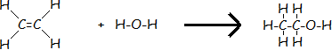

- Calculate the energy change when chlorine is reacted with ethene. State whether this reaction is exothermic or endothermic.
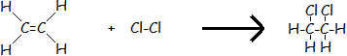

- Ethanol can be used as a renewable fuel in place of petrol. Calculate the energy change when ethanol burns. State whether this reaction is exothermic or endothermic.

- Hydrogen bromide decomposing to form hydrogen and bromine. State whether this reaction is exothermic or endothermic.
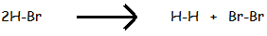

- Propane burning to produce carbon dioxide and water. State whether this reaction is exothermic or endothermic.

- When nitrogen reacts with hydrogen it produces ammonia (NH₃). However, ammonia can also react with itself to produce nitrogen and hydrogen. One of these reactions is exothermic and one is endothermic. Use bond energies to identify which is the exothermic and which is the endothermic reaction.
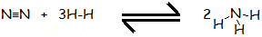

Blank Pages for Notes

Topic 8 – Fuels and Earth Science

For each content point put a tick next to it firstly when you understand it and secondly when you have learnt it. If you don’t understand a content point you must ask your teacher.

 | Content | Understand it | Learnt it
1 | Learn that hydrocarbons are compounds that contain hydrogen and carbon only.
2 | Be able to explain that crude oil:  - Contains many different size hydrocarbon molecules.  - Contains molecules in which some of the carbon chains are straight but in others they can join up to form rings.  - Is tremendously useful to humans both as fuels and as raw materials for making other substances.  - Is a finite resource (non-renewable).
3 | Before crude oil can be used it must first be separated into simpler more useful mixtures. Learn that this is done by fractional distillation. Be able to explain how fractional distillation works.
4 | Learn the names and uses of the main fractions of crude oil and the order in which they come out of the distillation tower.  - Gases – used in the home for cooking and heating.  - Petrol – used as a fuel for cars.  - Kerosene – used as a fuel for aircraft.  - Diesel oil – used as a fuel for some cars, lorries and trains.  - Fuel oil – used as a fuel for large ships and in some power stations where it is burnt to generate electricity.  - Bitumen – used to surface roads and roofs.
5 | For the fractions of crude oil learn that they are alkanes and the trends in:  - Number of carbon and hydrogen atoms in the molecule.  - Boiling points.  - Ease of ignition  - Viscosity.
6 | Learn that a homologous series is a family of hydrocarbons with molecules:  - Of the same general formula.  - That differ by CH₂ in molecular formulae from their neighbouring compounds.  - That show a gradual variation in physical properties, for example boiling point and viscosity.  - That have similar chemical properties.
7 | Learn that in the complete combustion of a hydrocarbon:  - Carbon dioxide and water are produced.  - The reaction is exothermic and heat energy is given out.
8 | Understand that there is another type of combustion called incomplete combustion. Explain why incomplete combustion can produce the products carbon and carbon monoxide.
9 | Be able to explain in your own words why carbon monoxide behaves as a toxic gas.
10 | Understand how incomplete combustion can occur in the home and the problems it can cause.
11 | Explain how sulfur impurities in hydrocarbon fuels lead to the production of sulfur dioxide.
12 | Name some of the problems from acid rain. Learn that acid rain is caused by the sulfur dioxide produced from burning hydrocarbon fuels.
13 | Understand how nitrogen oxides are also produced when hydrocarbon fuels are burnt in engines. The high temperatures of the engine cause the nitrogen and the oxygen in the air to react.
14 | Hydrogen is seen by some as the fuel of the future for cars. Name the advantages and disadvantages of using hydrogen, rather than petrol, as a fuel for cars.
15 | Learn that petrol, kerosene and diesel oil are non-renewable fossil fuels found in crude oil. Learn also that methane is a non-renewable fossil fuel found in natural gas.
16 | Learn that cracking long chain hydrocarbons involves taking a large alkane (saturated) molecule and breaking it down, cracking it.  Long chain hydrocarbons are cracked because they are not that flammable. This produces a shorter chain alkane (saturated), which is more flammable and therefore more useful as a fuel and a smaller alkene (unsaturated) molecule.
17 | Be able to explain why cracking is a necessary process.

Hydrocarbons
Crude oil is a mixture of different length hydrocarbon compounds. These only contain _________ and _________ atoms bonded together. The table below shows the first three hydrocarbons. You will need to complete the formula for the hydrocarbon and draw a diagram to show how the atoms are arranged.
How many bonds does a carbon atom form? _______________

How many bonds does a hydrogen atom form? _______________

Hydrocarbon | Formula | Diagram
Methane
Ethane
Propane

Are these compounds ionic or covalent? Draw diagrams to show the bonding in methane and ethane.

Type of bonding? __________________________

Methane bonding diagram

Ethane bonding diagram

Draw a diagram to show what a mixture of the hydrocarbons in crude oil would look like. (The longest carbon chains can have up to 40 carbon atoms in them.)

Activities
Some of these statements are correct, and some are not.
Say if each one is correct. If you think a statement is incorrect, write out a corrected version.
1 Crude oil is found in igneous rocks.

2 Oil is called a 'fossil fuel' because it is made from the remains of microscopic sea animals and plants that lived millions of years ago.

3 The energy stored in oil originally came from the Sun.

4 Hydrocarbon molecules always contain hydrogen, carbon and oxygen atoms.

5 Crude oil is a mixture of different compounds.

6 The hydrocarbon molecules in crude oil all have the same number of carbon atoms in their molecules.

7 Crude oil is being formed somewhere in the world right now.

8 Crude oil is a renewable resource.

9 Crude oil contains only hydrocarbon molecules.

10 The formation of crude oil is a quick process.

Look at the 2 hydrocarbons below, then decide which:
- Is the easier to ignite
- Has the higher boiling point
- Is most viscous
- Is most in-demand.

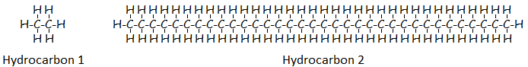

Property | Hydrocarbon 1 or 2
Easier to ignite
Higher boiling point
More viscous
More in-demand

What do the following terms mean?

Term | Definition
Chain length
Ease of ignition
Boiling point
Viscous
In-demand

Complete the following table showing the trend in hydrocarbon property as the length of the carbon chain increases.
Chain Length | Ease of ignition | Boiling point | Viscosity | In-demand
Short Chain

Long Chain

Which length hydrocarbon would be best to use as a fuel? Give reasons to support your answer.

Fractional Distillation of Crude Oil

What is the purpose of the fractional distillation of crude oil?

Crude oil is not useful because it is a mixture of different length hydrocarbons. To make it useful the crude oil must be separated into different parts called fractions. Each fraction contains hydrocarbons which have similar lengths. This process takes place in a fractionating column.

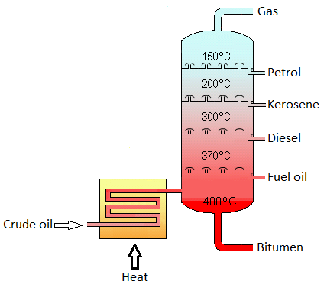
Length of hydrocarbon Chain _____________
Boiling Point _____________
Explain how a mixture containing petrol and bitumen is separated into different fractions using a fractionating column like the one shown above. You must use the following key words
Heat Cool Crude oil Fraction Evaporate Condense

Use of fractions
The fractions of crude oil have many and varied uses. Use information from the fractional distillation diagram, what you find below as well as your prior knowledge to complete the following table.
Number of carbon atoms in each fraction:
C₁ to C₄, C₅ to C₁₀, C₁₅ to C₂₀, C₂₀ to C₂₅, C₂₅ to C₃₅, over C₃₅
Uses of fractions
Domestic cooking, aircraft fuel, road tar, fuel for cars, fuel for some cars, fuel for large ships, roofing, domestic heating, fuel for some power stations, fuel for some trains.
Fractions (write in order of boiling point) | Approximate Boiling point | Number of Carbon atoms in fraction | Uses | Viscosity trend | Ease of Ignition trend

Hydrocarbons and Homologous Series

As the boiling point of a hydrocarbon increases what happens to the length of the carbon chain?

The carbon chain can increase by 1 carbon atom each time. How many hydrogen atoms will be joined to this carbon atom?

When you have 2 different compounds which have an identical structure, other than the number of carbon and hydrogen atoms present, these compounds are said to belong to the same homologous series.

Look at the six compounds below, and then answer the questions:
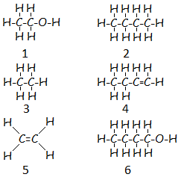
Which of these carbon based compounds are hydrocarbons?

How many different homologous series are there and which compounds belong in which series?

Number of homologous series? | Which compounds are in the same homologous series?

Crude oil contains mainly members of the alkane homologous series. What is the general formula for the alkane homologous series?

Give 4 reasons why compounds 1 and 6 are in the same homologous series.
reason
1
2
3
4

Ring structures.

In some hydrocarbon compounds the carbon chains are not straight. Can you draw molecules below where the carbon atoms form single bonds to other carbon atoms. In each case the carbon atoms should join up in a ring structure. Attempt this with 3 carbon atoms, 4 carbon atoms and 6 carbon atoms.

3 carbon ring | 4 carbon ring | 6 carbon ring

Now draw a hydrocarbon with a 4 carbon ring where there is a double bond between 2 of the carbon atoms.

Remember: carbon forms 4 bonds.

Complete Combustion
Why do we burn hydrocarbons?

Most of the fractions of crude oil are used as fuels. Predict what the products are of the complete combustion of methane, write a word and balanced symbol equation for what you think this reaction might look like.
Can you think of other words that link to combustion?

Word | →
Symbol | →
How could you test for Product 1, include details of the test and what a positive result would look like?

How could you test for Product 2 include details of the test and what a positive result would look like?

Apparatus
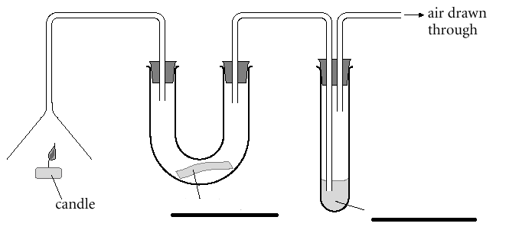

Questions:
What is the purpose of the candle?

Why is the U bend before the boiling tube in the apparatus set up?

What was the result of the experiment and what can we conclude from it?

Were there any other products of this reaction that we did not test for? What observation have you made to back up your answer? Why might they have been produced?
Product

Observation

Why

As well as the chemical substances named what else was given off from this reaction?

What is the difference between complete and incomplete combustion?

What is the formula of carbon monoxide? ______________________

Do you think carbon monoxide will be produced by complete or incomplete combustion? Explain your answer.

Why is carbon monoxide dangerous?
You must include these points in your answer:
Colourless, Odourless, Tasteless, Toxic, haemoglobin in blood, normally carry oxygen/carbon dioxide, carbon monoxide binds to haemoglobin, leaves no room for oxygen, symptoms difficult to recognise, headache, blue tinge to extremities, unconsciousness, death.
Extract from coroner’s report into the tragic death of a 14 year old girl on a camping trip who had placed a bbq in the porch of their tent.
Recording a verdict of accidental death, Coroner John Ellery told members of Hannah's family: "It's quite clear that you and many, many people were unaware of the risk of carbon monoxide poisoning.”

What are the tell-tale signs of carbon monoxide production and what can we do to keep ourselves safe?

Year 10 revision – What mass of carbon dioxide is produced from the complete combustion of 64 g of methane. (A_{r} C = 12, H = 1, O = 16)
CH₄ + 2O₂ CO₂ + 2H₂O

There are often impurities in fossil fuels and sulfur is one example. Explain how sulfur forms sulfur dioxide and how this becomes sulfuric acid in the atmosphere. Draw a diagram as part of the explanation. Include also the impact that acid rain has on the environment.

Nitrogen oxide can be formed when hydrocarbon fuels are burnt. Where does the nitrogen come from?

How does the burning of hydrocarbon fuels in engines lead to the formation of oxides of nitrogen?

Write a balanced symbol equation for the formation of nitrogen monoxide in a car engine.

Formation of nitrogen monoxide

Write a balanced symbol equation for the formation of nitrogen dioxide in a car engine.

Formation of nitrogen dioxide

Hydrogen as a fuel.

Literacy Exercise – Read the passage below and add punctuation where appropriate. Following this, answer the questions with information that can be found in the passage.
some vehicles contain a fuel cell which means that they react hydrogen with oxygen together too produce electrical energy

a fuel cell is an electrochemical energy device that produces electricity and heat to do this it uses hydrogen as a fuel to combine with the oxygen in the air converting it into water while producing the heat and electricity it is much like a battery except that a fuel cell does not run down or require recharging like a battery provided their is an adequate supply of hydrogen fuel it recharges itself while you are drawing power

fuel cells have lots of advantages they are more efficient which means that they waste less of the energy that they produce the vehicles which use the fuel cells do not produce any greenhouse gases or gases which cause acid rain

fuel cells do have some disadvantages the majority of the hydrogen which is used is made from natural gas hydrogen can also be made by the electrolysis of water but this requires a lot of electricity the cost of changing petrol stations to sell hydrogen which is a very flammable gas and would need compressing would be very expensive

- A confused parent is convinced that the hydrogen is burnt inside a fuel cell. They need correcting without their pride being dented; you must therefore tell them why a fuel cell is similar but different to burning.

- Write a word and balanced symbol equation for the chemical reaction which takes place inside a fuel cell.
Word

Symbol

- Why do some scientists consider fuel cells to be an environmentally friendly fuel?

- Give two advantages of a fuel cell compared to a fossil fuel e.g. petrol.

- Why do you think that some scientists argue that fuel cells are not an environmentally friendly source of energy?

- Do you think that hydrogen fuel cells should replace petrol as a fuel for cars in the future? Give reasons to support your answer.

Construct a table listing the advantages and disadvantages of using hydrogen as a fuel.

Advantages | Disadvantages
Cracking Long Chain Hydrocarbons

Starter:
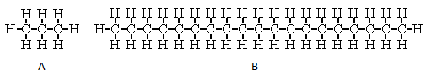
Look at molecule A and B and decide for which you think humans have a higher demand. Give reasons for your answer:

If we asked 20 of you to link arms in a straight line and spin around progressively faster what do you think would happen to the people on the end of the line?
If we had a longer chain hydrocarbon like molecule B, how could we make it move around more quickly and what would happen to it?
This process is called:

Complete the equation: (Assume one product has the formula C₈H₁₈)
C₁₀H₂₂ →

Draw the structure of the smaller product: - What’s the problem? Draw a solution
Structure | Problem | Solution
 |  | Name
 |  | Hydrocarbon family

The following apparatus can be used to crack long chain hydrocarbons in a science lab.

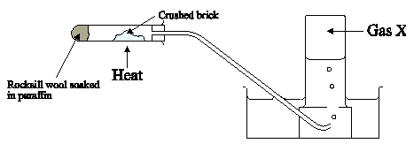
Explain the purpose of each of the following:

Paraffin

Heat

Crushed Brick

What is Gas X?

Full GCSE Chemistry only. What is a test for Gas X and what is the positive result?

Give 2 reasons why cracking is an important industrial process.
1)

2)

Complete this cracking equation and draw the structure of the alkene:
Equation  C₁₁H₂₄ → C₈H₁₈ + | Alkene Structure

Alkanes and Alkenes

Fill in the blanks:

Alkanes and alkenes are 2 different homologous series that are both ____________________. A hydrocarbon is a ______________ made of ________________ and __________________ only. Alkanes are found in __________ ______ and alkenes are produced when ________ chain alkanes are _______________. Alkanes have carbon to carbon ____________ bonds and are known as ________________ Whereas alkenes have a carbon to carbon _____________ bond and are known as _______________. The double bond is a reactive site, alkenes are therefore ___________ reactive than the corresponding member of the alkane family.

Why is methane the first member of the alkane family and yet no methene exists?

The number of carbon atoms in the chain gives us the first part of the name. Complete the following table with the prefix appropriate to the number of carbon atoms.
Number of carbon atoms in chain | Prefix
1

2

3

4

The end of a hydrocarbon name is derived from the hydrocarbon family from which it originates. What is the ending or all alkane and all alkene molecules?
Alkane | Alkene

Oil Summary
Fractional Distillation  Sketch apparatus and label key areas |  | Boiling point | Flammability | Viscosity
Long chain

Short Chain

Cracking  Sketch apparatus and label key areas | Example equation | 2 Reasons for Cracking | Alkanes (Separate Science only) |  | Alkenes (Separate Science only)
 |  |  | Members | Characteristics | Members | Characteristics
 |  |  |  | Single/double carbon bond |  | Single/double carbon bond
 |  |  |  | More or less reactive |  | More or less reactive
 |  |  |  | Test with bromine water |  | Test with bromine water
 |  |  |  | Saturated or unsaturated |  | Saturated or unsaturated

Complete Combustion  Name the products | Incomplete Combustion  Name the products and explain why they are formed. | Why is carbon monoxide toxic? | Advantages and disadvantages of using hydrogen as a fuel.

Blank Pages for Notes

Topic 8 – Earth and atmospheric science

For each content point put a tick next to it firstly when you understand it and secondly when you have learnt it. If you don’t understand a content point you must ask your teacher.

 | Content | Understand it | Learnt it
1 | Know that the first atmosphere was formed from the gases produced by volcanic activity.
2 | Learn that scientists think that the Earth’s early atmosphere contained:  - Little or no oxygen.  - Lots of carbon dioxide.  - Water vapour.  - Small amounts of other gases.
3 | Be able to explain how the first oceans were formed from condensing water vapour.
4 | Learn that the amount of carbon dioxide in the early atmosphere was reduced because it dissolved in the oceans.
5 | Be able to explain how the carbon dioxide levels fell further as the growth of the first green plants used carbon dioxide and released oxygen by photosynthesis. Understand that this increased the amount of oxygen in the atmosphere.
6 | Learn the chemical test for oxygen.
7 | Be able to write a detailed explanation to describe what the greenhouse effect is and what causes it. You should be able to name the following gases that are responsible: carbon dioxide, methane and water vapour.
8 | Use evidence both for and against global warming to evaluate both sides of the argument as to whether human activity is causing climate change. The arguments that you must know are:  - The link between the change in atmospheric carbon dioxide concentration , the use of fossil fuels and average global temperature.  - The error margin in recording historic atmospheric and climatic data from ice cores and rocks and also from where it is taken.
9 | Learn and be able to explain:  - What the potential effects of increasing carbon dioxide and methane levels due to human activity might be on the planet. Learn that the human activity is burning fossil fuels and livestock farming.  - How we could reduce the effects of climate change. Look at the advantages and disadvantages of these measures in terms of practicality (scale), risk and environmental implications.

The Evolving Atmosphere
Each box details how the atmosphere has changed over time; your task is to design and label a diagram to illustrate how the atmosphere has changed.
The earth was formed 4.54 billion (4.54×10⁹) years ago from the same cloud of material that formed the sun. The early earth was very hot and had no atmosphere. | The early atmosphere was formed as a result of volcanoes giving off carbon dioxide, water vapour and small amounts of other gases. The earth was still very hot.  Q: Which gas might you expect to find that is missing? | Over time the earth cooled meaning that the water vapour in the atmosphere condensed to form the oceans.  Q: If you had visited the earth at this point what would it have looked like?

The carbon dioxide in the atmosphere starts to reduce because firstly, it dissolves in the oceans and then secondly is used by marine organisms which will eventually mean that it gets locked up in carbonate rock formations.  Q: Explain how the Carbon dioxide gets locked up in carbonate rock formations. | The growth of primitive plants also reduced the amount of Carbon dioxide because of photosynthesis. This ‘polluted’ the atmosphere with oxygen. | The current atmosphere is comprised of mainly nitrogen and oxygen and is relatively stable. However, the composition is continually changing due to volcanic and human activity.  Q: What is meant by human activity?

Complete the table for the current composition of the atmosphere:
Gas | Formula | % in air

Draw an accurate pie chart showing the composition of the earth’s atmosphere. (The 3 smallest constituents can be joined together and labelled, ‘other gases’).

Explain why scientists are unable to be precise about how the atmosphere has evolved.

What is the chemical test for oxygen?

Literacy Activity.
Literacy Exercise – Read the passage below and add punctuation where appropriate. Following this, answer the questions with information that can be found in the passage.

the atmosphere today is constantly changing partly threw natural processes like Volcanoe’s and partly because of mans activitys volcanoes today release large quantitys of gases mainly carbon dioxide and water vapour but also small quantities of ammonia (NH₃) methane (CH₄) and nitrogen (N₂) human activity also has an affect on the composition of the atmosphere because of increased levels of carbon dioxide produced from the burning of fossil fuels and methane generated by livestock farming (the methane is generated primarily in the stomachs of cattle as they digest their food)
various gases in the atmosphere including carbon dioxide methane and water vapour absorb heat radiated from the earth subsequently releasing energy which keeps the earth warm this is known as the greenhouse effect however there are some people that believe adding carbon dioxide to the atmosphere doesn’t cause global warming but these are in the minority
deforestation also plays it’s part in global warming because by clearing areas of forrest they’re are fewer trees to turn carbon dioxide into oxygen. As other parts of the world like china and india continue to develop there economies the demand for fuel and beef is continually increasing these factors seem to suggest that global warming will dramatically accelerate in the coming decades
the intergovernmental panel on climate change (IPCC) which includes more than 1300 scientists from the united states and other countries forecast a temperateure rise of 1.5 to 5.5 ºC over the next century.

- Which gases are responsible for greenhouse effect?

- Describe how the gases responsible for the greenhouse effect heat up the atmosphere.

- What is the human race doing that leads to an increase in the greenhouse effect?

Evaluating Global Warming Data
This graph is a bit difficult to understand but is really great evidence for anyone who is interested in debating global warming. If you struggle with it do not worry, most people do, it is important to ask if you are not sure.
Questions
- Our species of humans first began to evolve about 200 000 years ago. Label the X axis with this piece of information.
- It was the industrial revolution that saw man starting to burn fossil fuels on a huge scale. The industrial revolution started in 1760. Can you approximately label the X axis with this piece of information?
- Currently we can measure an atmospheric CO₂ concentration of 400 ppm, mark this figure on the graph below with an X.
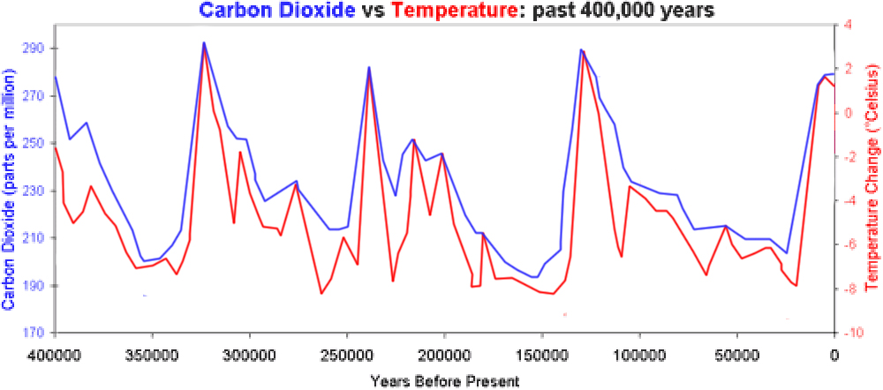

- Why is there such a gap between the amount of atmospheric CO₂ shown on the graph and the actual amount found in the atmosphere today?

- Why do some people use this graph as evidence that global warming is not a man-made problem?

- Why do other people use this graph as evidence that global warming is a huge concern to the human race?

Going green!
The burning of fossil fuels, which produce carbon dioxide, generates most of our electricity. What is the best alternative to burning fossil fuels to generate electricity? The following table gives information about alternative sources of generating electricity for approximately 500 000 people (500 Mega Watt).

Type of energy | Land needed | Number of generating days of use before it becomes carbon neutral. | Cost
Wind | 119 km² | 181 | $40 billion
Concentrated Solar power | 63 km² | 370 | $18.5 billion
Nuclear | 0.04 km² | 9 | $4.03 billion
Data taken from: http://energyrealityproject.com/lets-run-the-numbers-nuclear-energy-vs-wind-and-solar/
Why do you think it takes 181 days of generating electricity before a wind farm becomes carbon neutral?

When you answer the following questions think for each one in terms of:
- Scale
- Risk
- Environmental implications
Which method of generating electricity would you chose? Give reasons.
Method | Reasons

Why might other people not agree with your answer?
Blank Pages for Notes

Glossary
acid | a family of chemicals that can give off hydrogen ions in solution.
acid rain | rain water that is acidic because sulfur dioxide given off from coal burning power stations has dissolved in the moisture in clouds to form sulfuric acid.
activation energy | the amount of energy needed to break the bonds of reacting particles so as to start a chemical reaction.
alkali | a family of chemicals that can give off hydroxide ions in solution.
alkali metals | group 1 of the periodic table, these are reactive metals that form alkaline solutions. They have 1 electron in their outer shells.
alkane | a hydrocarbon family where the carbon atoms are joined together with carbon to carbon single bonds only. Alkanes are known as saturated hydrocarbons.
alkene | a hydrocarbon family where 2 carbon atoms are joined together with a carbon to carbon double bond. Alkenes are known as unsaturated hydrocarbons.
alloy | a mixture of 2 or more metals.
anion | a negatively charged ion.
aqueous | the name given to the state when a substance is dissolved in water.
atmosphere | the gases that surround a planet.
atom | the smallest particles of an element. Atoms are made from protons, neutrons and electrons.
atomic number | the number of protons in an element, this is unique for every element.
Avogadro constant | 6.02 x 1023 particles. Also see the definition of the mole.
basalt | an intrusive igneous rock, formed when lava cools quickly outside of the earth’s crust, it has small crystals.
base | a substance that will react with an acid to make a salt and water.
biofuel | a fuel that is created from growing plants, once the plant is harvested more are planted leading to a renewable fuel.
bitumen | a long chain alkane found in crude oil used to surface roads and roofs.
boiling | changing from a liquid to a gas, this occurs at the substances' boiling point.
boiling point | the temperature needed to turn a substance from the liquid state to the gaseous state, this is different for all substances and if the substance is pure it happens at a very clear temperature.
bromine water | used as a test for unsaturation; bromine water is decolourised by alkenes.
carat | a scale used to indicate the purity of a sample of gold.
carbon monoxide | formula: CO - a colourless and odourless toxic gas formed from the incomplete combustion of fuels.
catalyst | a substance that speeds up a chemical reaction without being changed itself and without altering the products and without changing mass. It does this by providing an alternative route for the reaction that requires less energy.
cation | a positively charged ion.
chalk | a sedimentary rock made of calcium carbonate.
chemical change | a permanent change brought about by a chemical reaction.
chlorination | adding small quantities of chlorine to drinking water to kill bacteria.
chromatography | a separating technique used to separate and identify a mixture of liquids e.g. different ink colours that make up a felt tip pen.
complete combustion | where a fuel burns with plenty of oxygen and the products are carbon dioxide and water.
compound | a substance made up of 2 or more different atoms chemically joined together.
concentration | a measure of how much of a substance is dissolved in the solvent.
condensation | a gas changing back to a liquid.
conductor | a substance that allows either electricity or heat to pass through it. Metals are good at both but some other substances like carbon graphite are good electrical conductors but not good thermal conductors.
conservation of mass | a basic law of chemistry that states in a chemical reaction matter is neither created nor destroyed, therefore the overall mass of the reactants is the same as the mass of the products.
corrosion | a metal reacting with oxygen in the atmosphere.
covalent bond | the bond formed when non-metals share a pair or pairs of electrons.
cracking | an example of thermal decomposition; a long chain alkane is heated and it decomposes into a shorter chain alkane and an alkene.
crude oil | a mixture of hydrocarbons belonging to the alkane family.
crystallisation | forming a solid by evaporating the liquid from a solution.
d.c. supply | a direct current supply is an electrical supply in which the current always flows in the same direction.
displacement | a type of chemical reaction in which a more reactive element displaces a less reactive one from its compound.
dissociation | the splitting of a molecule into ions e.g. water dissociating into H+ and OH- ions
dissolved | a substance is taken and mixed with a solvent which changes it from the solid state into a solution.
dissolving | when a solid or a gas completely mixes with a liquid to make a solution.
earth's crust | the relatively thin layer of solid rock that surrounds the earth.
electrolysis | a reaction which involves electricity and results in the decomposition of the compound undergoing electrolysis.
electron | a sub atomic particle found in shells surrounding the nucleus, this particle is negatively charged and has a mass of 1/1837 (almost zero).
electronic configuration | the arrangement of electrons in shells around the nucleus.
electrostatic forces of attraction | the name given to the attractive forces present between oppositely charged ions.
element | a substance made up of the same type of atom.
empirical formulae | the formula that gives the proportions of the elements that make up a compound, note: it does not give the actual formula.
endothermic | a reaction where less heat energy is released in forming bonds in the products than is required in breaking bonds in the reactants.
enzymes | a biological catalyst
evaporating | changing from a liquid to a gas beneath the liquid's boiling point.
excess | when there is too much of one reactant. We use this to ensure all of the other reactant is used up.
exothermic | a reaction where more heat energy is released in forming bonds in the products than is required in breaking bonds in the reactants.
filtration | a separating technique used to separate an insoluble solid and a liquid.
flammable | how easily a fuel ignites.
fossil | an imprint of an ancient plant or animal left in sedimentary rock.
fossil fuel | a carbon based fuel (coal, oil or gas) formed from ancient plants or animals.
fractional distillation | a separating technique used to separate a mixture of different liquids e.g. crude oil.
freezing | changing from a liquid to a solid.
fuel oil | a long chain alkane found in crude oil used as a fuel for ships and some power stations.
fullerene | a form of elemental carbon that forms simple molecules that can act as super conductors.
giant molecular structure | a covalent structure where the bonds spread throughout the entire structure e.g. carbon diamond, carbon graphite, silicon dioxide.
granite | an intrusive igneous rock, formed when magma cools slowly in the earth’s crust, it has big crystals.
group | a vertical column on the periodic table where the elements that comprise it have similar properties.
halide | the ion of a halogen, carrying a single negative charge.
halogens | group 7 of the periodic table, these elements react with hydrogen and produce acidic solutions when dissolved in water. These elements all need 1 electron to complete their outer shells.
hazard symbols | pictures found on chemical bottles that warn of the dangers of the substance.
homologous series | A family of compounds with similar properties and the same general formula, e.g. alkanes. Usually they differ by CH2 in molecular formulae from neighbouring compounds.
hydrocarbon | a compound containing only hydrogen and carbon.
hydrochloric acid | a commonly occurring lab acid with the formula HCl, also found in human stomachs to help digestion and kill bacteria.
igneous rock | rock formed when hot magma cools and solidifies.
incomplete combustion | where a fuel burns with insufficient oxygen which can lead to products which include carbon monoxide or carbon (soot).
inert | unreactive
ion | a charged atom or group of atoms.
ionic bond | the name given to the type of bond formed when a metal gives an electron(s) to a non-metal.
ionic lattice | the name given to the structure that is formed when many oppositely charged ions attract each other.
isotope | 2 or more atoms of the same element with the same number of protons but a different number of neutrons.
kerosene | an alkane found in crude oil used as a fuel for jet engines.
lava | molten rock outside the earth's crust.
limestone | a sedimentary rock made of calcium carbonate.
limewater | a solution of calcium hydroxide that is used to test for the presence of carbon dioxide gas.
litmus | an indicator that turns red in acid and blue in alkali.
magma | molten rock inside the earth's crust.
malleable | a substance that can bend without breaking e.g. metals.
mass number | the mass of an atom, this is equal to the number of protons and neutrons in the nucleus.
melting | changing from a solid to a liquid.
melting point | the temperature needed to turn a substance from the solid state to the liquid state; this is different for all substances and, if the substance is pure, it happens at a very clear temperature.
metallic structure | a lattice arrangement of metal cations surrounded by a sea of delocalised electrons.
metamorphic rock | rock formed by the heating and pressurising of existing rock. E.g. limestone, when heated and pressurised it forms marble.
methyl orange | an indicator that goes orange in acid and yellow in alkali.
mole | the unit in chemistry that details the amount of a substance. 1 mole of a substance is said to contain the Avogadro constant. 1 mole always contains 6.02 x 1023 particles.
molecule | a particle made of non-metals only where the bonding is covalent. We never use the word molecule to refer to anything ionic or metallic.
neutralisation | an acid reacting with a base to make a salt and water.
neutron | a sub atomic particle found in the nucleus, this particle is neutrally charged and has a mass of 1.
nitinol | a shape memory alloy made from nickel and titanium.
noble gases | group 0 of the periodic table. These elements are inert (unreactive) because they all have a full outer shell of electrons.
non-biodegradable | a material that does not naturally breakdown in the environment e.g. plastics.
non-renewable fuels | fuels that when burnt cannot be replaced examples include fossil fuels (coal, oil and gas).
nucleus | the area at the centre of the atom that contains all the protons and neutrons
ore | a type of rock that contains important elements like metals. These elements can be extracted from the ore.
oxidation | the basic definition is: a reaction in which oxygen is added. However a better definition is when a substance loses electrons.
particle | a term that is used to describe a small amount of matter.
period | a horizontal row on the periodic table.
periodic table | a list of all the elements.
phenolphthalein | an indicator that turns pink in alkali but is colourless in acid.
photosynthesis | the chemical reaction that takes place in plants to enable them to make their own food. The plant takes in carbon dioxide and water and makes glucose and oxygen.
physical change | a change of state e.g. a liquid boiling and turning into a gas. These can be undone by changing the conditions.
physical state | whether a substance is a solid, liquid or gas.
physical property | a characteristic of matter that may be observed and measured without changing the chemical identity of the sample.
phytoextraction | a process where plants remove elements or compounds from soil or water.
polymerisation | a reaction involving unsaturated molecules joining together to make extremely long molecules called polymers.
polymers | very large molecules that have carbon as the backbone of the molecule.
precipitate | a solid formed from a solution.
precipitation reaction | a reaction that forms a precipitate.
pressure | the force applied divided by the area onto which it is applied. When referring to a gas the pressure increases when you have more gas particles present as there are more particles to bump into the walls of the container.
proton | a sub atomic particle found in the nucleus, this particle gives the atom its identity, is positively charged and has a mass of 1.
PVC | polyvinylchloride is a polymer used to make window frames.
rate of reaction | speed of reaction, they always start quickly and end slowly.
reactivity series | a list of elements in order of reactivity, the most reactive is at the top and the least reactive at the bottom.
redox | a reaction where a reduction process and an oxidation process can be identified. Reduction involves the gain of electrons and oxidation is the loss of electrons.
reduction | the basic definition is: a reaction in which oxygen is lost. However a better definition is when a substance gains electrons.
relative atomic mass | the mass of the atom relative to 1/12 mass of a carbon - 12 atom.
renewable fuels | fuels that when used can be replaced examples include biofuels.
salt | a family of compounds of neutral pH formed by the reaction of acids with metal oxides, metal hydroxides or metal carbonates. A salt contains a metal and a non-metal.
saturated | a hydrocarbon family like the alkanes where the carbon to carbon bonds are all single.
sedimentary rock | a rock formed from sediment building up at the bottom of lakes and oceans over a long period of time.
sedimentation | leaving a mixture of an insoluble solid and a liquid to settle. This results in the solid falling to the bottom so that the liquid can be poured off. Used as part of the water treatment process for drinking water.
shape memory alloy | an alloy that will return to its initial shape after it has been deformed, useful for spectacle frames and stents.
simple distillation | a separating technique used to separate a mixture of a solid dissolved in a liquid or two liquids with very different boiling points.
simple molecular structure | a covalent structure where the bonds are contained within the molecule e.g. H₂O, CO₂, O₂, C₆₀
solution | a liquid mixture.
solvent | a substance that can dissolve others e.g. water.
state symbols | symbols that indicate the physical state of the reactants and products in symbol equations (s) = solid, (l) = liquid, (g) = gas, (aq) = aqueous (dissolved in water).
stent | a small expandable tube that can be inserted into a blocked blood vessel.
stoichiometry | the name given to the big numbers in reaction equations that show the proportions of reactants used and products made.
sulfur dioxide | a polluting gas formed when coal burns. Coal naturally contains some sulfur which oxidises on burning.
surface area | the area of an outer part or uppermost layer of something.
symbol equation | a way of summarising a chemical reaction by writing the chemical formulae of the reactants and products.
temperature | a measurement of hot or cold.
thermal decomposition | a reaction where you heat the reactant and it breaks down into 2 or more products.
titration | a common lab method of quantitative analysis. We use it to measure exactly how much of one reactant is needed to react with a known volume of another.
unsaturated | a hydrocarbon family like the alkenes where there is a carbon to carbon double bond.
viscosity | how thick a liquid is.
word equation | a way of summarising a chemical reaction by writing the names of all reactants and products.

Essential Knowledge Questions
Learn the answers to each of these:
 | Question | Answer
1 | What do we call group 1, group 7 and group 0 in the periodic table? | The alkali metals, the halogens and the noble gases.
2 | In terms of electronic configuration, what do all the elements in:  - Group 1 have in common?  - Group 7 have in common?  - Group 0 have in common? | They have:  - 1 electron on their outer shell  - 1 electron is needed to complete their outer shell.  - A full outer shell of electrons.
3 | How are the alkali metals different from transition metals? | - They are soft (can be cut with a knife).  - They have comparatively low melting points.
4 | Describe the reaction of sodium with water. | - The metal reacts and moves around the surface of the water.  - The reaction gives off a gas.  - The product of the reaction is soluble in the water.
5 | What two products are formed when alkali metals are added to water? | A hydroxide and hydrogen gas.
6 | State the order of reactivity in group one and explain it. | Reactivity increases as you go down the group. This is because the outer electron is further away from the nucleus and is therefore more easily lost.
7 | What are the colours and physical states of the halogens at room temperature? | Fluorine is a pale yellow gas. Chlorine is a yellow/green gas. Bromine is a brown liquid. Iodine is a grey solid.
8 | What is the pattern in:  - Boiling point  - Colour intensity  - Reactivity  As you go down the halogen group? | - Boiling point increases  - Colour intensity increases  - Reactivity decreases
9 | What is the test for chlorine? | Chlorine turns damp litmus paper red and then bleaches it.
10 | What is formed when halogens react with hydrogen? | Hydrogen halides. These can dissolve in water to from acids e.g. HCl, hydrogen chloride dissolves in water to form hydrochloric acid.
11 | What is formed when halogens react with metals? | Metal halides. E.g. 2Fe + 3Cl₂ = 2FeCl₃ (iron(III)chloride)
12 | State the order of reactivity of the halogens and explain it. | Reactivity decreases as you go down the group.
13 | If chlorine is added to sodium bromide solution what happens? | A displacement reaction takes place forming sodium chloride solution and bromine. This is because the chlorine is more reactive than the bromine.
14 | When chlorine reacts with sodium bromide what type of reaction is it? | Displacement reaction which is a redox reaction.
15 | When chlorine reacts with sodium bromide, what is oxidised and what is reduced? Explain your answer in terms of electrons. | The chlorine will gain electrons and therefore be reduced.  The bromide ion will lose electrons and is therefore oxidised.
16 | Why do the halogens become less reactive as you go down the group? | The halogens all need to gain an electron to complete their outer shells. The positive nucleus attracts the electron the halogens need to fill the outer shell. The halogens at the top of the group have less shells so the attractive force of the nucleus is much stronger as the gap is closer which makes them more reactive.
17 | Why are the noble gases unreactive? | They already have a full outer shell of electrons.
18 | What are the properties of the noble gases? | - Inertness (so used in welding and filament lamps).  - Low density (used in balloons).  - non-flammability.
19 | What is the trend in density and boiling point as you go down the noble gas group? | Both the densities and the boiling points of the noble gases increase as you go down the group.
20 | How could you monitor the rate of a reaction? | By looking at how quickly a product like a gas is produced, this could be done by collecting the gas in a syringe. Alternatively, by seeing how quickly a reactant is used up, this could be done by monitoring the mass of solid reactant.
21 | If a reaction is to occur what 2 things need to happen between reacting particles? | The particles must collide and the collision must have enough energy.
22 | Explain why increasing the temperature speeds up a reaction. | It gives the particles more energy so they collide more often and the collisions have more energy.
23 | Explain why increasing the concentration of a solution speeds up a reaction. | It means there are more particles present so it will increase the number of collisions.
24 | Explain why increasing the pressure on reactions involving gases speeds up the rate of reaction. | Increasing the pressure increases the number of gas particles present in a certain volume. This increases the number collisions between reacting particles, which increases the rate of reaction.
25 | Explain how breaking up a solid reactant increases the rate of reaction. | Breaking up a solid increases the surface area. This means that there is a greater area of solid exposed for other particles to collide with. This increases the likelihood of a successful collision and therefore speeds up the reaction.
26 | What happens to the rate as a reaction progresses and what would a rate of reaction graph look like? | Reactions start quickly and slow down as they progress. A rate curve will start off steep and the gradient will continually decrease to reflect the changing rate.
27 | What is a catalyst? | A catalyst is a substance that speeds up the rate of a reaction without altering the products of the reaction, being itself unchanged chemically and in mass at the end of the reaction.
28 | How does a catalyst speed up a reaction? | A catalyst provides an alternative route which requires less activation energy.
29 | What are enzymes and what are they used for? | Enzymes are biological catalysts and they are used in the production of alcoholic drinks.
30 | What is an exothermic reaction and give an example? | A reaction that gives out heat energy. For example combustion.
31 | What is an endothermic reaction and give an example? | A reaction that takes in heat energy. For example photosynthesis.
32 | Is the breaking of bonds exothermic or endothermic? | Endothermic.
33 | Is the making of bonds exothermic or endothermic? | Exothermic.
34 | Why is a reaction exothermic? | In an exothermic reaction less heat energy is needed to break bonds than is given out when new bonds are made.
35 | Why is a reaction endothermic? | In an endothermic reaction less energy is released in forming bonds in the products than is required in breaking bonds in the reactants.
36 | How do you calculate the energy change in a reaction? | Bond breaking – bond making.  The energy required to break bonds – energy given out when bonds are formed.  If the answer is negative then the reaction is giving out energy and is exothermic.
37 | What is the unit for measuring the energy change in reactions? | KJ mol⁻¹ (kilojoule per mole)
38 | What is meant by the term activation energy? | The energy needed for a reaction to start. This is equal to the energy needed to break all the reactants’ bonds.
39 | What does the reaction profile for an exothermic reaction look like?
40 | What does the reaction profile for an endothermic reaction look like?
41 | What is a hydrocarbon? | A hydrocarbon is a compound that contains hydrogen and carbon ONLY.
42 | What is crude oil? | Crude oil is a complex mixture of alkane hydrocarbons. Some of these hydrocarbons contain molecules in which carbon atoms are in chains and in some, they are in rings. Crude oil is an important source of useful substances and a finite resource.
43 | With respect to crude oil, what is a “fraction”? | A fraction is a simpler, more useful mixture of hydrocarbons with a similar boiling point, e.g. petrol or bitumen.
44 | What is the name of the process used to separate crude oil into its fractions? | Fractional distillation.
45 | How does the fractional distillation of crude oil work? | The crude oil is heated and boiled. The vapour is then passed into a cooling tower. The hot vapours rise up the tower and cool as they do so. The first substance in crude oil to change back to a liquid is bitumen and this falls to the bottom of the tower and exits, the hot vapours rise through the tower and pass through one-way traps. This process continues until all the fractions have been separated and the gases at room temperature leave at the top of the tower.
46 | The fractions come off the fractionating column in the following order (starting from the top of the column). Name the uses of each fraction:  - Refinery gases  - Petrol  - Kerosene  - Diesel oil  - Fuel oil  - Bitumen | - domestic heating and cooking  - fuel for cars  - fuel for aircraft  - fuel for some cars and trains  - fuel for large ships and in some power stations  - used to surface roads and roofs
47 | Hydrocarbons in different fractions differ from each other in:  Number of carbon atoms in their molecules, boiling points, ease of ignition (flammability) and viscosity (stickiness).  a) which fraction has the most carbon atoms in its molecules (the longest carbon chain)?  b) which fraction has the lowest boiling point?  c) which fraction is the hardest to ignite (least flammable)?  d) which fraction has the lowest viscosity? | a) bitumen  b) refinery gases  c) bitumen  d) refinery gases
48 | What is a homologous series? | A homologous series is a series of compounds that have similar properties and the same general formula. A compound will differ by CH₂ in molecular formulae from neighbouring compounds. There will be a gradual change in physical properties as the carbon chain gets longer.
49 | What are the reactants and products of the complete combustion of hydrocarbons? | Reactants – hydrocarbon and oxygen.  Products - carbon dioxide and water ONLY.  (Energy is released, but it is not a product, because it is not a chemical substance.)
50 | What are the products of the incomplete combustion of hydrocarbons? Why are they different from the products of complete combustion? | Products – carbon monoxide and/or carbon and water. Incomplete combustion produces a mixture of carbon compounds.)  Carbon monoxide (CO) and/or carbon (C) are produced because there is not enough oxygen available to form carbon dioxide (CO₂).
51 | Why are we concerned about incomplete combustion? | Incomplete combustion can cause the release of carbon monoxide, which is toxic. The soot (carbon) produced can damage appliances.
52 | What effect does carbon monoxide have on the body? | Carbon monoxide is toxic. It binds to heamoglobin and doesn’t let go. It therefore reduces the amount of oxygen that’s transported around the body by the blood depriving vital organs of oxygen. Unconsciousness and death follows.
53 | What is “acid rain”, and how does it arise? | Acid rain is rain that is more acidic than normal.  All fossil fuels (coal, gas and crude oil) contain impurities, particularly sulfur. When the fuel is burnt the sulfur combines with oxygen to produce sulfur dioxide gas. When water vapour in the atmosphere condenses the sulfur dioxide gas dissolves in it to form an acidic solution. This can then fall as rain and because it is more acidic than normal rainwater it is called “acid rain”.
54 | What are the problems associated with acid rain? | Acid rain makes rivers, lakes and soils acidic, harming the organisms living there.  Acid rain damages the leaves and roots of plants and trees.  Acid rain can speed up the weathering of limestone (rocks or buildings) and marble.
55 | How are nitrogen oxides produced? | Many hydrocarbons are burnt in engines. The high temperatures involved mean that the nitrogen and oxygen from the air combine to produce oxides of nitrogen.
56 | What is a nonrenewable fuel? | A fuel that once it has been used cannot be used again. E.g. kerosene, diesel, petrol, methane (from natural gas).
57 | What is the cause of a sooty flame? | Incomplete combustion. (Not enough oxygen present to convert all the carbon in the hydrocarbon fuel to carbon dioxide, so carbon particles are one of the products of the reaction.)
58 | Give an advantage and a disadvantage of combining hydrogen and oxygen in a fuel cell¸ rather than petrol, as a fuel for cars. | Advantage – hydrogen is a clean fuel. The only product of the combination of hydrogen and oxygen is water. Therefore no carbon dioxide, nitrogen oxide or acid rain would be produced.  Disadvantage – hydrogen can be explosive/hydrogen is not readily available in filling stations at present /the process needed to produce the hydrogen fuel results in the production of carbon dioxide.
59 | Are alkanes saturated or unsaturated? | Saturated.  (They have no carbon-carbon double bonds that can open up to bond with any more hydrogen atoms – they are saturated with hydrogen.)
60 | What is the formula for  - methane  - ethane  - propane  Draw the structures of these molecules | - CH₄  - C₂H₆  - C₃H₈  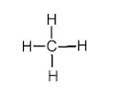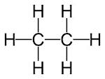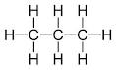
61 | What is the formula for the alkenes  - ethene  - propene | - C₂H₄  - C₃H₆
62 | a) Explain what “cracking” is, and what products are made.  b) Why do oil companies bother to carry out this reaction? | a) Cracking is the splitting (using heat) of a long chain saturated hydrocarbon (an alkane) to form a shorter chained alkane and an alkene.  b) Shorter chained hydrocarbons make better fuels. Crude oil contains too many of the longer chained molecules, so oil companies crack them to i) make more of the useful fuels, and ii) make alkenes (which can be used to make polymers).
63 | How was the earth’s first atmosphere formed? | From gases produced by volcanic activity.
64 | What are thought to be the relative proportions of the gases that formed the early atmosphere? | Little or no oxygen, large amounts of carbon dioxide, large amounts of water vapour and small amounts of other gases.
65 | Why can’t we be certain about how the earth’s atmosphere formed? | There is only limited evidence (e.g. from rocks and ice cores) about the earth’s early atmosphere.
66 | How were the earth’s oceans formed? | Water vapour, released by volcanoes, condensed to form the oceans.
67 | How did the amount of oxygen in the atmosphere gradually increase? | Green plants evolved. The growth of these primitive plants used carbon dioxide and released oxygen by photosynthesis.
68 | What is a chemical test for oxygen? | Oxygen will relight a glowing splint.
69 | Describe the processes, other than photosynthesis, that reduced the amount of carbon dioxide in the atmosphere. | - Carbon dioxide dissolved into the oceans.  - Dissolved carbon dioxide was incorporated into the shells of marine organisms. When marine organisms die their shells can eventually form carbonate rocks.
70 | What is the greenhouse effect? | This is when various gases are added to the atmosphere, including carbon dioxide, methane and water vapour. These gases absorb heat radiated from the Earth and subsequently release the energy that keeps the Earth warm.
71 | What evidence do we have for global warming and why can we not be absolutely certain about it? | Scientists have discovered a correlation between historical global temperature and carbon dioxide levels. They also know how much carbon dioxide we are presently adding to the atmosphere.  We cannot be certain about this because of historical accuracy of the temperature and carbon dioxide levels and also due to uncertainties caused by the location where measurements are taken.
72 | List the percentages of the gases in our modern atmosphere. | Nitrogen 78%, oxygen 21%, 1% other gases (argon, carbon dioxide and water vapour).
73 | What are the potential effects on the climate of increased levels of carbon dioxide and methane caused by human activity? | The climate will warm up although we cannot be certain by how much. It is also suspected we will have a long term change in weather (e.g. more/less rain) and more extreme weather events.
74 | How might the greenhouse effect be mitigated? | We would need to reduce the consumption of fossil fuels by looking at alternative sources of energy e.g. nuclear or renewables. Also, a different fuel for transport e.g. electricity or fuel cells.
75 | Why can we not just stop burning fossil fuels to generate electricity? | Nuclear power is not liked by all and the waste is a risk and can be a problem for the environment. Solar and wind don’t produce that much electricity so you would need thousands of solar and wind farms and this would take too much space and be extremely expensive. Generation from solar and wind is not always continuous.

Homework – 1

Give a definition of relative atomic mass.

1
Give a definition of isotope.

1

Complete the following table showing the numbers of sub atomic particles in magnesium and its isotopes. Magnesium has an atomic number of 12.

Sub atomic particle | ²⁴Mg | ²⁵Mg | ²⁶Mg
Proton
Neutron
Electron
3

A sample of Lithium contains 10% of lithium-6 atoms and 90% of lithium-7 atoms. What is the relative atomic mass of lithium?

3

A sample of titanium contains:
- 8% of titanium-46 atoms.
- 8% of titanium-47 atoms.
- 74% of titanium-48 atoms.
- 5% of titanium-49 atoms.
- 5% of titanium-50 atoms.

What is the relative atomic mass of titanium?
3

Total _________/11

Homework – 2
How many protons, neutrons and electrons are there in Na⁺?
Sub atomic particle | Na⁺
Proton
Neutron
Electron
3
Use the formulae of the anions below to give the formulae of the following ionic compounds containing sodium.
OH⁻ SO₄²⁻ NO₃⁻

- Sodium hydroxide _____________________________

- Sodium sulphate _____________________________

- Sodium nitrate _____________________________

3
What would be the pH of each of these compounds?

- Sodium hydroxide _____________________________

- Sodium sulphate _____________________________

- Sodium nitrate _____________________________ 3
Draw the electronic configurations of ₁₂Mg and ₂₀Ca and use these diagrams to explain which you think is the more reactive.

₁₂Mg | ₂₀Ca
4
Lithium, when exposed to the air reacts with oxygen. Write a balanced symbol equation for this reaction.
3

Draw a diagram to show the bonding in lithium oxide.
3

Does lithium oxide have a high or low melting point? Explain.
3

Under what circumstances will lithium oxide conduct electricity and explain?

3
Thallium is made of two naturally occurring isotopes: thallium-203 (30%) and thallium-205 (70%). Calculate the relative atomic mass of thallium.

(3)

Total _________/28
Homework – 3

Chlorine water is added to lithium bromide.
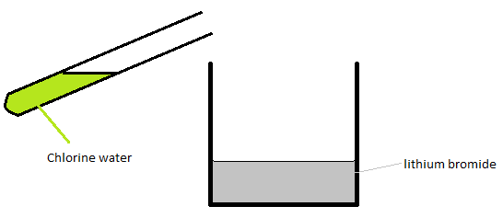

What colour is the chlorine water at the start? Give a reason for your answer.

Colour | Reason
2

Write a balanced symbol equation for the reaction?

3

What colour would the mixture be after the reaction? Give a reason for your answer.

Colour | Reason
2
Explain why this is a redox reaction.

2

What mass of hydrogen chloride is made when 8g of hydrogen reacts with excess chlorine? (A_{r} H =1, Cl = 35.5)
H₂ + Cl₂ 2HCl
3
What pH does the solution of hydrogen chloride have when it is dissolved in water?

________________________
1
What is a test for chlorine?
2

Total _________/15

Homework – 4

When sodium reacts with oxygen, sodium oxide is formed. It is made up of positive and negative ions.

What charge do the sodium ions have and how are they formed?

Charge | How the sodium ions are formed.
2
What charge do the oxide ions have and how are they formed?

Charge | How the oxide ions are formed.
3

How are the ions held together in sodium oxide?
1
Name this type of bonding. ____________________________________
1
Chlorine also forms a gaseous compound with oxygen, with the formula Cl₂O.
Explain or show by means of a diagram, how these two elements bond to form Cl₂O, and name the type of bonding used.
Type of bonding | Explanation or diagram
3
Explain why the bonding in sodium oxide produces a solid with a high melting point.
2

Explain why chlorine oxide is a gas at room temperature.
2
One of these compounds (sodium oxide or chlorine oxide) will conduct electricity under certain circumstances. Which of these will conduct, state the conditions necessary and explain why it does conduct electricity.

Name of conducting substance | Conditions | Reason
4
What are the products of the electrolysis of sodium chloride (aq)

Cathode product ___________________________________

Anode product ___________________________________
2
Write half equations for the reactions at the cathode and anode

Electrode | Half equation
Cathode
Anode
2

Total _________/22

Homework – 5

Magnesium ribbon reacts with hydrochloric acid to produce hydrogen gas. The volume of hydrogen produced in a reaction was measured using a gas syringe. The acid was present in excess.

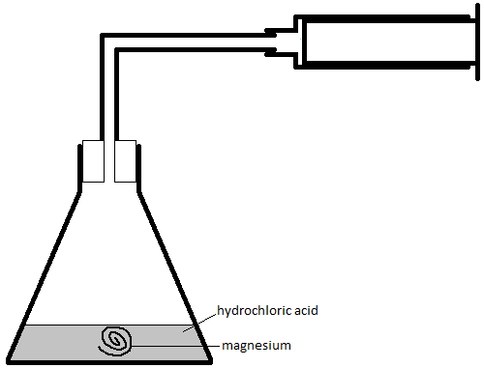

Write a balanced symbol equation for this reaction.

3
On the graph paper below plot a graph of the following results. Include a line of best fit.

Time (s) | 0 | 20 | 40 | 60 | 80 | 100 | 120 | 140
Volume of gas (cm³) | 0 | 18 | 42 | 44 | 51 | 53 | 55 | 55
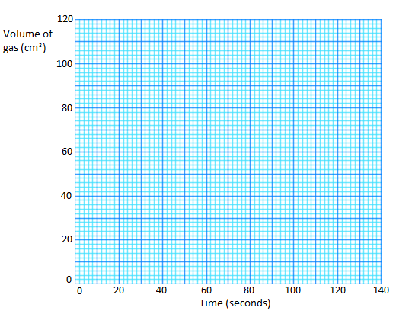
3
Are there any anomalous points? If so which one(s)?

1

The acid was present in excess. What does excess mean?

1

If the same length of magnesium ribbon had been cut into small pieces, with the acid the same as used before, sketch on the same graph paper the graph that would have been obtained and label it B.
2

If the magnesium ribbon had been replaced by a piece twice as long, with the acid the same as before and still in excess, sketch on the same graph paper the graph that would have been obtained and label it C
2
Apart from changes to the magnesium, give 2 ways in which the first experiment could have been slowed down.

1
2
2
Calculate the rate at the beginning of the reaction.
1
An equation for aluminium reacting with hydrochloric acid is:
2Al + 6HCl 2 AlCl₃ + H₂
What mass of hydrogen is obtained from 270g of aluminium and excess acid? A_{r} Al = 27, H = 1.

3

What is the relative formula mass (M_{r}) of aluminium chloride? A_{r} Al = 27, Cl = 35.5.
1

Total _________/19

Homework – 6
Use the table of bond energies to answer the following questions:
Covalent bond | Bond energy (kj mol⁻¹) | Covalent bond | Bond energy (kj mol⁻¹)
C-H | 413 | H-H | 436
O=O | 498 | C-O | 358
C=O | 805 | C-Cl | 328
O-H | 464 | Cl-Cl | 242
C=C | 614 | C-C | 348
H-Br | 366 | Br-Br | 193
N≡N | 941 | N-H | 391

In year 10 you learnt about the electrolysis of water (equation below). Calculate the energy change in this reaction and state whether it is an endothermic or exothermic process. Once complete then finish the energy level diagram by both clearly labelling and stating the activation energy.

2H₂O 2H₂ + O₂

Bond energy calculation

____________________ Kj mol⁻¹
3
Exothermic or endothermic | 1
Energy Level diagram ( complete and label the activation energy)

3
Activation energy | ____________________ Kj mol⁻¹  1

What mass of water is needed to make 128 tonnes of oxygen? (A_{r} H = 1, O = 16)
3

Total _________/18

Homework – 7

The following processes are all related to crude oil, for each one state whether it is a chemical or physical process. Write a sentence explaining it and a sentence explaining why it is a necessary process.
Name | Chemical or Physical | Explanation | Why necessary
Cracking
Combustion
Distillation
Polymerisation
12
Kerosene is an important product, how is it obtained and what is it used for?
2

Depending on the conditions when cracking is carried out different products can be obtained. In one particular experiment, molecules of C₁₂H₂₆ are cracked and three different products are produced; one of them has the formula C₃H₆, another is C₂H₄ and you need to work out the formula of the last. Complete the table filling in each cell.
Formula | Name | Structure | Hydrocarbon Family.
C₃H₆
C₂H₄
9

There are 2 homologous series named in the previous table. Fully explain the differences between them. Include in your answer where they are obtained, the differences in their chemical structures and (single chemistry only) a suitable test to distinguish between them giving the results of the test with each family.
3

Write a balanced symbol equation for the complete combustion of methane.
3

Explain the difference between complete and incomplete combustion. Include in your explanation the conditions that determine the combustion type and the differing products of each reaction.
3

One of the products of incomplete combustion is known as the ‘silent killer’. Why does this product have this name? Include in your answer the type of appliance that produces it, why it is known as ‘silent’ and how it kills.
3

Total _________/35

Homework – 8
Write an explanation to describe each of the following reactions or processes:

Reaction | Explanation
Electrolysis
Neutralisation
Oxidation
Reduction
Distillation
Cracking
Polymerisation
7

In an experiment, 0.18 g of X reacted with 0.34 g of Y. What is the empirical formula of the compound XY?
(A_{r}: X – 56, Y – 35.5)

3

The table shows gas tests you need to know for both papers. Complete all the blank spaces:
Gas | Apparatus | Method | Result
 |  | Test with a lit splint
Ethane/ethene

Single Chemistry only
 |  |  | Splint relights
Chlorine
15

Total _________/25

Homework – 9

There are 3 naturally occurring isotopes of oxygen; oxygen – 16, oxygen – 17 and oxygen – 18.

Give the electronic structure (configuration) of oxygen.

1
Draw a diagram to show the electronic structure of the oxygen molecule. Show outer electrons only.

2
What is an isotope?

1
Oxygen has an atomic number of 8. What does the atomic number tell us about the atom?

1
Give the composition of the atoms of the oxygen isotopes in the table below.

Isotope | Protons | Neutrons | Electrons
oxygen – 16
oxygen – 17
oxygen – 18
3

What would be the number of protons, neutrons and electrons in ?

Number
Protons
Neutrons
Electrons
2
Oxygen can bond with many metals. What type of bonding will this be?

1
Explain how magnesium bonds with oxygen.

4
Give the formula of the compounds produced when oxygen bonds with lithium, calcium and iron (III).

Cation | Formula
Lithium
Calcium
Iron (III)
3
It was found that 1.335 g of aluminium chloride contained 0.270 g of aluminium. Calculate the empirical formula of aluminium chloride.

3

Total _________/19
Homework – 10

Write a balanced symbol equation for each of the following reactions and state what type of reaction it is.
Example | Balanced symbol equation | Reaction type
Hydrochloric acid reacting with calcium carbonate
Sodium iodide reacting with chlorine
Methane burning in plenty of oxygen.
Methane burning in limited oxygen | Equation does not need balancing.
Heating and pressurising ethene
Heating copper oxide with carbon.
Passing a direct current through water | 2 half equations required
Passing a long chain hydrocarbon of a hot porous catalyst | Just give an example of an equation
The half equation for the reaction at the anode when a solution containing sulfate ions is electrolysed
18

5 g of sodium hydroxide is dissolved in 40 cm³ of water, what is its concentration in g dm⁻³?

2
Calculate how many molecules are present in 5 moles of carbon monoxide (CO).
(Avogadro constant = 6.02 x 10²³)

2

Total _________/22
Homework – 11
What were the gases in the first atmosphere?
3
Why can we not be certain of the makeup of the earth’s original atmosphere?
2
How was oxygen added to the atmosphere?
1
Why did the carbon dioxide in the earth’s early atmosphere decrease?
3
What is leading to an increase in the amount of carbon dioxide in the atmosphere today?
3
Complete and label the chart to show the gases that make up the current atmosphere. You may round the proportions of each gas to the nearest 10%.

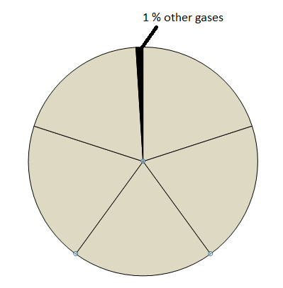
1

Complete the table below to show the difference between global warming and acid rain. As part of this draw a diagram to illustrate your explanation

 | Global Warming | Acid Rain
Gas responsible
Explanation
Diagram
Solutions
7

What is the relative atomic mass of a sample of thallium that is comprised 30% thallium-203 and 70% thallium-205?

3

Total _________/23
Homework – 12

A class tried to work out the percentage of oxygen in the atmosphere with the following apparatus:
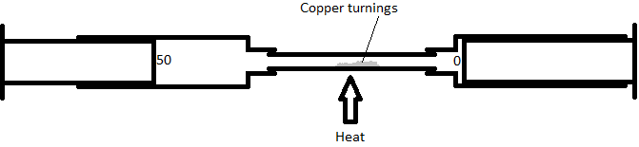
Two gas syringes were connected with a piece of glass tubing that contained copper turnings. One gas syringe was filled to exactly 50 cm³ with air from the room and the other was left empty. The copper turnings were then heated and the air from the syringe was passed over them and into the other syringe. This process was repeated for several minutes.

After the tubes had cooled down, did the volume of gas go up, down or stay the same? Explain your answer.
Up/down/same

Explanation

2

Why would the class have to have wait until the tubes had cooled to take their reading?
2
Given that the air is 20% oxygen, calculate what volume of gas you would expect in the gas syringes at the end of the experiment?
2
Would the mass of the copper go up, down or stay the same in this reaction?

1
Look at the reactions below, the mass of container holding each reaction can increase, decrease or stay the same. State which you would expect and give a reason.

Reaction | Mass | Reason
CaCO₃ (s) → CaO (s) + CO₂ (g)
Mg (s) + O₂ (g) → MgO (s)
NaOH (aq) + HCl (aq) → NaCl (aq) + H₂O (l)
CaCO₃(s) + 2HCl(aq) → CaCl₂(aq) + H₂O(l) + CO₂(g)
CaO (s) + H₂O (l) → Ca(OH)₂ (aq)
5
What is responsible for carbon dioxide being added to the atmosphere?

- __________________________________

- __________________________________

2
What is responsible for removing carbon dioxide from the atmosphere?

- __________________________________

- __________________________________
2

The graph shows a continuous record of the concentration of carbon dioxide in the Earth's atmosphere from 1958.
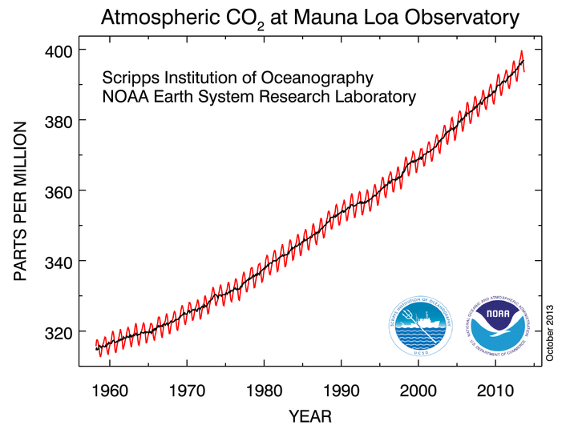

Fully describe how the amount of carbon dioxide in the atmosphere has changed since 1958 to October 2013. (Remember it is possible to answer questions in science quite correctly but very badly if the required level of detail is not present. For example, if you just say the amount of carbon dioxide has increased, it would be correct but an awful answer.)
3
Can you give reasons for all the trends you have identified?
3

Total _________/22

Homework Scores:
Homework | Score | Knowledge Test | Score
1 | __________/11 | 1 | __________/5
2 | __________/28 | 2 | __________/5
3 | __________/15 | 3 | __________/5
4 | __________/22 | 4 | __________/5
5 | __________/19 | 5 | __________/5
6 | __________/18 | 6 | __________/5
7 | __________/38 | 7 | __________/5
8 | __________/25 | 8 | __________/5
9 | __________/19 | 9 | __________/5
10 | __________/22 | 10 | __________/5
11 | __________/23 | 11 | __________/5
12 | __________/22 | 12 | __________/5

