Core essential knowledge
for
Year 10 Internal assessment 2022
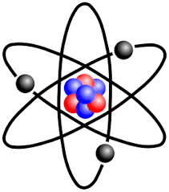

Student name __________________

Topics | QR code |  | Topics | QR code
Calculate relative formula mass |  |  | Calculating Rf values
Calculate mass of isotope
Calculate empirical formula
Calculate the concentration in gdm⁻³
Balancing equations
Atomic structure
Electron arrangement and position in the periodic table
Finding formula based on ions
Drawing covalent molecules
Metal, covalent, ionic bonding, structure and properties

Chemistry code of success
In order to be successful we need to work together and support each other. The code of success is designed to share with you the things that need to happen for you to be successful. Success is not based on intelligence. Success is based on hard work, practice and repetition, learning from mistakes and a desire to be the best you can.
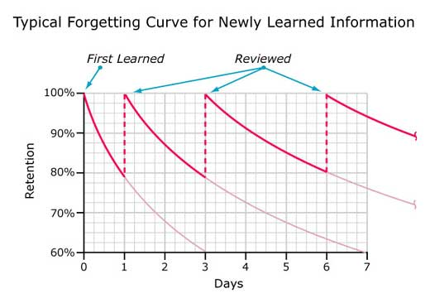
Core knowledge is a crucial part of your chemistry studies. Students that have a good recall of their core knowledge have a greater chance of success in chemistry.
This booklet contains the core knowledge that you must learn during the next two years of your studies. There is also a quizlet that you can use to practice your core knowledge. This can be found with Quizlet by searching for buildyouriceberg.
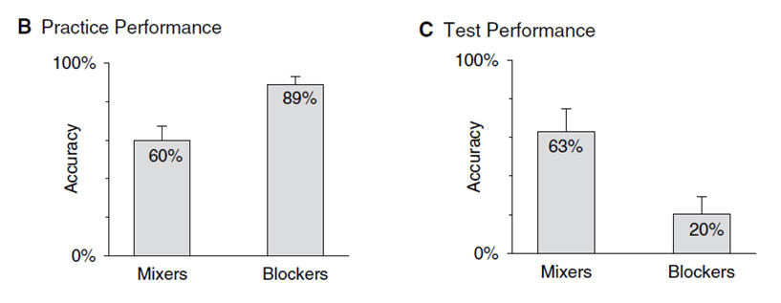
To help students learning and remember these facts the following strategies are recommended:
a) Regular quizzing - Three 15-20 minute sessions a week would help greatly.
b) Spacing – leaving time between each sessions will allow students to forget information. This forgetting and relearning strengthens the recall of information.
c) Interleaving – cover a different topic in each revision session helps to strengthen a student’s memory of the core knowledge.
Parents/carers if you are able to support your child with the learning of this material then that is a great help. You can quiz them by asking them the questions within the book. The answers have been included to support the use of this booklet.
Remember that your success in chemistry is your responsibility. Your success will be based on how hard you work.
Core Questions:
1 | What is an atom? | The smallest particle that has the properties of a chemical element.
2 | Describe the structure of an atom. | A nucleus containing protons and neutrons, surrounded by electrons in shells.
3 | What are the relative charges and masses of protons, neutrons and electrons. | Protons: mass 1, charge +1  Neutrons: mass 1, charge 0  Electrons: mass almost zero, charge -1.
4 | Why do atoms contain the same number of protons and electrons? | Atoms are neutrally charged so they must have the same number of positive particles (protons) as negative particles (electrons)
5 | How would you describe the size of the nucleus relative to the rest of the atom? | Very small
6 | Where is most of the mass of the atom found? | In the nucleus.
7 | What is the mass number of an element? | The total number of protons and neutrons.
8 | What is the atomic number of an element? | The number of protons.
9 | The number of which particle is unique to an element and gives it its identity? | Protons
10 | If an atom contains 12 protons, how many electrons will it have? | 12.
11 | If an atom has a mass number of 23 and an atomic number of 11, how many protons, neutrons and electrons does it contain? | 11 protons  11 electrons  23-11 = 12 neutrons
12 | What is an isotope? | Two or more atoms of the same element (the same number of protons) but with a different number of neutrons.
13 | What is the relative atomic mass, (A_{r})? | The relative mass of an atom compared to the mass of an atom of carbon-12.
14 | Why do some elements have a relative atomic mass that is not a whole number. | The relative atomic mass is an average mass of all the isotopes that make up the element.
15 | What is the formula for calculating relative atomic mass of an element from the relative mass and abundance of its isotopes?
16 | How did Mendeleev arrange the elements known at the time into a periodic table? | By using the mass number and the properties of the elements and the properties of their compounds of the elements.
17 | How did Mendeleev use his table? | To predict the existence and properties of some elements that were still to be discovered.
18 | Why does Mendeleev’s method of organising elements in order of increasing atomic mass not always work? | The relative abundancies of some elements isotopes means they can be placed in the wrong place.

19 | How are elements in the modern periodic table arranged? | In order of increasing atomic number in rows called periods and elements with similar properties are placed in the same vertical columns called groups.
20 | Where are the non-metals found in the periodic table? | At the top on the right hand side.
21 | What do all elements in the same row of the periodic table have in common? | They have the same number of shells of electrons.
22 | What do all elements in the same column of the periodic table have in common? | They have the same number of electrons in their outer shell (and therefore have similar chemical properties).
23 | What is an ion? | A charged atom or group of atoms.
24 | Describe how an ionic bond is formed. | A metal loses electron(s) to a non-metal. This results in the metal becoming a positively charged ion (cation) and the non-metal a negatively charged ion (anion). These oppositely charged ions then attract.
25 | Is a cation positively or negatively charged? | Positive
26 | Is a anion positively or negatively charged? | Negative
27 | What charge do the ions have when formed from elements in group:  - 1  - 2  - 6  - 7 | - +  - 2+  - 2-  - -
28 | What do the compound endings:  - ide  - ate  mean? | - ide – a compound of only the named substances  - ate – a compound of the named substances and oxygen
29 | What is the formula of the compounds formed from:  - Mg²⁺ and Cl⁻  - Na⁺ and O²⁻? | - MgCl₂  - Na₂O
30 | Describe the structure of ionic substances. | Ionic substances are a regular arrangement of oppositely charged ions held together in a lattice structure by strong electrostatic forces.
31 | How many electrons does Mg²⁺ have? Mg has an atomic number of 12 | 10
32 | Describe what happens in covalent bonding? | Two non-metals overlap their outer electron shells and share at least one pair of electrons.
33 | What does covalent bonding result in the formation of? | molecules
34 | Name and explain two physical properties of ionic compounds. | - They have high melting and boiling points because there are strong electrostatic forces holding the oppositely charged ions in place, therefore a lot of energy is needed to separate the ions.  - They can conduct electricity when molten or in aqueous solution (dissolved in water) because the ions are free to move and carry their charge.
35 | Name and explain two physical properties of covalent, simple molecular compounds. | - They have low melting and boiling points because there are weak intermolecular forces of attraction between molecules.  - They do not conduct electricity because the molecules are not charged.
36 | Describe the structures of:  - Diamond  - Graphite | - Each carbon atom is held in place by 4 strong covalent bonds to other carbon atoms. This arrangement is replicated throughout the whole structure creating a giant structure.  - Each carbon atom is held in place by 3 strong covalent bonds. This creates flat layers of carbon atoms which stack on top of each other. The unused outer electron on each carbon atom sits between these layers and is delocalised (free to move).
37 | Why is diamond used in cutting tools? | Diamond is very hard because all the carbon atoms are joined by 4 strong covalent bonds.
38 | Why does diamond have such a high melting point? | In diamond each carbon atom is held in place by 4 strong covalent bonds and it takes a lot of energy to break these bonds.
39 | Why does graphite conduct electricity? | In graphite each carbon forms 3 bonds, this leaves one electron left over from each carbon atom which sits between the graphite layers and is free to move and carry a charge.
40 | Why can graphite act as a lubricant? | The layers of carbon atoms in graphite are only very weakly joined and are therefore free to slide past each other.
41 | What are fullerenes? Explain its properties in terms of its structure and bonding. | C₆₀ is one example where 60 carbons bond together covalently making a structure that looks like a football. These are simple molecules and behave as such. It is possible to ‘dope ‘ the C₆₀ with metal atoms and it then becomes a superconductor.
42 | What is graphene? Explain its properties in terms of its structure and bonding. | Graphene is like graphite, just 1 layer thick. It therefore conducts electricity and for its thickness is very strong.
43 | Describe polythene’s structure | Polythene is an example of a polymer. It is a large molecule containing chains of carbon atoms surrounded by hydrogen.
44 | Describe the bonding in metals? | All metals form positive ions and their outer electrons are delocalised and sit between the metal ions (forming a ‘sea of electrons’).
45 | Why do metals conduct electricity? | There are free electrons in the metallic structure that can move.
46 | Why are metals malleable? | They bend because the ions can slide over one another.
47 | Why is it difficult to represent models of compounds on paper? | Compounds are normally 3 dimensional and contain different sized atoms. This can give them particular shapes that are hard to draw clearly in 2 dimensions (on paper).
48 | What are the properties of most metals? | Shiny solid, high melting points, high density and good conductors of electricity.
49 | What is an empirical formula? | The simplest ratio of the elements in a compound.
50 | What is the law of conservation of mass? | During any chemical reaction no particles are created or destroyed. So the overall mass of the reactants must equal the mass of the products.
51 | What unit do we use for concentration? | g dm⁻³ (grams per decimetre cubed)
52 | What is 1 mole of particles? | The Avogadro constant (6.02 x 10²³ particles).
53 | What is the formula to calculate moles? | Moles = Mass/Relative formula mass
54 | What are the 3 states of matter? | Solid, liquid and gas
55 | Name the interconversion between the:  - Solid to the liquid state  - Liquid to the gaseous state  - gaseous state to the liquid state  - Liquid to the solid state | - Melting  - Evaporating (or if heated to boiling point – Boiling)  - Condensing  - Freezing
56 | Describe how the particles arrangement, movement and energy changes during melting. | The particles energy increases on heating causing the vibrations between particles to increase to an extent that they break free from their regular arrangement and start moving over one another.
57 | Describe how the particles arrangement, movement and energy changes during melting. | The particles energy decreases on cooling causing the particles to slow down and become attracted to other particles.
58 | What is the difference between a pure substance and a mixture? | A pure substance is made of just one thing whereas a mixture is made of more than one substance which are not chemically joined.
59 | What type of mixtures can be separated by each of these techniques?  - Simple distillation  - Fractional distillation  - Filtration  - Crystallisation  - Paper chromatography | - A dissolved solid where you want to keep the liquid or 2 liquids with very different boiling points.  - A large sample of a mixture of liquids with similar boiling points  - An insoluble solid and a liquid.  - A dissolved solid where you do not want the liquid.  - A small sample of a mixture of liquids.

60 | What is Chromatography? | A separating technique used to separate mixtures of soluble substances by running a solvent (mobile phase) through the mixture on the paper (stationary phase) which causes the substances to move at different rates over the paper.
61 | How can you use paper chromatography to identify a substance? | Each substance will run a specific distance up the paper and have its own unique R_{f}.
62 | In chromatography, define the R_{f} value. | R_{f} = distance moved by the component  distance moved by the solvent
63 | How can ground water be made potable? | Sedimentation, filtration and chlorination
64 | How can sea water be made potable? | Distillation.
65 | Why must water used in analysis not contain any dissolved salts? | Dissolved salts could cause an analysis to give a false positive result. In other words you might get a positive result for something that isn’t really there.

Paper 1 – Topic 0 key concepts answers
- Balance the following equations
- Ca + HF → CaF₂ + H₂ | - NaBr + Cl₂ → NaCl + Br₂
- Zn + H₂O ZnO + H₂ | - Li + O₂ Li₂O
- CH₄ + O₂ CO₂ + H₂O | - Al₂O₃ Al + O₂
- N₂ + H₂ NH₃ | - Fe₂O₃ + CO Fe + CO₂
- Li + H₂O LiOH + H₂ | - CO₂ + H₂O C₆H₁₂O₆ + O₂

Paper 1 and 2 – Topic 1 atomic structure answers
- Draw the structure of an atom of lithium. Include the correct number of protons, neutrons and electrons and label the nucleus and energy levels.
Diagram of labelled atom

- Complete the following table
Particle | Location in the atom | Mass | Charge
Proton
Neutron
Electron

- Explain why atoms have no overall charge (1)
_______________________________________________________________________________

- What is the definition for an isotope?
_______________________________________________________________________________
_______________________________________________________________________________

- What is the formula used to calculate the relative atomic mass of an element from the relative mass and abundance of its isotope?
Relative  atomic mass | =

- The mass and abundance of boron’s isotopes are 19.9% boron-10 and 80.1% boron-11. Use this information to calculate the relative atomic mass for boron.
_______________________________________________________________________________
_______________________________________________________________________________
_______________________________________________________________________________

- Describe the relationship between an atoms location in the periodic table and it electron structure. You should use calcium (2, 8, 8, 2) as your example and refer to the period and group which aluminium is found in. (2)
_______________________________________________________________________________
_______________________________________________________________________________

Paper 1 and 2 – Topic 1 ionic bonding answers
- Draw diagrams to show the electron arrangement for each stage of the reaction between sodium and chlorine.
Sodium atom before bonding | Chlorine atom before bonding | Sodium ion after bonding | Chloride ion after bonding

- Explain why the sodium ion and chloride ion become charged.
_______________________________________________________________________________
_______________________________________________________________________________

- Describe how an ionic compound is held together.
_______________________________________________________________________________

- Use the information below to find the formula of the compounds in the table.
Information
Mg²⁺ O²⁻ Na⁺ F⁻ CO₃²⁻ OH⁻ SO₄²⁻
Sodium fluoride | Magnesium fluoride | Sodium carbonate | Magnesium oxide
Sodium sulfate | Magnesium sulfate | Sodium oxide | Magnesium hydroxide

- Draw a diagram of an ionic lattice and describe what is meant by the phrase ‘ionic lattice’.

_______________________________________________________________________________
_______________________________________________________________________________

- Explain why sodium chloride has a high melting and boiling point. (2)
_______________________________________________________________________________

- Complete the following table
 | Does it conduct electricity | Explanation
Solid Sodium chloride

Molten Sodium chloride
Dissolved sodium chloride

Paper 1 and 2 – topic 1 covalent bonding answers
- What is a covalent bond?
_______________________________________________________________________________

- Draw diagrams to show the covalent bonds in the following molecules. Hydrogen has been completed for you.
Hydrogen molecule  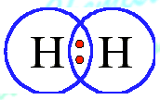 | Hydrogen chloride
Water | Methane
Oxygen | Carbon Dioxide

- Complete the table below to explain why simple covalent compounds have the following properties:
Property | Reason
Low melting and boiling point
Poor conductors of electricity

- Draw a labelled diagram to show the structure of a metal.

- Use the structure of metals to explain why metals have the following properties
Property | Reason
Malleable
Conduct electricity

Paper 1 and 2 – Topic 1 masses and calculations answers
- Calculate the relative formula mass for the following compounds
Compound | Relative formula mass |  | Compound | Relative formula mass
Methane, CH₄ |  |  | ethanol, CH₃CH₂OH
Sodium chloride, NaCl |  |  | iron(III) sulphate, Fe₂(SO₄)₃
Ammonia, NH₃ |  |  | lead nitrate, Pb(NO₃)₂

- A compound contains 0.31g of phosphorus and 1.07g of chlorine. Calculate the empirical formula based on this information.
_______________________________________________________________________________
_______________________________________________________________________________
______________________________________________________________________________________________________________________________________________________________
_______________________________________________________________________________
_______________________________________________________________________________

- Calculate the concentration when 2.1g of of sodium hydrogencarbonate, NaHCO₃, in 250cm³ of solution?
______________________________________________________________________________________________________________________________________________________________
_______________________________________________________________________________

Paper 1 – Topic 2 states of matter answers
- Link each separation technique to the mixture it can be used to separate.
Separation technique |  | Mixture
Simple distillation |  | A dissolved solid where you do not want the liquid.
Fractional distillation |  | A mixture of soluble substances e.g. inks.
Filtration |  | A dissolved solid where you want to keep the liquid or 2 liquids with very different boiling points.
Crystallisation |  | A large sample of a mixture of liquids with similar boiling points.
Paper chromatography |  | An insoluble solid and a liquid.

- Calculate the R_{f} value for sample a, b and c below. Show your working out.
Sample | R_{f} value
A
B
c

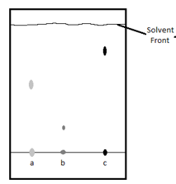

- Explain how you can tell is a substance is pure or a mixture from the chromatography results.
______________________________________________________________________________________________________________________________________________________________
_______________________________________________________________________________

- During filtration a residue and filtrate are produced. Explain the meaning of these two words.
Filtrate
Residue

Paper 1 – Topic 0 key concepts answers
- Balance the following equations
- Ca + HF → CaF₂ + H₂  Ca + 2HF → CaF₂ + H₂ | - NaBr + Cl₂ → NaCl + Br₂  2NaBr + Cl₂ → 2 NaCl + Br₂
- Zn + H₂O ZnO + H₂  Zn + H₂O ZnO + H₂ | - Li + O₂ Li₂O  4Li + O₂ 2 Li₂O
- CH₄ + O₂ CO₂ + H₂O  CH₄ + 2 O₂ CO₂ + 2H₂O | - Al₂O₃ Al + O₂  2Al₂O₃ 4 Al + 3O₂
- N₂ + H₂ NH₃  N₂ + 3H₂ 2NH₃ | - Fe₂O₃ + CO Fe + CO₂  Fe₂O₃ + 3 CO 2Fe + 3 CO₂
- Li + H₂O LiOH + H₂  2Li + 2 H₂O 2 LiOH + H₂ | - CO₂ + H₂O C₆H₁₂O₆ + O₂  6CO₂ + 6H₂O C₆H₁₂O₆ + 6 O₂

Paper 1 and 2 – Topic 1 atomic structure answers
- Draw the structure of an atom of lithium. Include the correct number of protons, neutrons and electrons and label the nucleus and energy levels.
Diagram of labelled atom
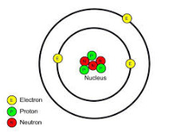

- Complete the following table
Particle | Location in the atom | Mass | Charge
Proton | nucleus | 1 | +1
Neutron | nucleus | 1 | 0
Electron | Energy level | 1/1840 | -1
- Explain why atoms have no overall charge (1)
they have the same number of positive protons as they have negative electrons.

- What is the definition for an isotope?
Isotopes are atoms of the same element which have different numbers of neutrons but the same number of protons.

- What is the formula used to calculate the relative atomic mass of an element from the relative mass and abundance of its isotope?
Relative  atomic mass | = % abundance atom 1 x atomic mass atom 1 + % abundance atom 2 x atomic mass atom 2  100 100

- The mass and abundance of boron’s isotopes are 19.9% boron-10 and 80.1% boron-11. Use this information to calculate the relative atomic mass for boron.
relative atomic mass = 19.9 x 10 + 80.1 x 11 = 10.8
100 100

- Describe the relationship between an atoms location in the periodic table and it electron structure. You should use calcium (2, 8, 8, 2) as your example and refer to the period and group which aluminium is found in. (2)
calcium is in group 2 because it has two electrons in the outer energy level. Calcium is in the fourth period because it has four energy levels.

Paper 1 and 2 – Topic 1 ionic bonding answers
- Draw diagrams to show the electron arrangement for each stage of the reaction between sodium and chlorine.
Sodium atom before bonding | Chlorine atom before bonding | Sodium ion after bonding | Chloride ion after bonding
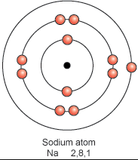 | 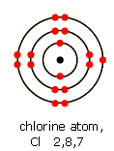 | 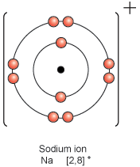 | 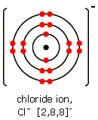

- Explain why the sodium ion and chloride ion become charged.
The sodium ion has a positive charge because it has lost electrons
The chloride ion has a negative charge because it has gained an electron
- Describe how an ionic compound is held together.
there is an electrostatic attraction between the positive sodium ions and negative chloride ions
- Use the information below to find the formula of the compounds in the table.
Information
Mg²⁺ O²⁻ Na⁺ F⁻ CO₃²⁻ OH⁻ SO₄²⁻
Sodium fluoride  NaF | Magnesium fluoride  MgF₂ | Sodium carbonate  Na₂CO₃ | Magnesium oxide  MgO
Sodium sulfate  Na₂SO₄ | Magnesium sulfate  MgSO₄ | Sodium oxide  Na₂O | Magnesium hydroxide  Mg(OH)₂

- Draw a diagram of an ionic lattice and describe what is meant by the phrase ‘ionic lattice’.
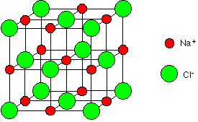

An ionic lattice is a regular repeated pattern of positive and negative ions which are held together by electrostatic attractions.
- Explain why sodium chloride has a high melting and boiling point. (2)
The electrostatic attraction between the ions is strong and requires a lot of energy to break
- Complete the following table
 | Does it conduct electricity | Explanation
Solid Sodium chloride | No | Ions are held in a lattice by an electrostatic attraction. They are not able to move
Molten Sodium chloride | Yes | The electrostatic attractions have been broken and the ions are free to move.
Dissolved sodium chloride | Yes | The electrostatic attractions have been broken and the ions are free to move.

Paper 1 and 2 – topic 1 covalent bonding answers
- What is a covalent bond?
A covalent bond is formed when two atoms share a pair of electrons.
- Draw diagrams to show the covalent bonds in the following molecules. Hydrogen has been completed for you.
Hydrogen molecule | Hydrogen chloride  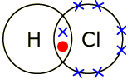
Water  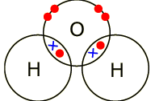 | Methane  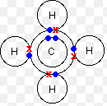
Oxygen  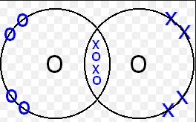 | Carbon Dioxide  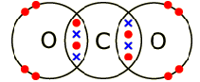

- Complete the table below to explain why simple covalent compounds have the following properties:
Property | Reason
Low melting and boiling point | There are weak forces of attraction between molecules which do not require a lot of energy to break them.
Poor conductors of electricity | There are no free electrons because they are used in bonding.

- Draw a labelled diagram to show the structure of a metal.
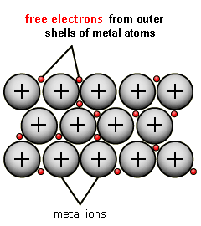

- Use the structure of metals to explain why metals have the following properties
Property | Reason
Malleable | The layers of ions are able to slide
Conduct electricity | The delocalised electrons are able to move about to carry the electrical current

Paper 1 and 2 – Topic 1 masses and calculations answers
- Calculate the relative formula mass for the following compounds
Compound | Relative formula mass |  | Compound | Relative formula mass
Methane, CH₄ | 1xC=1x12=12  4xH=4x1=4  Total = 16 |  | ethanol, CH₃CH₂OH | 2xC=2x12=24  6xH=6x1=6  1xO=1x16=16  Total = 46
Sodium chloride, NaCl | 1xNa=1x23=23  1xCl=1x35.5=35.5  total = 58.5 |  | iron(III) sulphate, Fe₂(SO₄)₃ | 2xFe=2x56=112  3xS=3x32=96  12xO=12x16=192  Total = 400
Ammonia, NH₃ | 1xN=1x14=14  3xH=3x1=3  Total = 17 |  | lead nitrate, Pb(NO₃)₂ | 1xPb=1x207=207  2xN=2x14=28  6xO=6x16=96  Total = 331

- A compound contains 0.31g of phosphorus and 1.07g of chlorine. Calculate the empirical formula based on this information.
 | Phosphorus | Chlorine
mass | 0.31 | 1.07
Relative atomic mass | 31 | 35.5
No of moles | 0.31/31 = 0.01 | 1.07/35.5 = 0.03
Divide by smallest number | 0.01/0.01 = 1 | 0.03/0.01 = 3
Empirical formula | PCl₃

- Calculate the concentration when 2.1g of of sodium hydrogencarbonate, NaHCO₃, in 250cm³ of solution?
Concentration = amount = 2.1 = 8.4gdm⁻³
volume (250/1000)

Paper 1 – Topic 2 states of matter answers
- Link each separation technique to the mixture it can be used to separate.
Separation technique |  | Mixture
Simple distillation |  | A dissolved solid where you want to keep the liquid or 2 liquids with very different boiling points.
Fractional distillation |  | A large sample of a mixture of liquids with similar boiling points.
Filtration |  | An insoluble solid and a liquid.
Crystallisation |  | A dissolved solid where you do not want the liquid.
Paper chromatography |  | A mixture of soluble substances e.g. inks.

- Calculate the R_{f} value for sample a, b and c below. Show your working out.
Sample | R_{f} value
A | R_{f} = 2.4 = 0.6  4
B | R_{f} = 0.8 = 0.2  4
c | R_{f} = 3.1 = 0.8  4

- Explain how you can tell is a substance is pure or a mixture from the chromatography results.
Pure – the substance will only produce one spot.
Mixture – the substance will separate in to two or more spots.

- During filtration a residue and filtrate are produced. Explain the meaning of these two words.
Filtrate | This is the substance which passes through the filter paper and is collected in the conical flask.
Residue | This is the insoluble substance which remains in the filter paper.

